Scotian Shelf Climatology Report

Emily O’Grady

February 2025

Contents

Introduction 3

Data Distribution 3

Quality Control 3

Parameter Details 4

Ammonia 4

Nitrite 7

Oxygen 9

Phaeophytin 12

Nitrate 15

Silicate 19

Phosphate 23

Chlorophyll A 27

Comparison of Climatology Products 31

Climatology Computation 31

Implementation 32

References 32

Appendix I: QC Range Tables 33

Appendix II: Climatology Plots 35

Ammonia 36

Chlorophyll A 44

Nitrate 53

Nitrite 62

Oxygen 71

Phaeophytin 80

Phosphate 89

Silicate 98

# Introduction

# This report details the generation of a climatology to update the quality control procedures used at the Bedford Institute of Oceanography. This work builds upon a project initiated in 2014 (Unpublished, Lazin 2014). The primary objective of this project was to incorporate more recent data into the existing climatology, thereby ensuring the continued efficacy of the quality control procedures applied to bottle data at the Bedford Institute of Oceanography.

# The updated climatology integrates data collected over the past decade, providing a more comprehensive and current dataset for quality control purposes. This enhancement is crucial for maintaining the accuracy and reliability of the data, particularly in light of changing oceanographic conditions. The inclusion of recent data allows for the detection of new trends and anomalies that may not have been apparent in the earlier dataset.

# Additionally, this project involved a thorough review of the existing quality control protocols to identify potential areas for improvement. By refining these procedures, we aim to enhance the robustness of the quality control process, ensuring that all data points are accurately assessed and validated. This includes addressing known issues with the assumption of normal data distribution and exploring alternative statistical methods to better capture the variability in oceanographic data.

# The updated climatology and revised quality control procedures will be implemented in future data collection missions, providing a solid foundation for ongoing research and monitoring efforts at the Bedford Institute of Oceanography. This work underscores our commitment to maintaining the highest standards of data quality and integrity in our oceanographic research.

# Data Distribution

Data was extracted from BioChem in the same geographic range as Lazin 2014, 37° N to 48° N and 71° W to 48° W. The temporal range of the extraction was limited from 1999-2023 (which was at the time the most recent data available). This is significantly different from the previous version of the climatology which was not temporally limited and included all historical records in Biochem, back to the 1950s.

Depth bins were defined at 4 intervals, and range values were calculated for 0-10m, 10-30m, 30-100m and 100m to a maximum depth of 5000m (Brickman and Petrie 2003).

# Quality Control

Since there has been a large cleanup effort on BioChem data, and data post 1999 is much less prone to metadata errors, the quality control required for this version of the climatology was slightly less involved than the previous version. The general quality checks on data were the same.

* Check methodology

Each parameter contains multiple methods, and so a check was performed to ensure that all methods were comparable. This mostly impacted oxygen data as other parameter’s had been sampled under all comparable methods. Oxygen data was filtered to include only Winkler titration data records.

* Check units

It was confirmed that all units were identical within each parameter

* Metadata checks

Depth and position metadata were checked with no major issues detected. This included checking for 0 values in position information, negative depth values, checking date ranges, as well as time and date QC codes

* Data checks
  + Quality control flags
    - Flags of 0, 1, 2, 3, 6 were included in climatology calculations. This excluded only data points with flags of 4 (erroneous), and 5 (which was used sparsely in historical data to denote a manual modification was made)
  + Coastal exclusion
    - Data within 5km of the coast was excluded from climatology calculations due to major shifts in nutrient regimes in near-shore areas
  + Climatology boxes (Figure 1)
    - Data outside the defined boxes was also excluded from the climatology

Each individual variable was then run through range checks, including global and regional ranges which were defined based on WOD23 data values (Appendix I). Data outside these expected ranges was excluded from the climatology product. There were also three missions (CAR2021221, BCD2005667, BCD2019666) which were manually filtered out due to errors in the BioChem database, which are awaiting resolution.

The following sections detail the results of these QC processes on each variable including the number of data points excluded based on each test, as well as the temporal and spatial range of the data.



Figure 1 The boxes used for the Scotian Shelf climatology. They are based on Petrie boxes (Petrie 1996), modified by Andrew Cogswell (2014). Figure from Lazin 2014.

# Parameter Details

## Ammonia

Ammonia was not previously included in the climatology product, therefore it has not undergone consistent QC through the last 10 years. There have been some flags applied to the data from lab insight and QC efforts. Ammonia also does not currently have any global, regional, or profile range values in our QC methodology. This dataset could benefit from some additional QC. The inclusion of this variable in the updated climatology will allow us to QC the entire nutrient datasets produced from AZMP missions, and increase the coverage of our QC methods. Ammonia methods included fresh, frozen and undefined protocols.

Table 1 Ammonia data included in the 2024 climatology

|  |  |  |
| --- | --- | --- |
| **Ammonia 2024** | Data removed | Total data |
| extracted |  | 77770 |
| data flags | 1493 |  |
| spatial filters (coastal buffer+boxes) | 7824 + 13053 |  |
| Test 2.1 (global range) | NA |  |
| Test 2.2 (regional range) | NA |  |
| Test 2.4 (profile envelope) | NA |  |
| manual filtering for errors | 46 |  |
|  |  | **55358** |

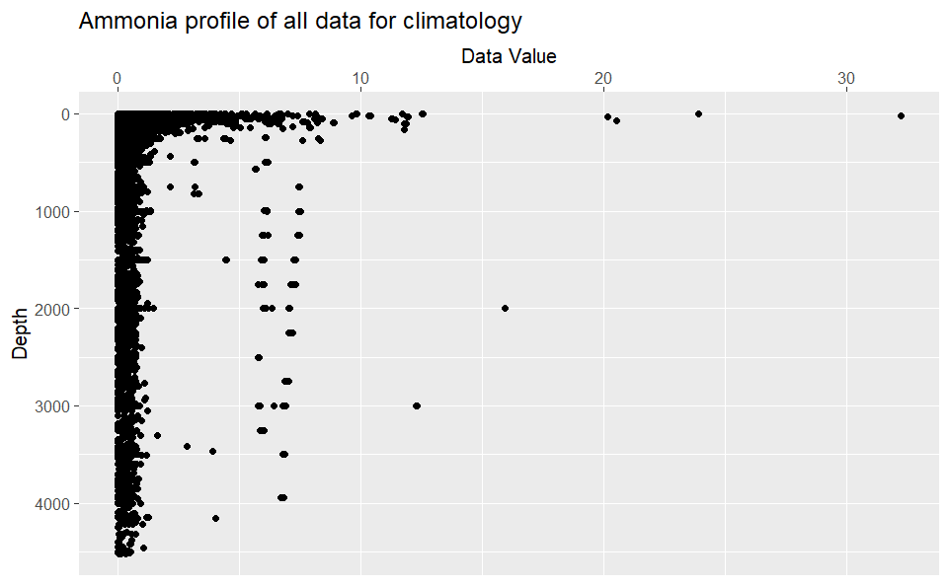

Figure 2 Depth profile of all ammonia data used for 2024 climatology [1999-2023]. Unit is mmol/m3.

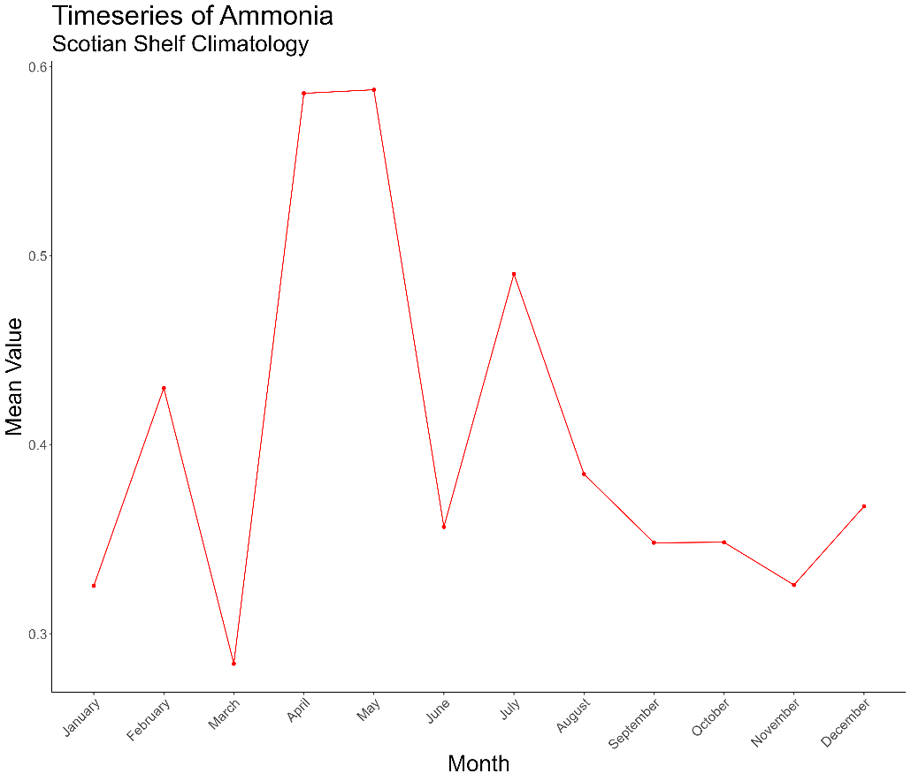

Figure 3 Monthly mean values for ammonia on the Scotian Shelf, harmonized over all boxes and depth strata. Data values are in mmol/m3.

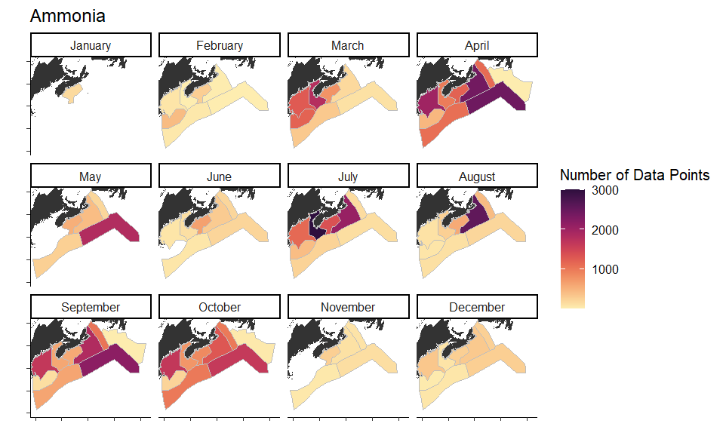

Figure 4 Spatial distribution of ammonia data in 2024 climatology product.

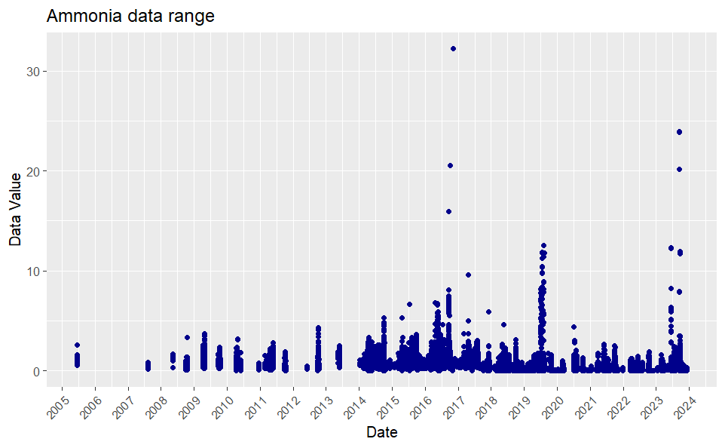

Figure 5 Temporal distribution of ammonia data

## Nitrite

Nitrite was not included in the previous version of the climatology, although it has been run through stage 2 of the QC methodology over the last 10 years, so it has undergone partial QC based on expected global, regional and profile ranges. The inclusion of this variable in the updated climatology will help increase the coverage of QC for AZMP nutrient data and improve the quality of future nutrient datasets. Nitrite methods included in this dataset were fresh, frozen, super frozen and undefined protocols.

Table 2 Nitrite data included in the 2024 climatology

|  |  |  |
| --- | --- | --- |
| **Nitrite 2024** | data removed | total data |
| extracted |  | 91537 |
| data flags | 434 |  |
| spatial filters (coastal buffer+boxes) | 9186+21569 |  |
| Test 2.1 (global range) | 0 |  |
| Test 2.2 (regional range) | 0 |  |
| Test 2.4 (profile envelope) | 0 |  |
| manual filtering for errors | 41 |  |
|  |  | 60356 |

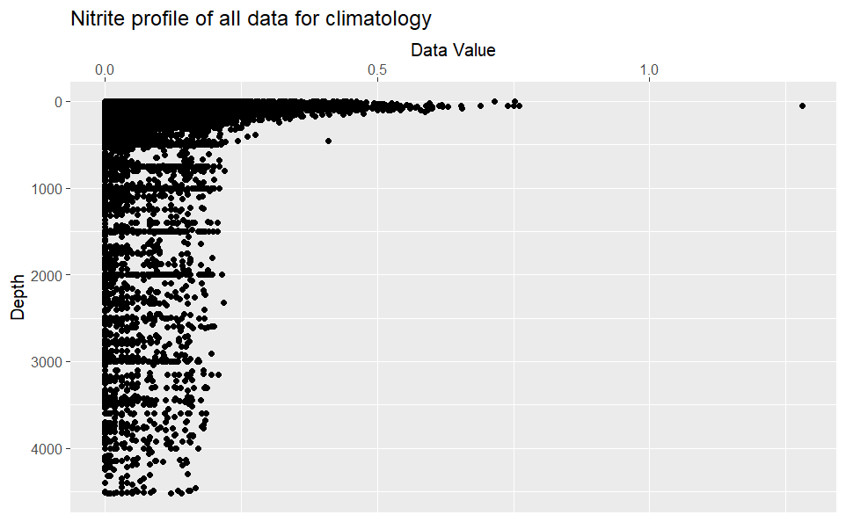

Figure 6 Depth profile of all nitrite data used for 2024 climatology [1999-2023]. Unit is mmol/m3.

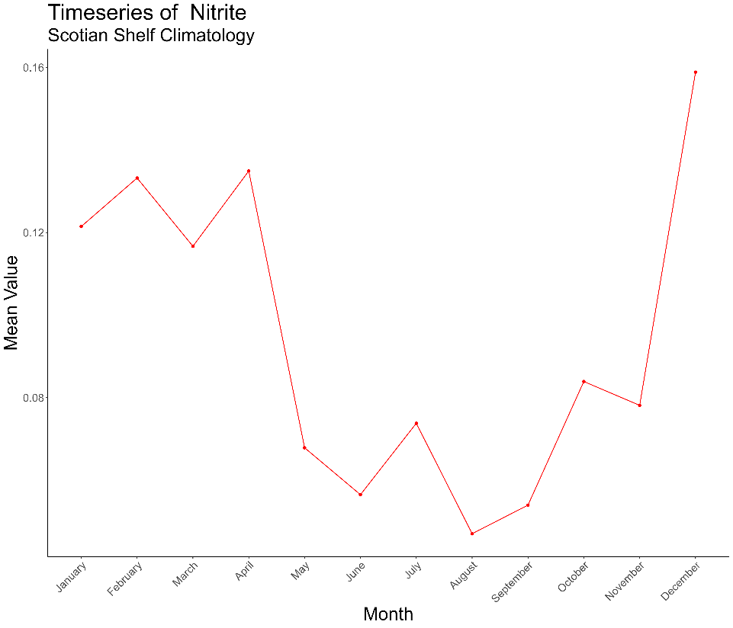

Figure 7 Monthly mean values for nitrite on the Scotian Shelf, harmonized over all boxes and depth strata. Data values are in mmol/m3

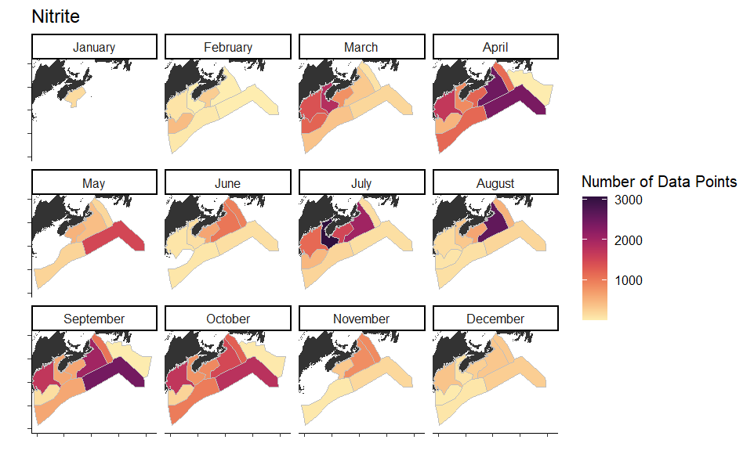

Figure 8 Spatial distribution of nitrite data in 2024 climatology product

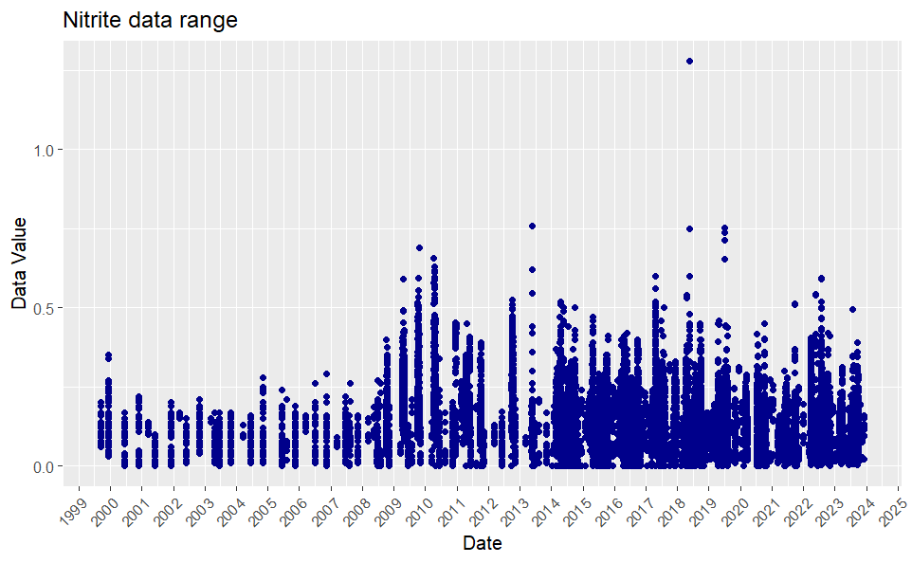

Figure 9 Temporal distribution of nitrite data

## Oxygen

Oxygen data was not previously included in the climatology product, although oxygen data has undergone stage 2 QC over the last 10 years. Oxygen data has been thoroughly checked by stage 2 tests including global, regional and profile ranges as well as comparative CTD- Bottle checks. Oxygen data also currently undergoes additional checks in the QC system including an oxygen saturation test for surface data. Some initial filtering was done to isolate oxygen methodologies and units, this resulted in a smaller initial dataset. Only Winkler data was used to calculate the climatology, due to the lack of confidence in other methods. Adding this variable to the climatology will ensure the highest quality oxygen data moving forward.

Table 3 Oxygen data included in the 2024 climatology

|  |  |  |
| --- | --- | --- |
| **O2 2024** | Data removed | Total data |
| extracted |  | 17829 |
| data flags | 203 |  |
| spatial filters (coastal buffer+boxes) | 1509+919 |  |
| Test 2.1 (global range) | 0 |  |
| Test 2.2 (regional range) | 0 |  |
| Test 2.4 (profile envelope) | 1 |  |
| manual filtering for errors | 0 |  |
|  |  | 15198 |

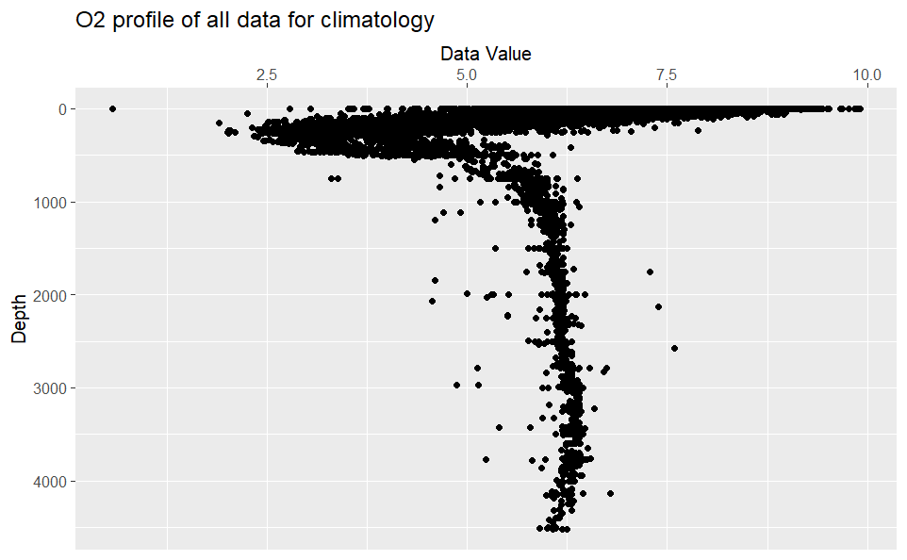

Figure 10 Depth profile of all oxygen data used for 2024 climatology [1999-2023]. Unit is ml/l.

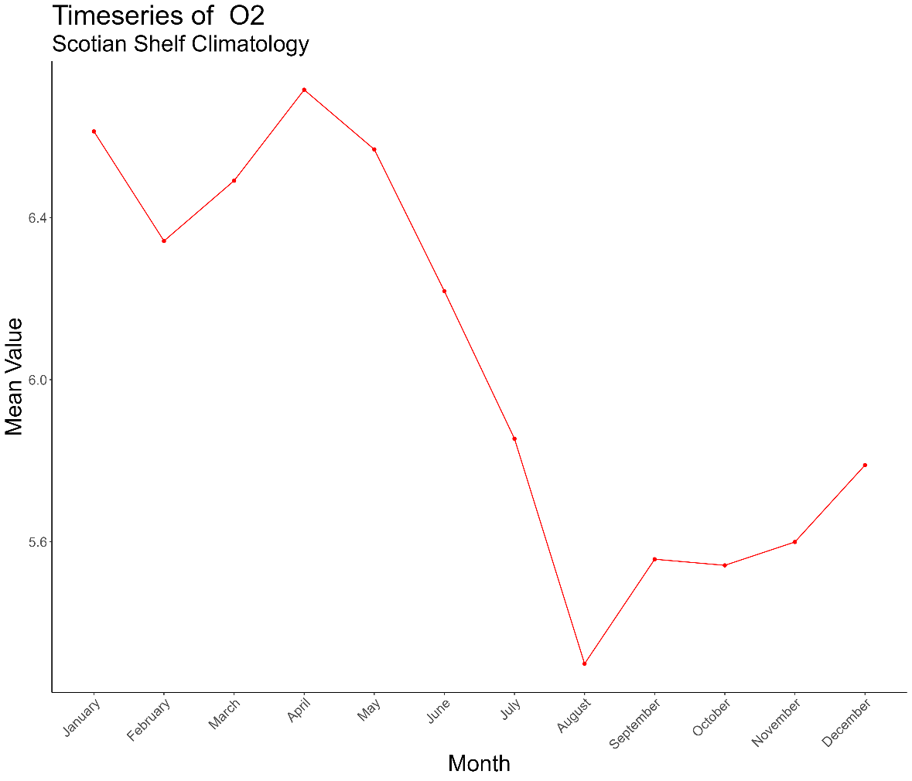

Figure 11 Monthly mean values for oxygen on the Scotian Shelf, harmonized over all boxes and depth strata. Data values are in ml/l.

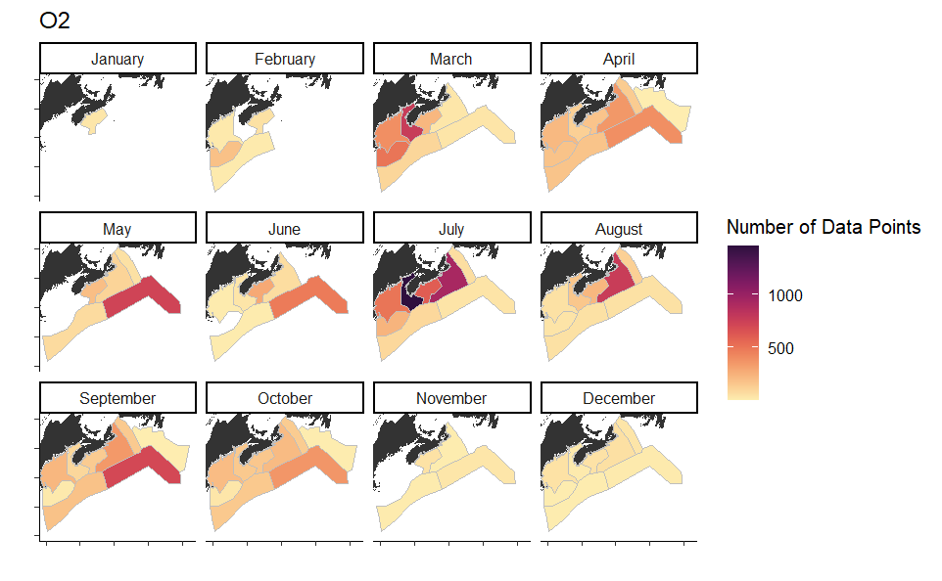

Figure 12 Spatial distribution of oxygen data for 2024 climatology product

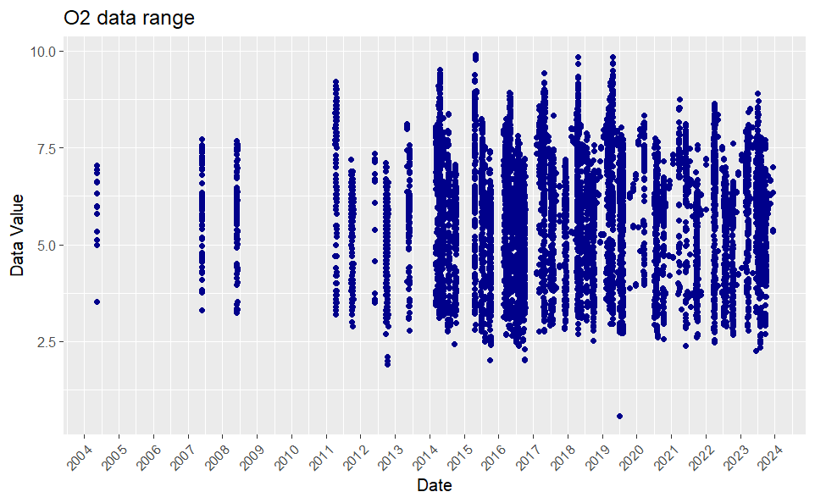

Figure 13 Temporal distribution of oxygen data

## Phaeophytin

Phaeophytin data was not previously included in the climatology product for the Scotian Shelf. The methods available included Holm-Hansen fresh and frozen, as well as some undefined protocol data. This data set does not currently have any global or regional ranges for the Scotian Shelf and so no data was filtered out through range check QC before inclusion in the climatology. Some flags have been applied by data producers.

Table 4 Phaeophytin data included in the 2024 climatology

|  |  |  |
| --- | --- | --- |
| **Phaeophytin 2024** | Data removed | Total data |
| extracted |  | 72592 |
| data flags | 71 |  |
| spatial filters (coastal buffer+boxes) | 5980+11137 |  |
| Test 2.1 (global range) | NA |  |
| Test 2.2 (regional range) | NA |  |
| Test 2.4 (profile envelope) | NA |  |
| manual filtering for errors | 44 |  |
|  |  | 55378 |

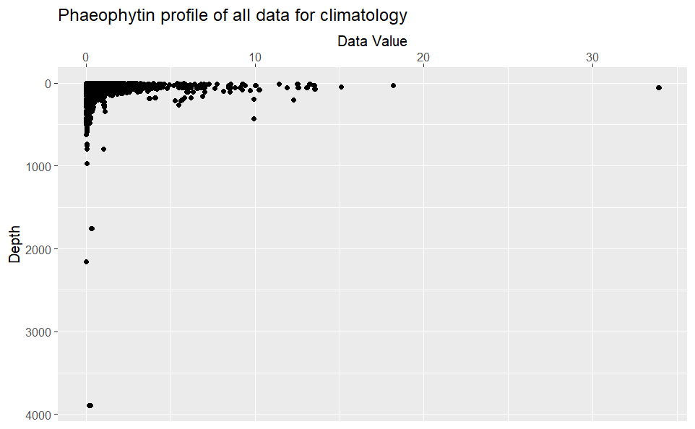

Figure 14 Depth profile of all phaeophytin data used for 2024 climatology [1999-2023]. Unit is mg/m3.

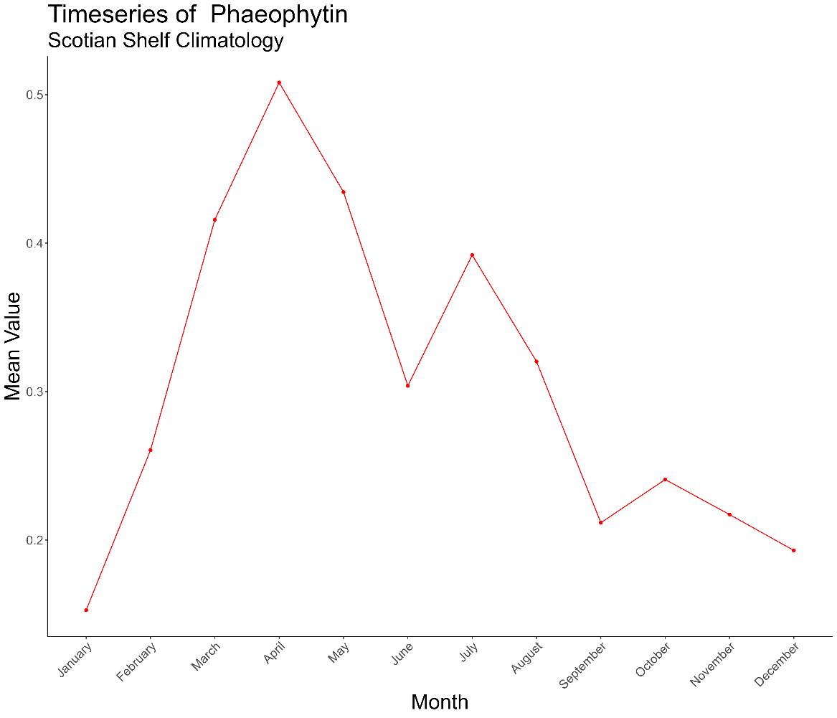

Figure 15 Monthly mean values for phaeophytin on the Scotian Shelf, harmonized over all boxes and depth strata. Data values are in mg/m3.

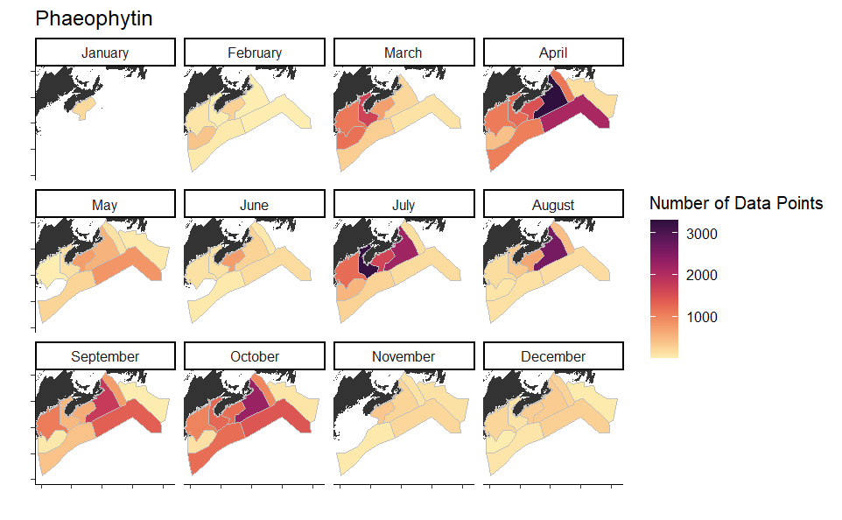

Figure 16 Spatial distribution of phaeophytin data for 2024 climatology product

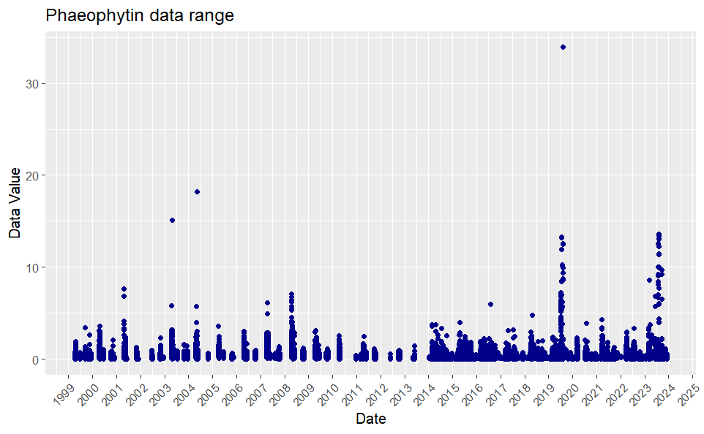

Figure 17 Temporal distribution of phaeophytin data

## Nitrate

Nitrate data was previously included in the climatology product, which allows us to compare our updated values to those calculated in 2014. The methods in this dataset included fresh, frozen and super frozen as well as undefined protocol data. These data have been undergoing through QC over the last 10 years, including climatology and expected range tests, so this is a very high quality dataset. Despite a significant shift in temporal restrictions between the 2014 and 2025 product, the final number of records used to calculate the climatology are quite close due to the increase an increase in available data post 2014.

|  |  |
| --- | --- |
| extracted | 109239 |
| Ocean data within all sub-areas | 72 000 |
| Data Flagged | 301 |
| Position Flagged | 0 |
| Exceeding upper limit (515 mmol/m3) | 0 |
| Negative | 1 |
| Total removed | 302 |
| Filtered dataset | **71 698** |

Table 5 Number of nitrate records identified during quality control. [Lazin 2014]

Table 6 Nitrate data included in the 2024 climatology

|  |  |  |
| --- | --- | --- |
| **Nitrate 2024** | Data removed | Total data |
| extracted |  | 110023 |
| data flags | 452 |  |
| spatial filters (coastal buffer+boxes) | 11093 + 24572 |  |
| Test 2.1 (global range) | 3 |  |
| Test 2.2 (regional range) | 0 |  |
| Test 2.4 (profile envelope) | 0 |  |
| manual filtering for errors | 64 |  |
|  |  | 73926 |



Figure 18 Depth profile of all nitrate data used for the climatology computation. Nitrate unit is mmol/m3 [Lazin 2014]

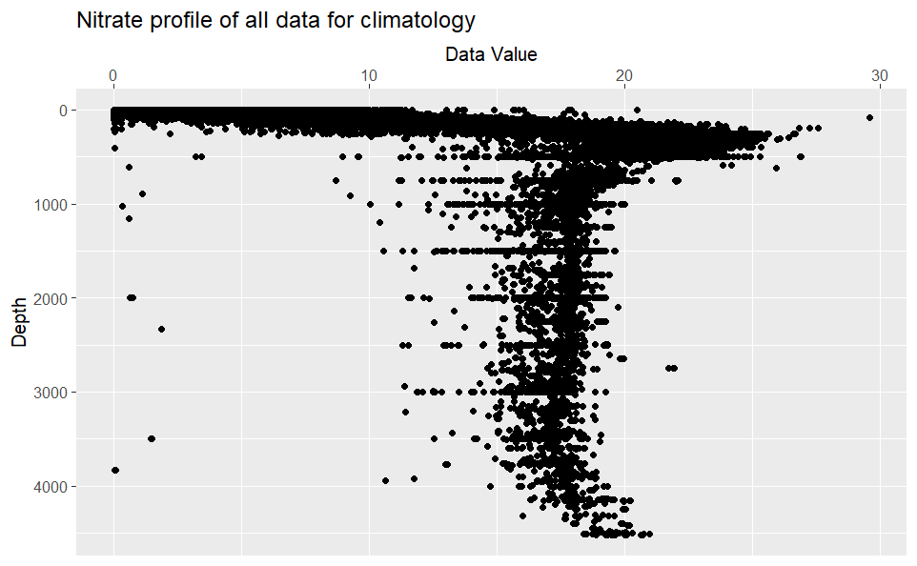

Figure 19 Depth profile of all nitrate data used for 2024 climatology [1999-2023]. Unit is mmol/m3.

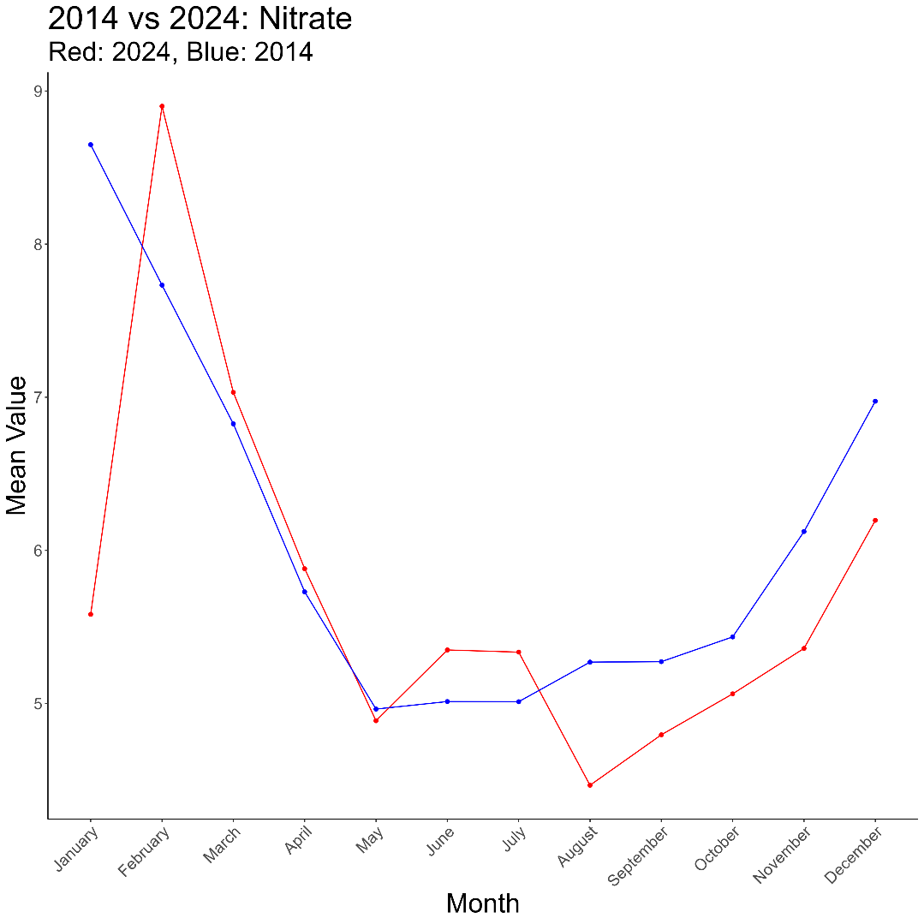

Figure 20 Monthly mean nitrate values for Scotian Shelf climatology, harmonized across boxes and depth strata. Red shows 2024 mean value trend, and blue shows 2014 mean value trend.

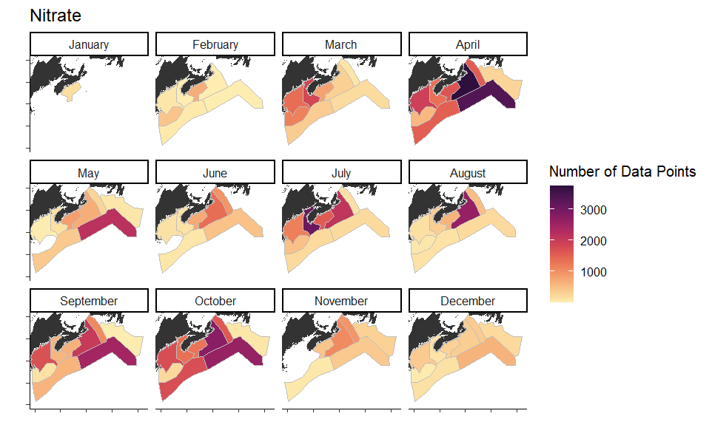

Figure 21 Spatial distribution of nitrate data in 2024 climatology product

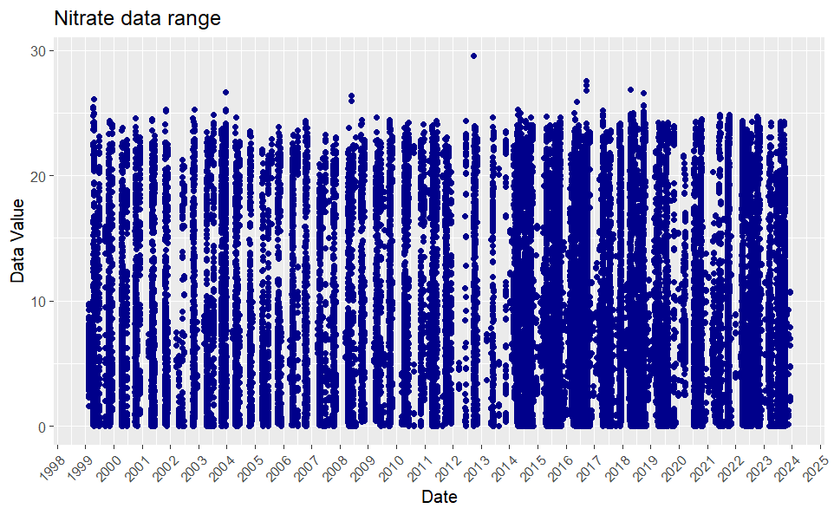

Figure 22 Temporal distribution of nitrate data

## Silicate

Silicate was previously included in the climatology product, and has been confidently quality controlled over the past 10 years. This has included both climatology and global, regional and profile range checks. Similar to nitrate, this data set has an equivalent number of data points used to generate the climatology to the 2014 product, despite the temporal restrictions, due to an increase in data availability and sampling frequency. Silicate protocols included fresh, frozen and super frozen as well as some undefined protocol data.

Table 7 Number of silicate records identified during quality control. [Lazin 2014]

|  |  |
| --- | --- |
| Extracted | 115047 |
| Ocean data within all sub-areas | 73 387 |
| Data Flagged | 1876 |
| Position Flagged | 0 |
| Exceeding upper limit | 0 |
| Negative | 0 |
| Outside envelope | 12 |
| Total removed | 1888 |
| **Filtered dataset** | **71 499** |

Table 8 Silicate data included in the 2024 climatology

|  |  |  |
| --- | --- | --- |
| **Silicate 2024** | Data removed | Total data |
| extracted |  | 109164 |
| data flags | 411 |  |
| spatial filters (coastal buffer+boxes) | 11009 + 24104 |  |
| Test 2.1 (global range) | 0 |  |
| Test 2.2 (regional range) | 0 |  |
| Test 2.4 (profile envelope) | 0 |  |
| manual filtering for errors | 64 |  |
|  |  | 73663 |



Figure 23 Depth profile of all silicate data used for the climatology computation. Silicate unit is mmol/m3. [Lazin 2014]

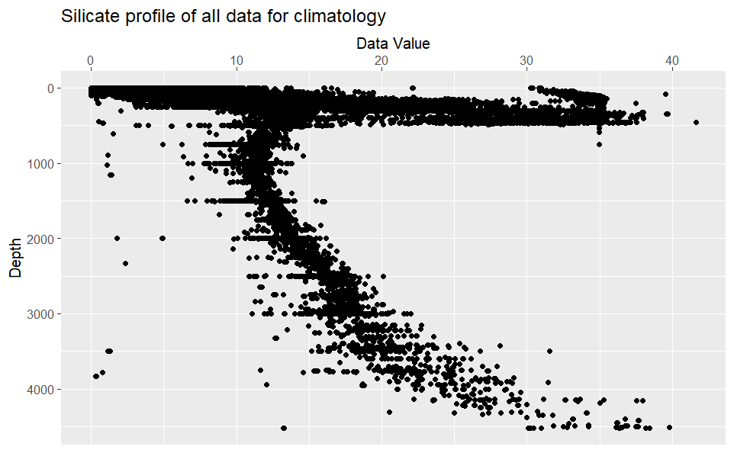

Figure 24 Depth profile of all silicate data used for 2024 climatology [1999-2023]. Unit is mmol/m3.

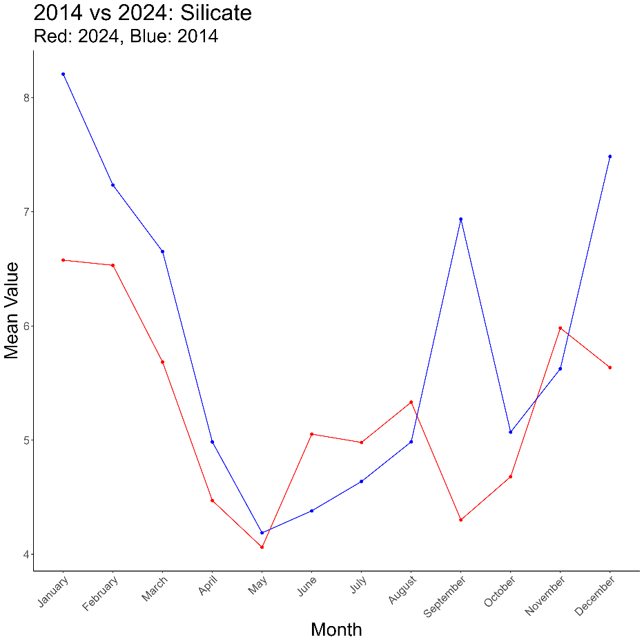

Figure 25 Monthly mean silicate values for Scotian Shelf climatology, harmonized across boxes and depth strata. Red shows 2024 mean value trend, and blue shows 2014 mean value trend.

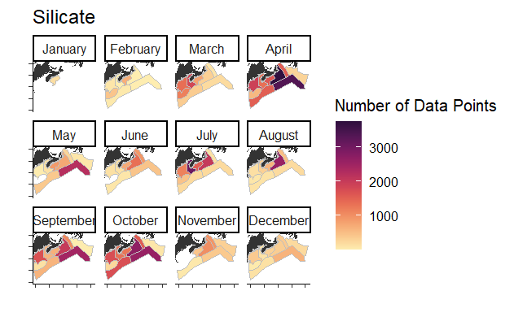

Figure 26 Spatial distribution of silicate data for 2024 climatology product

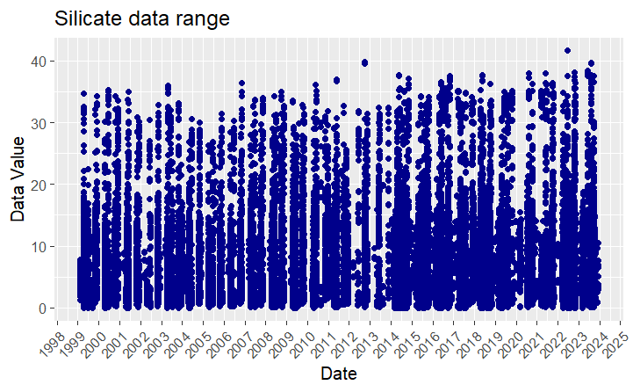

Figure 27 Temporal distribution of silicate data

## Phosphate

Phosphate was previously included in the climatology product, and has been confidently quality controlled over the past 10 years. This has included both climatology and global, regional and profile range checks. Similar to nitrate, and silicate this data set has an equivalent number of data points used to generate the climatology to the 2014 product, despite the temporal restrictions, due to an increase in data availability and sampling frequency. There are slightly more data points flagged in this dataset compared to other nutrients due to the tendency of phosphate to be sensitive to contamination. This dataset specifically is vulnerable to producing poor replicate measurements under certain conditions, and is generally more sensitive to data quality issues. Phosphate methods included fresh, frozen and super frozen as well as some undefined protocol data.

Table 9 Number of phosphate records identified during quality control. [Lazin 2014]

|  |  |
| --- | --- |
| extracted | 121630 |
| Ocean data within all sub-areas | 75 250 |
| Data Flagged | 728 |
| Position Flagged | 0 |
| Exceeding upper limit | 2 |
| Negative | 0 |
| Outside envelope | 6 |
| Total removed | 736 |
| **Filtered dataset** | **74 514** |

Table 10 Phosphate data included in the 2024 climatology

|  |  |  |
| --- | --- | --- |
| **Phosphate 2024** | data removed | total data |
| extracted |  | 109722 |
| data flags | 511 |  |
| spatial filters (coastal buffer+boxes) | 11064 + 24553 |  |
| Test 2.1 (global range) | 0 |  |
| Test 2.2 (regional range) | 0 |  |
| Test 2.4 (profile envelope) | 0 |  |
| manual filtering for errors | 58 |  |
|  |  | 73623 |



Figure 28 Depth profile of all phosphate data used for the climatology computation. Phosphate unit is mmol/m3. [Lazin 2014]

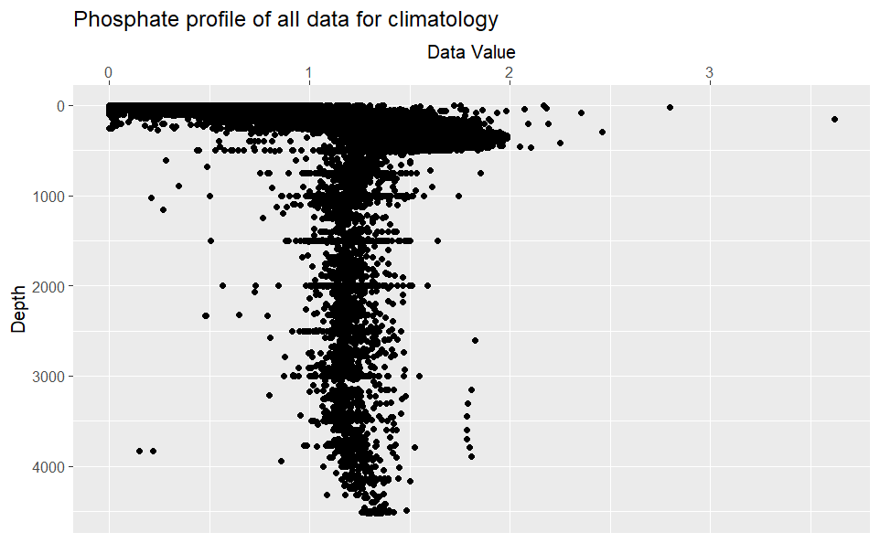

Figure 29 Depth profile of all phosphate data used for 2024 climatology [1999-2023]. Unit is mmol/m3.

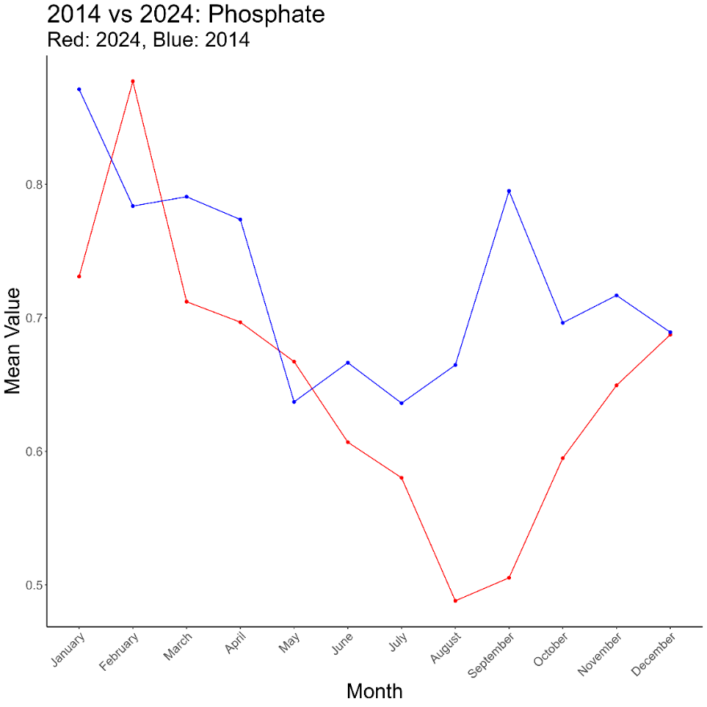

Figure 30 Monthly mean phosphate values for Scotian Shelf climatology, harmonized across boxes and depth strata. Red shows 2024 mean value trend, and blue shows 2014 mean value trend.

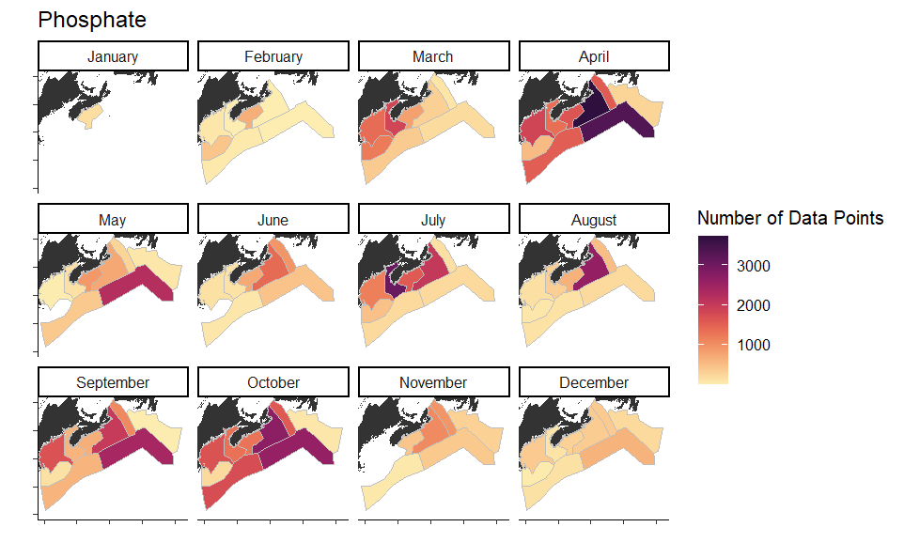

Figure 31 Spatial distribution of phosphate data in 2024 climatology product

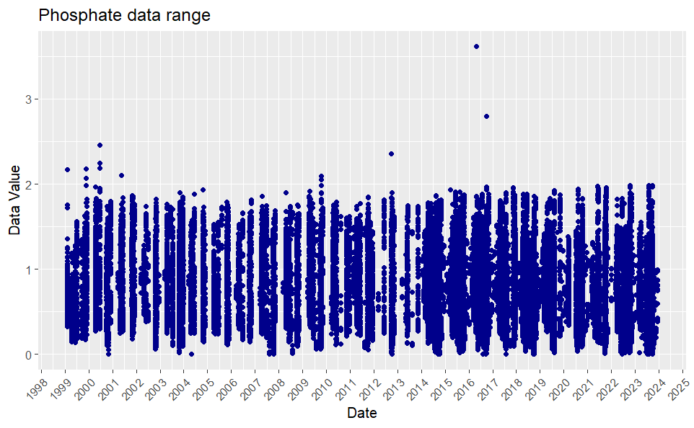

Figure 32 Temporal distribution of phosphate data

## Chlorophyll A

Chlorophyll A was included in the 2014 climatology product, and has been confidently quality controlled over the last 10 years, producing a high quality dataset. These quality control checks have included stage 2 QC comparison to global, regional and profile ranges, as well as stage 3 climatology range tests. Notably, although there are fluorometers typically included on our CTD packages, the CTD and bottle data are not compared in quality control methods due to the variability of CTD measurements and the mis-aligned scale of the CTD fluorometer with the bottle measurements. This dataset includes Welschmeyer and Holm-Hansen fresh, frozen and super frozen protocols, as well as some undefined protocol data.

Table 11 Number of chlorophyll records identified during quality control. [Lazin 2014]

|  |  |
| --- | --- |
| Extracted | 89799 |
| Ocean data within all sub-areas | 59 407 |
| Data Flagged | 983 |
| Position Flagged | 0 |
| Exceeding upper limit | 0 |
| Negative | 0 |
| Total removed | 983 |
| Filtered dataset | **58 424** |

Table 12 Chlorophyll-a data included in the 2024 climatology

|  |  |  |
| --- | --- | --- |
| **Chlorophyll A 2024** | Data removed | Total data |
| extracted |  | 92187 |
| data flags | 314 |  |
| spatial filters (coastal buffer+boxes) | 10791 + 22989 |  |
| Test 2.1 (global range) | 0 |  |
| Test 2.2 (regional range) | 0 |  |
| Test 2.4 (profile envelope) | 0 |  |
| manual filtering for errors | 58 |  |
|  |  | 58099 |



Figure 33: Depth profile of all chlorophyll data used for the climatology computation. Chlorophyll unit is mg/m3. [Lazin 2014]

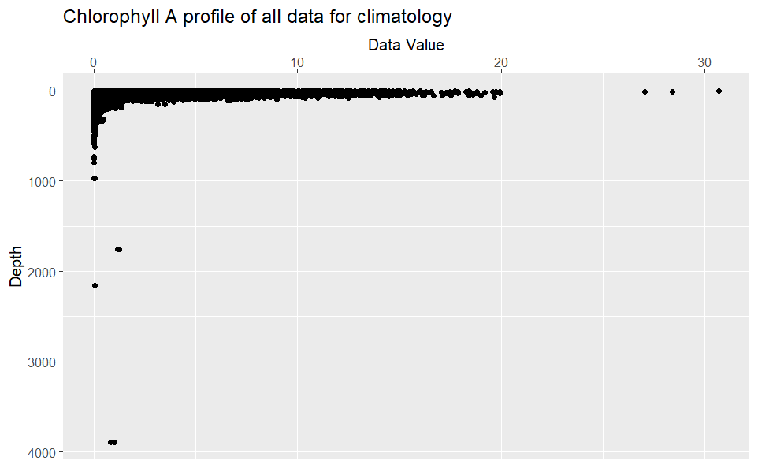

Figure 34 Depth profile of all chlorophyll A data used for 2024 climatology [1999-2023]. Unit is mg/m3.

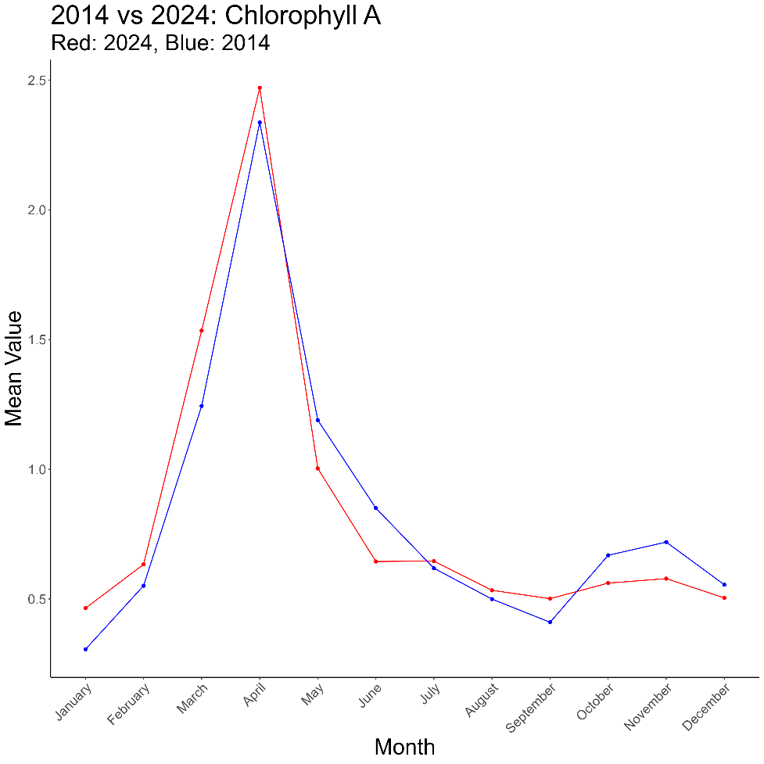

Figure 35 Monthly mean phosphate values for Scotian Shelf climatology, harmonized across boxes and depth strata. Red shows 2024 mean value trend, and blue shows 2014 mean value trend.

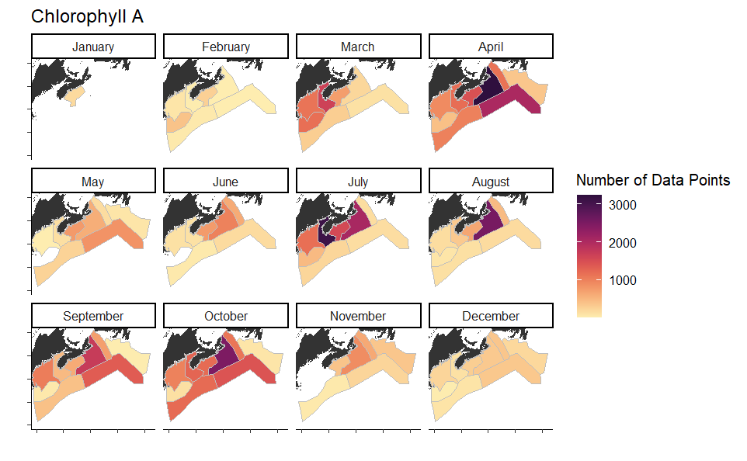

Figure 36 Spatial distribution of chlorophyll-a data in 2024 climatology product

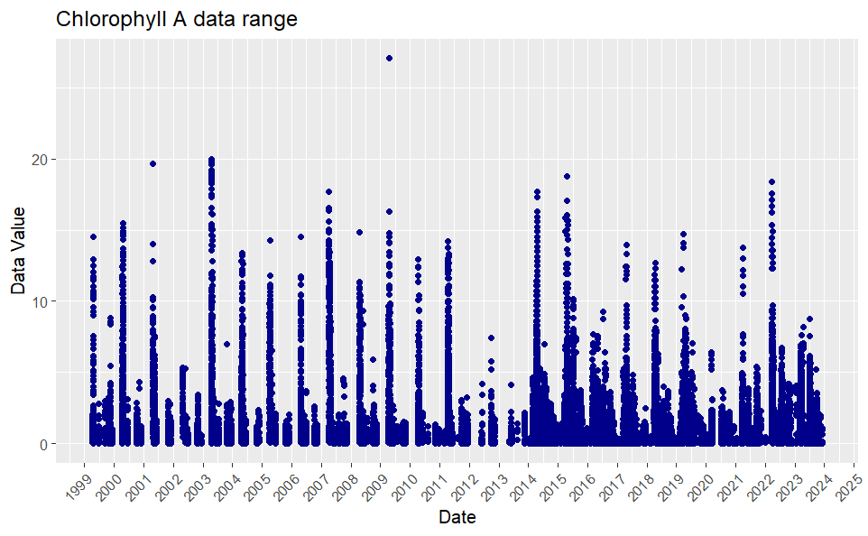

Figure 37 Temporal distribution of chlorophyll-a data

# Comparison of Climatology Products

Although it is outside the scope of this project to comment on the potential change in Scotian Shelf trends observed through the shift between these climatology products, it is clearly visible that there are differences between these products. Some differences may be explained by data quality, where the previous product was known to have some data quality issues (Lazin, 2014). The removal of these outliers may have significant effects on the range and mean values of the 2024 product. The 2024 product overall has narrower climatology ranges than the 2014 product. This could have impacts on the number of automated flags produced during quality control efforts, although the full impacts will remain to be seen. It may be of interest to other projects to compare the shift between these two products, particularly in seasonal timing of trends in chlorphyll-a, and nutrient availability.

# Climatology Computation

The climatology calculations included monthly mean, minimum and maximum values for each individual box and depth bin combination. Due to data availability, there were cases were there were not enough data points (n < 2) in a specific area, depth and month. In these cases, if there was data available in the 2014 climatology, those values were merged into the final climatology product. These cases were rare and represent less than 10% of the climatology.

The final climatology product has been exported as a csv from the R processing workflow. The workflow can be found on GitHub ([AZMP_climatology](https://github.com/EOGrady21/AZMP_climatology)). Once the csv was exported, it was also reformatted to fit the MatLab structure of the current QC system. The data products are archived on github and also on the BIO shared drive (link).

Details of data processing can be found in the README on the GitHub repository’s homepage.

# Implementation

This climatology product will be implemented in the quality control of bottle data collected on the Scotian Shelf. The values calculated here will be inserted into a MatLab file format, which will be used to compare future data through Stage 3 tests of the IML QC procedure. The climatology ranges used to compare data in IML QC are the greater of the minimum/maximum values or three standard deviations from the mean. There are some known issues with this approach, as it assumes a normal distribution of data. Particularly challenging is how this can result in minimum test values that fall outside of possible ranges. For example, if three standard deviations below the mean value falls below zero for a variable where negative values are not expected. This could be a future project to further define possible climatology ranges or to change the distribution assumptions of the climatology tests. For example, the test could be changed to flag data anywhere outside the minimum and maximum range, regardless of the standard deviation of the data. This could result in more automated flags being produced and would need to be carefully reviewed for impacts on the QC workflow.

It is also important to note that data points which fail these Stage 3 climatology tests in IML QC procedures are not necessarily flagged as erroneous in the final iteration of the data, which would be published in BioChem and other databases. Each automated flag is carefully reviewed, and there are many cases where data that falls outside of the climatology ranges is marked as valid due to real trends visible in a particular variable over a mission or profile scale. This is particularly common in pigments when blooms result in maximum values outside of the expected climatological range. Details on individual flagging decisions can be found with associated QC data in mission folders on SRC on the BIO shared drive, where each mission should have a report on QC results for bottle data.

# References

**[DRAFT]** Lazin, G., Johnson, C., Cogswell, A., Bond, S., Jackson, J. 2014. Nitrate, Silicate, Phosphate and Chlorophyll-a Climatology for the Maritimes Region. *Unpublished*. R:\Science\BIODataSvc\SRC\BIOCHEMInventory\1_REBOOT_Gordana\nutrient_climatology_files\Climatology report.docx. Last Accessed: February 27th 2025.

Brickman, D. and B. Petrie. 2003. Nitrate, silicate and phosphate atlas for the Gulf of St. Lawrence. Can. Tech. Rep. Hydrogr. Ocean Sci. 231, xi+152 pp.

IML quality control procedure for bottle data:

<http://slgo.ca/app-sgdo/en/docs_reference/botl_odf_quality.html>

DFO (2014). BioChem: database of biological and chemical oceanographic data. Department of Fisheries and Oceans, Canada.[http://www.meds-sdmm.dfo-mpo.gc.ca/biochem/biochem-eng.htm](http://www.meds-sdmm.dfo-mpo.gc.ca/BioChem/biochem-eng.htm).

Devine, L., M.K. Kennedy, I. St-Pierre, C. Lafleur, M. Ouellet, and S. Bond. 2014. BioChem: the Fisheries and Oceans Canada database for biological and chemical data. Can. Tech. Rep. Fish. Aquat. Sci. 3073: iv + 40 pp. <http://www.dfo-mpo.gc.ca/Library/351319.pdf>

# Appendix I: QC Range Tables

Tables of Global and regional ranges used to QC data before inclusion in climatology

Test 2.1 – Global Range

|  |  |  |  |
| --- | --- | --- | --- |
| Variable | Unit | Min | Max |
| Salinity | (psu) | 0 | 40 |
| Dissolved oxygen | mL/L | 0 | 11 |
| Chlorophyll | mg/m³ | 0 | 50 |
| Phaeophytin | mg/m³ | NA | NA |
| Nitrate+Nitrite | mmol/m³ | 0 | 500 |
| Nitrite | mmol/m³ | 0 | 15 |
| Ammonia | mmol/m³ | NA | NA |
| Phosphate | mmol/m³ | 0 | 60 |
| Silicate | mmol/m³ | 0 | 250 |

Test 2.2 – Regional Range

|  |  |  |  |
| --- | --- | --- | --- |
| Variable | Unit | Min | Max |
| Salinity | (psu) | 5 | 40 |
| Dissolved oxygen | mL/L | 0 | 10 |
| Chlorophyll | mg/m³ | 0 | 50 |
| Phaeophytin | mg/m³ | NA | NA |
| Nitrate+Nitrite | mmol/m³ | 0 | 48 |
| Nitrite | mmol/m³ | 0 | 15 |
| Ammonia | mmol/m³ | NA | NA |
| Phosphate | mmol/m³ | 0 | 4.5 |
| Silicate | mmol/m³ | 0 | 250 |

Test 2.4 – Profile Envelopes

|  |  |  |  |  |
| --- | --- | --- | --- | --- |
| Variable | Min Depth | Max Depth | Min Value | Max Value |
| phosphate | 0 | 500 | 0 | 4.5 |
| phosphate | 500 | 5500 | 0.01 | 4.5 |
| silicate | 0 | 200 | 0 | 150 |
| silicate | 200 | 1000 | 0.01 | 150 |
| silicate | 1000 | 1500 | 2.5 | 150 |
| silicate | 1500 | 4500 | 5 | 150 |
| silicate | 4500 | 5500 | 10 | 150 |
| nitrate | 0 | 50 | 0 | 18 |
| nitrate | 50 | 200 | 0 | 30 |
| nitrate | 200 | 300 | 0 | 34 |
| nitrate | 300 | 700 | 0 | 42 |
| nitrate | 700 | 1100 | 6 | 46 |
| nitrate | 1100 | 4000 | 6 | 48 |
| nitrate | 4000 | 5500 | 10 | 46 |
| chlorophyll | 0 | 20 | 0 | 3 |
| chlorophyll | 20 | 50 | 0 | 2.5 |
| chlorophyll | 50 | 100 | 0 | 2 |
| chlorophyll | 100 | 250 | 0 | 0.5 |
| chlorophyll | 250 | 2500 | 0 | 0.4 |
| chlorophyll | 2500 | 3000 | 0 | 0.3 |
| chlorophyll | 3000 | 5500 | 0 | 0.05 |
| temperature | 0 | 10 | -2.1 | 35 |
| temperature | 10 | 50 | -2.1 | 32 |
| temperature | 50 | 100 | -2.1 | 30 |
| temperature | 100 | 300 | -2 | 28 |
| temperature | 300 | 1000 | -1.7 | 20 |
| temperature | 1000 | 1500 | -1.5 | 18 |
| temperature | 1500 | 3000 | -1.5 | 13 |
| temperature | 3000 | 5500 | -1.5 | 7 |
| salinity | 0 | 10 | 5 | 40 |
| salinity | 10 | 50 | 27 | 38.2 |
| salinity | 50 | 125 | 28.9 | 38 |
| salinity | 125 | 300 | 29.4 | 37.6 |
| salinity | 300 | 600 | 30.8 | 36.8 |
| salinity | 600 | 2000 | 32.2 | 36.6 |
| salinity | 2000 | 5500 | 34.7 | 35.5 |
| Oxygen | 0 | 30 | 0 | 10 |
| Oxygen | 30 | 200 | 0 | 9 |
| Oxygen | 200 | 1500 | 0 | 8 |

# Appendix II: Climatology Plots

The plots below detail the full resolution of the 2024 climatology product for each variable. Each plot represents a monthly timeseries of a particular variable of a particular box, as noted in the figure title. Within each figure, the four panels represent the 4 depth bins. The blue text indicates the number of data points used to in the climatology calculation for that particular variable, month, depth bin and box. The whiskers visible show the minimum and maximum values of the data which will be used to compare future data points in the quality control methods. If a future data point falls outside of this range it will be flagged by the automated quality control tests, and the flag will be individually reviewed (the data point be subsequently be flagged erroneous or exonerated and marked as valid).

## Ammonia

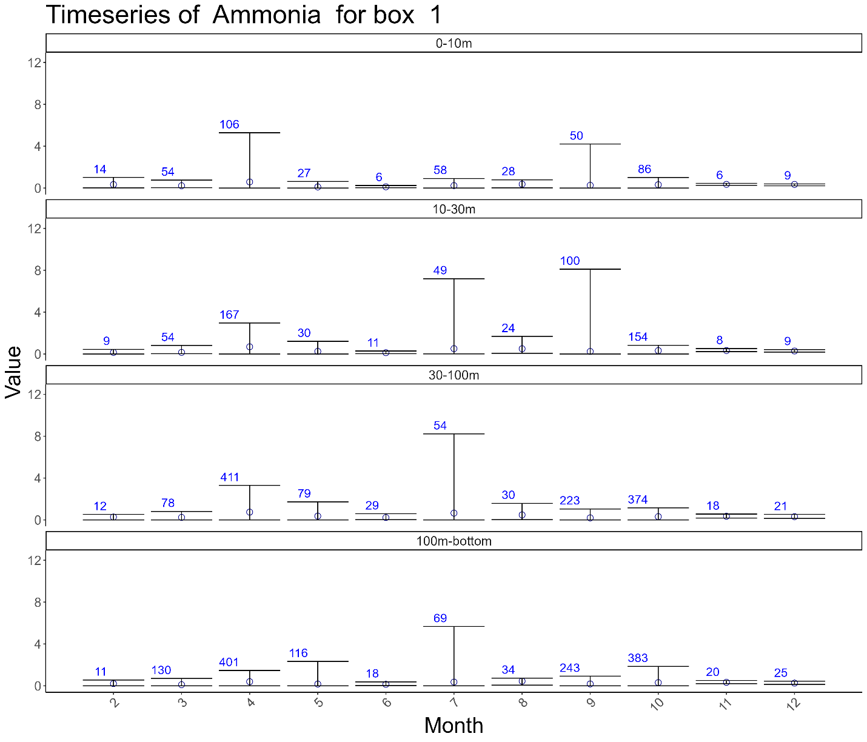

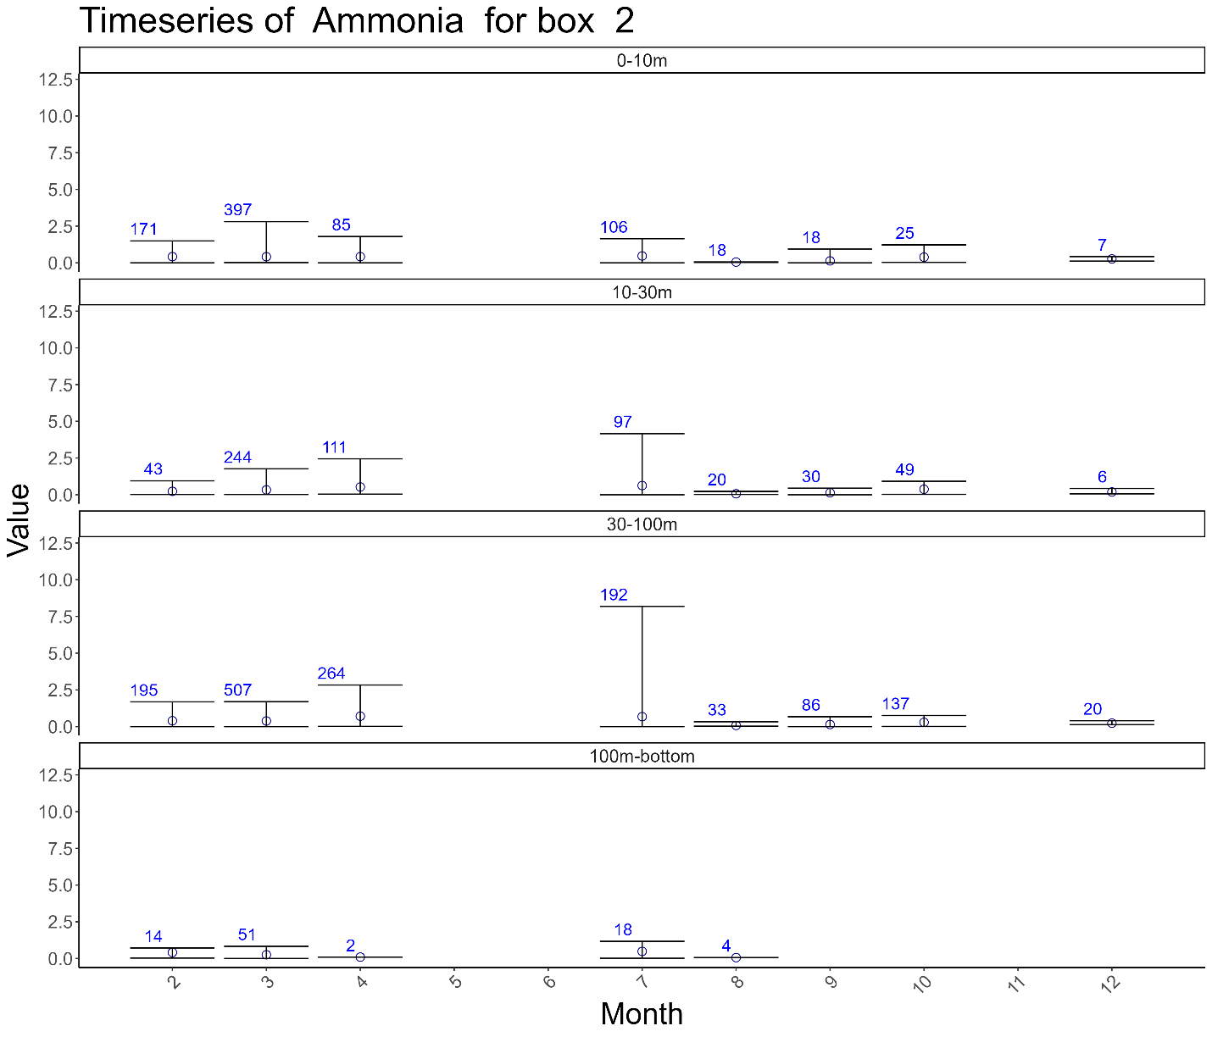

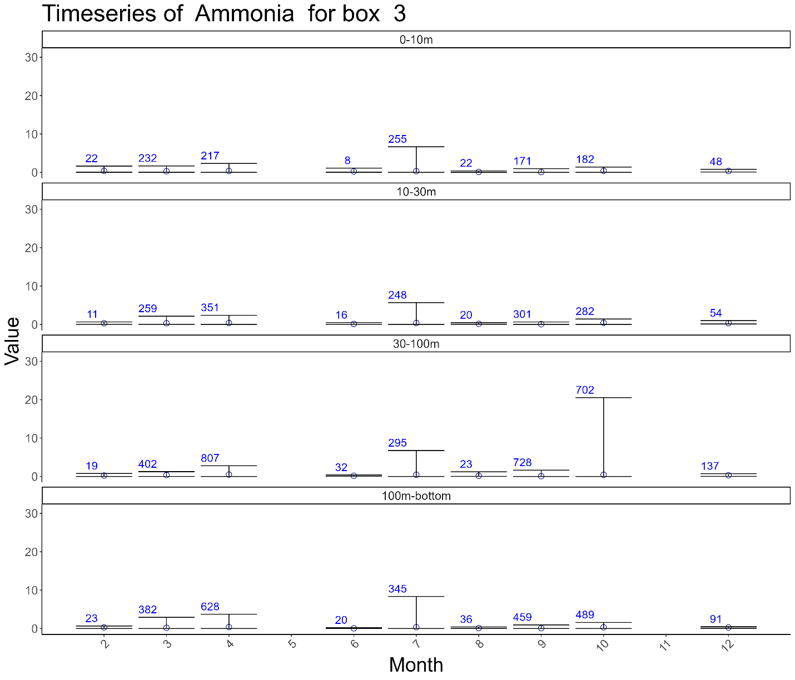

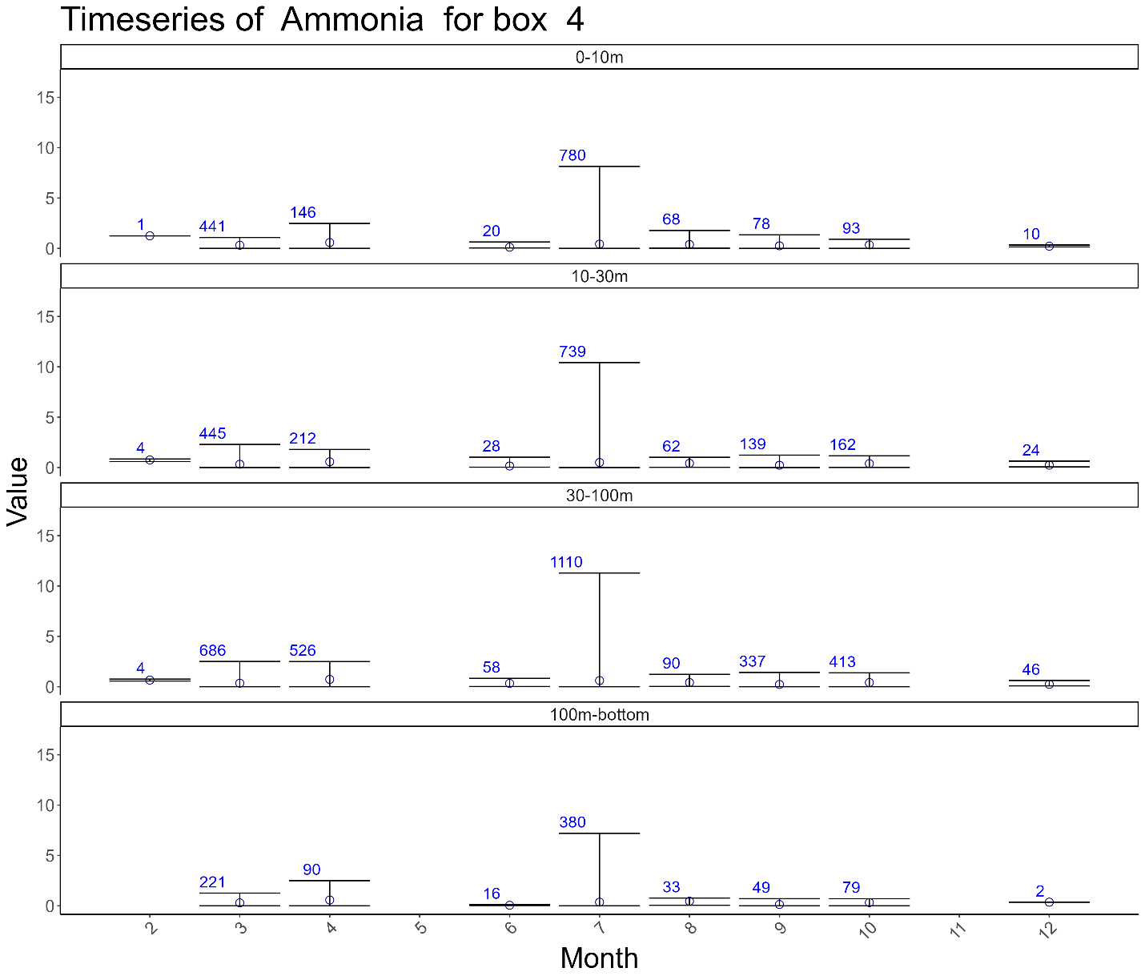

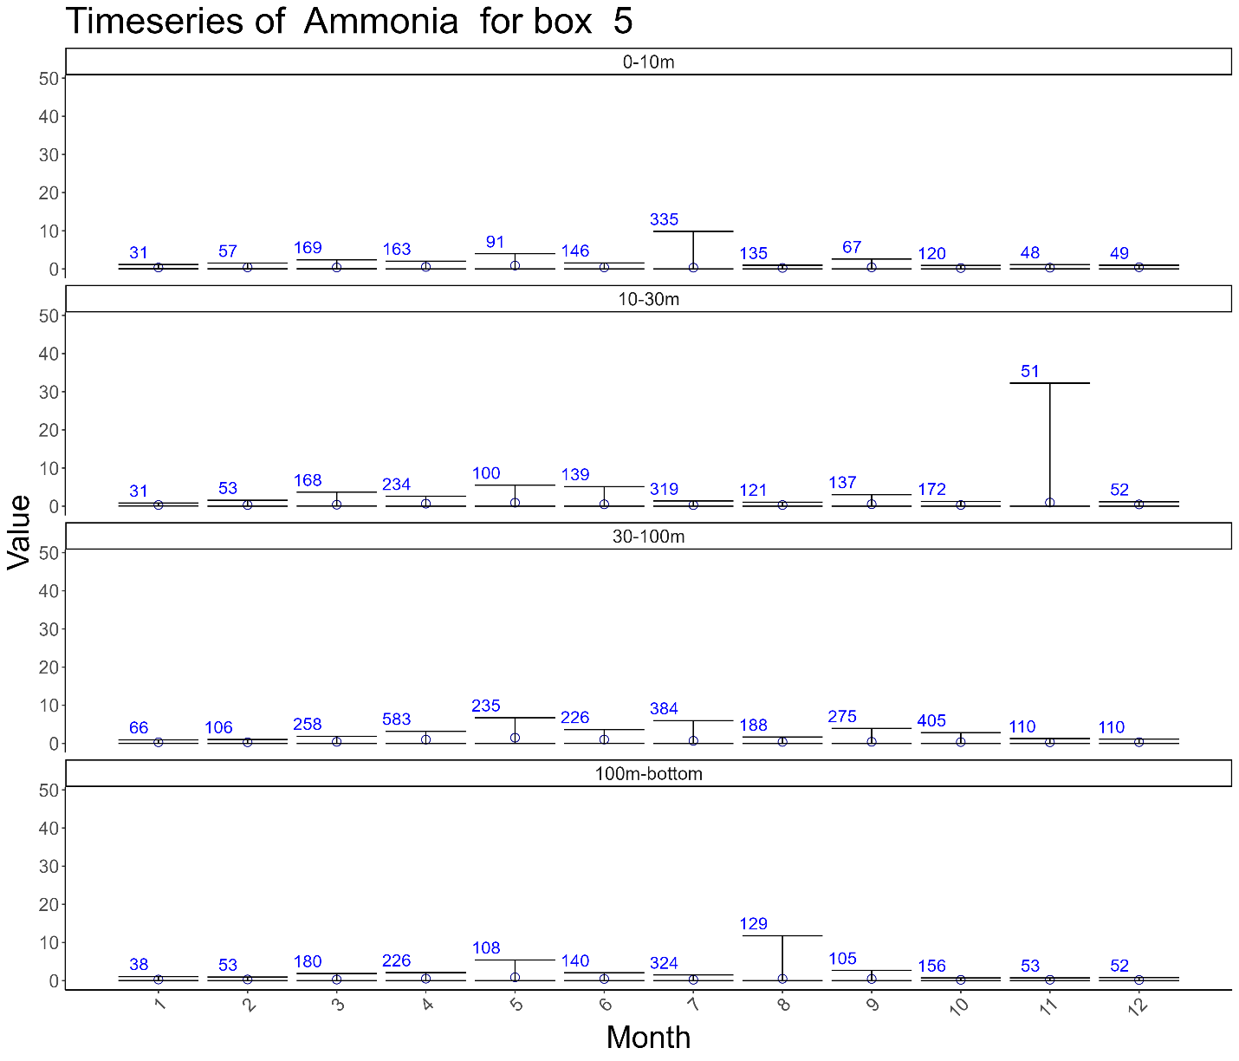

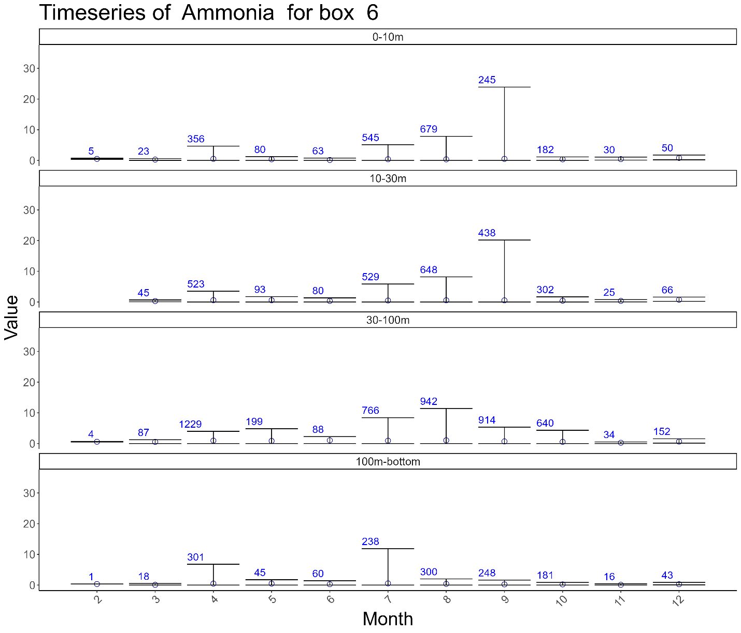

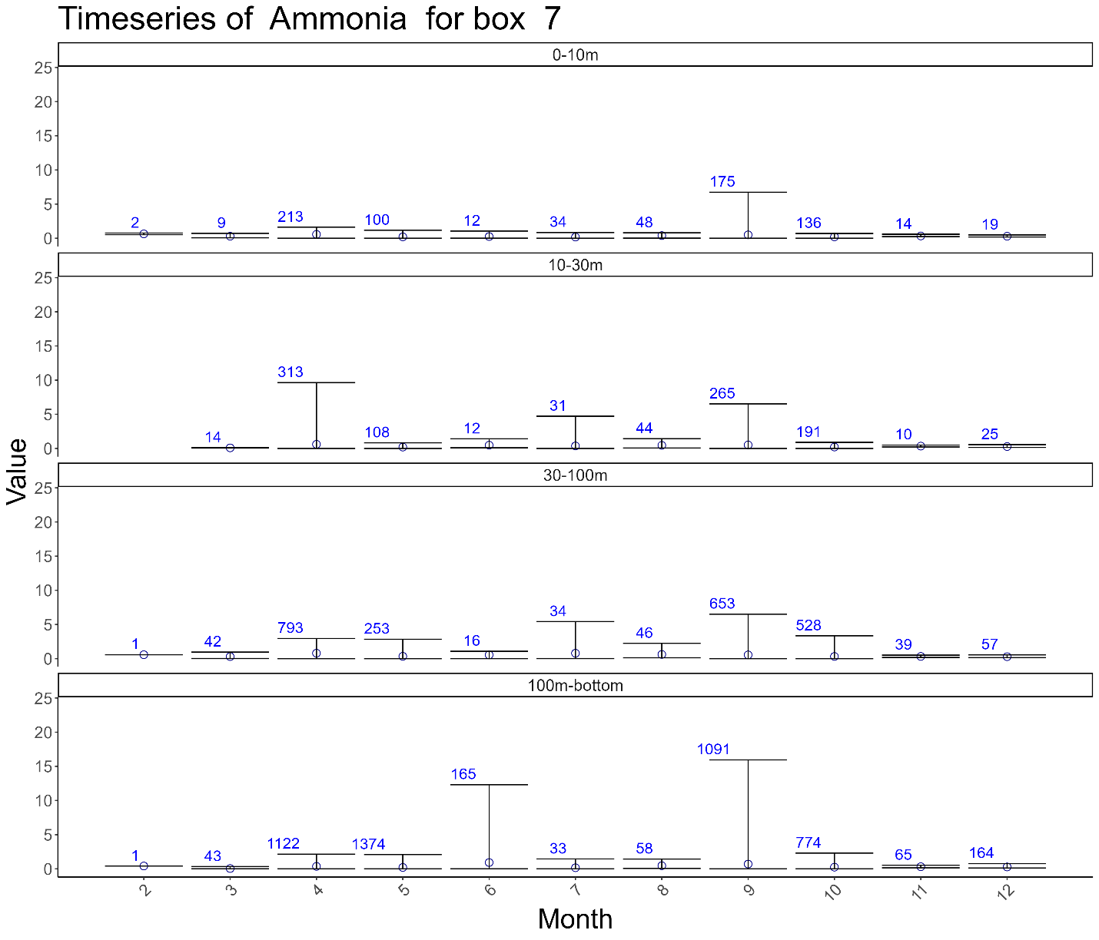

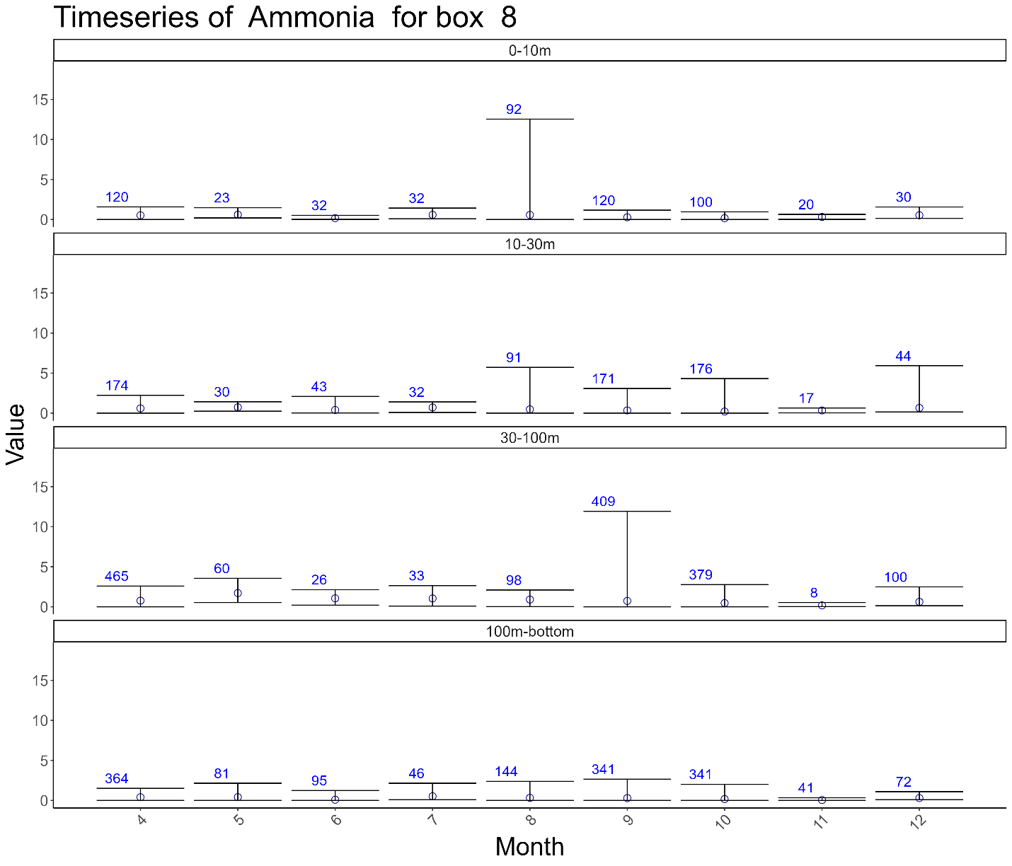

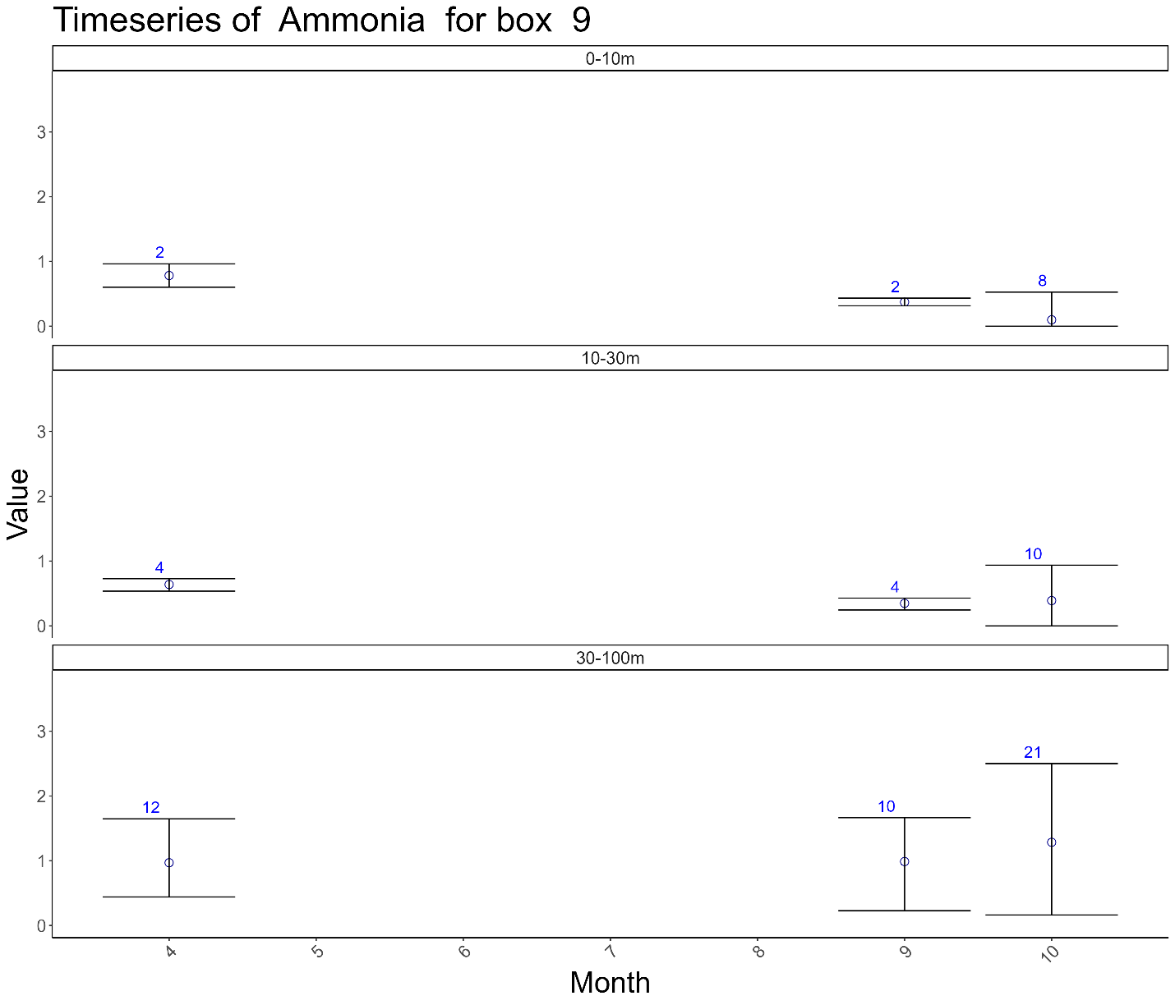

## Chlorophyll A

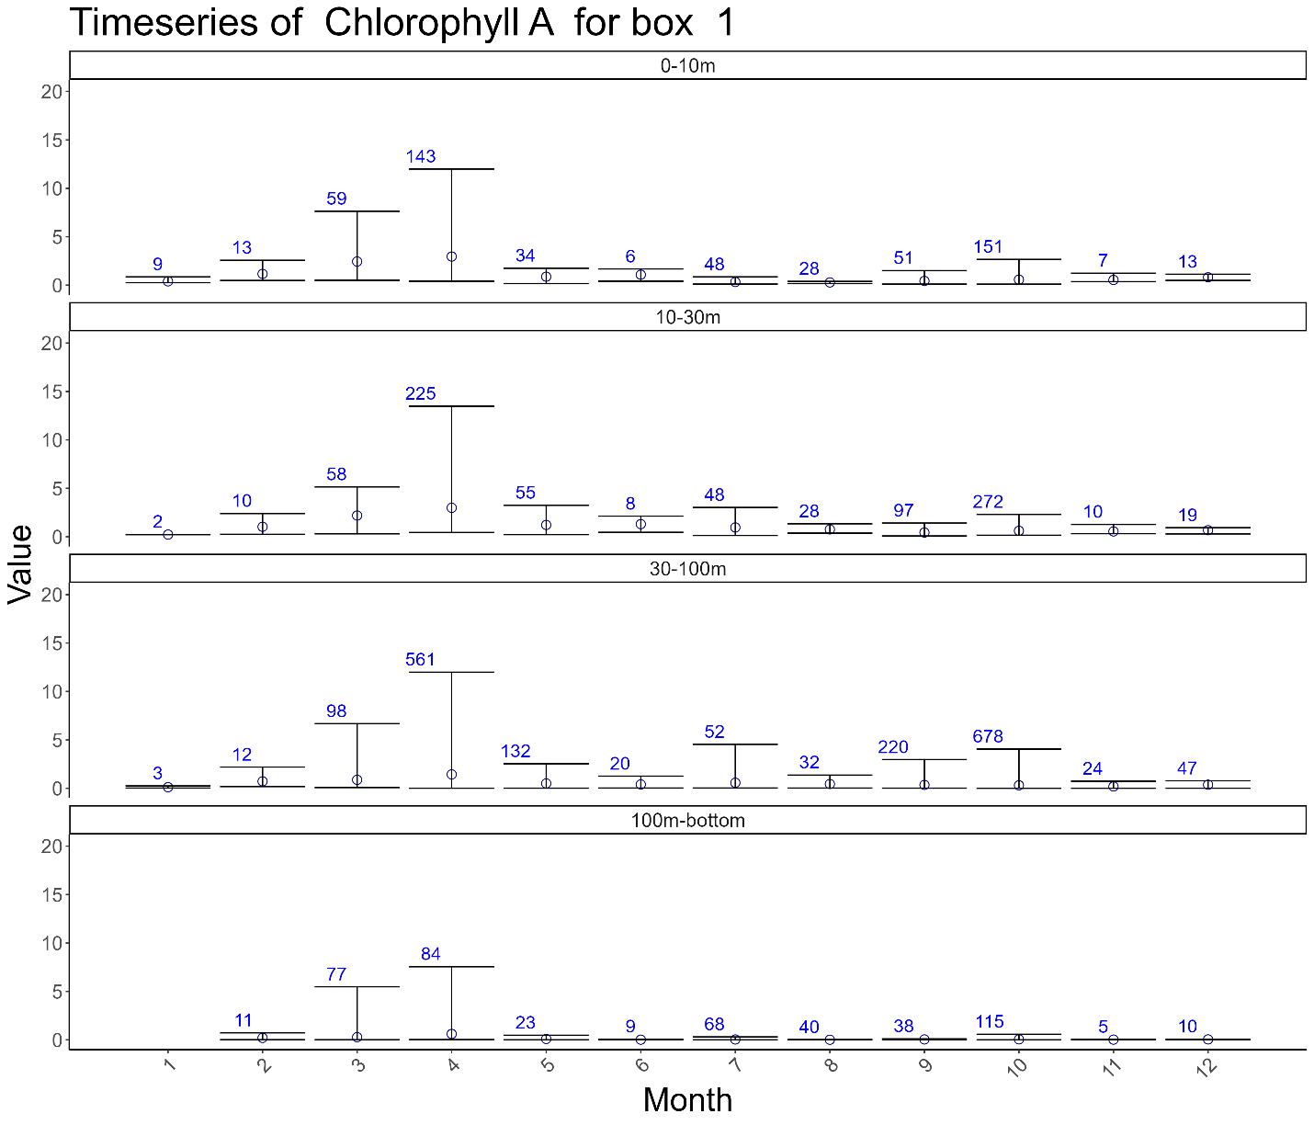

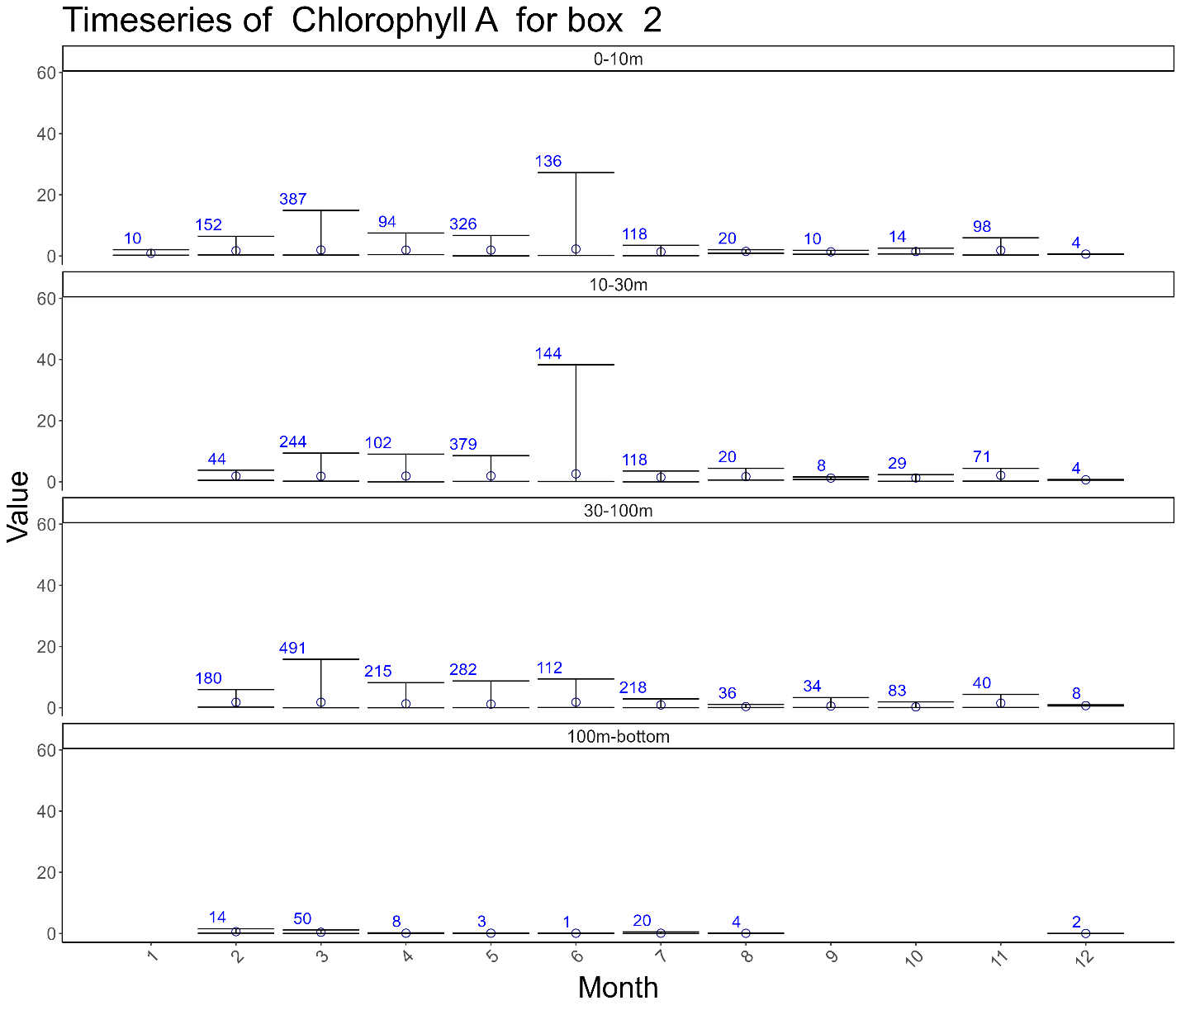

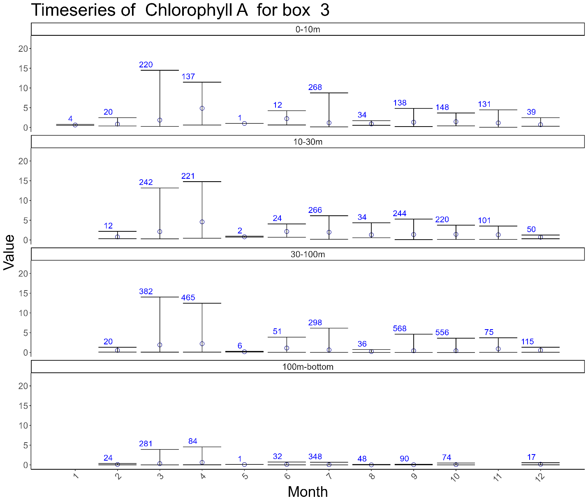

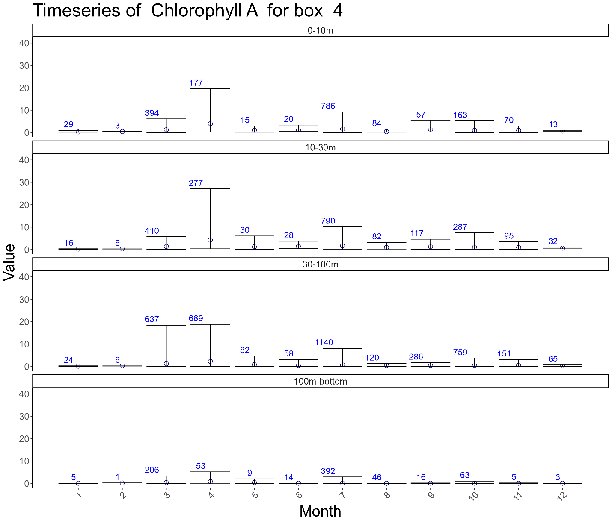

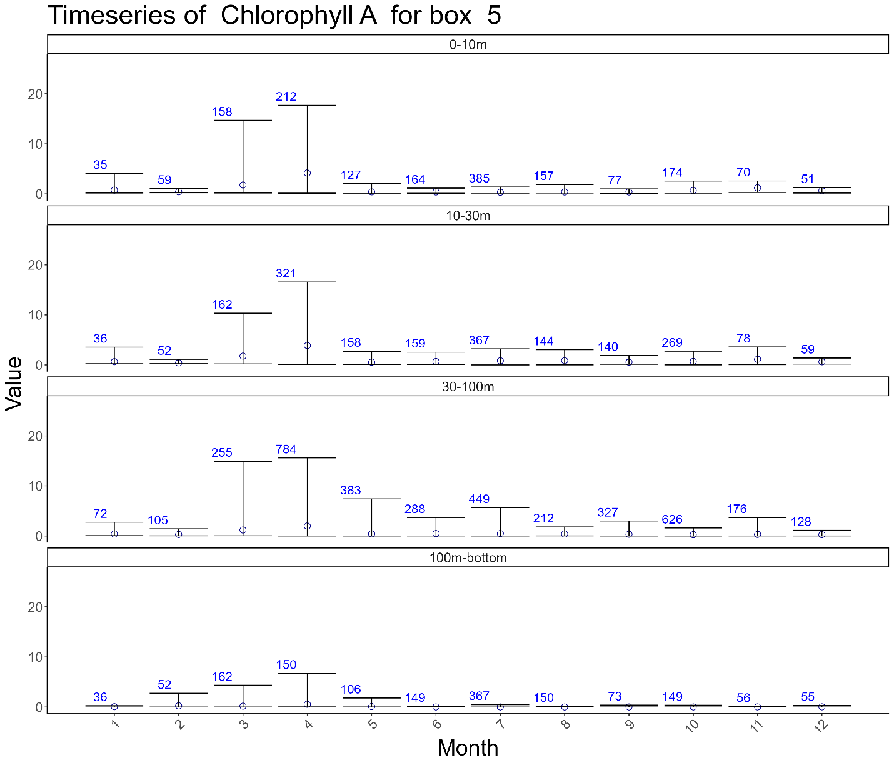

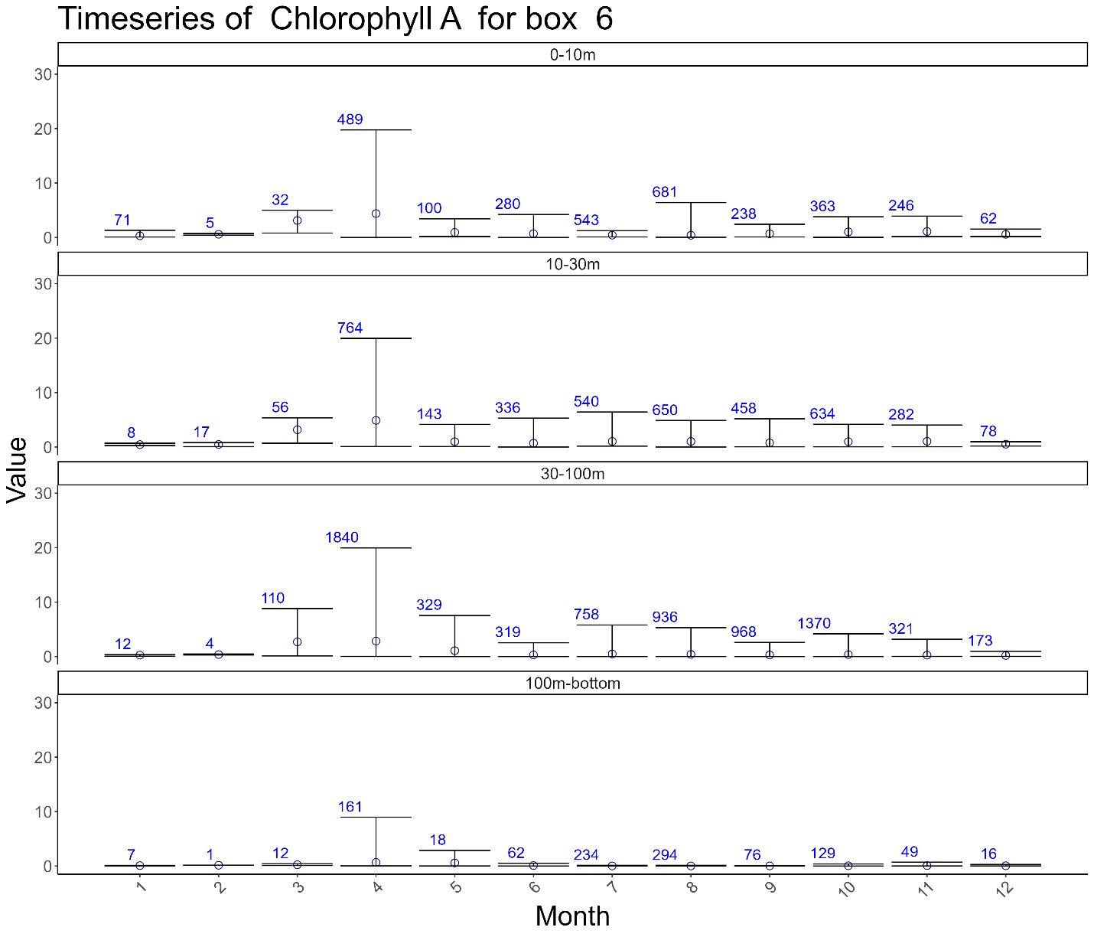

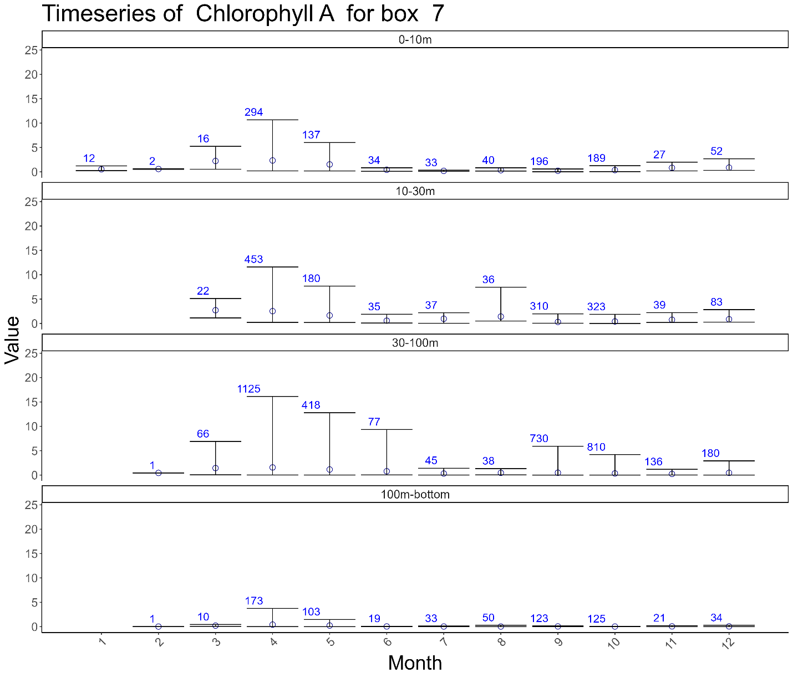

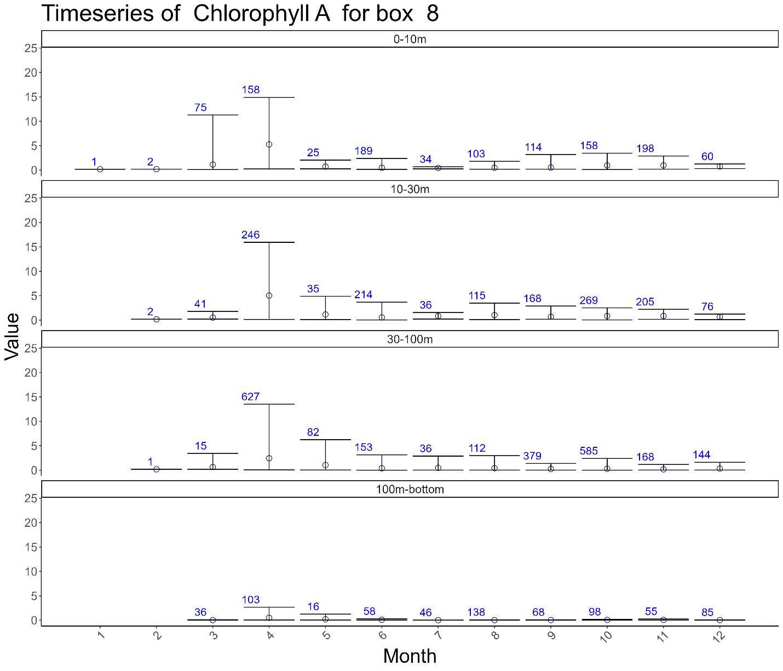

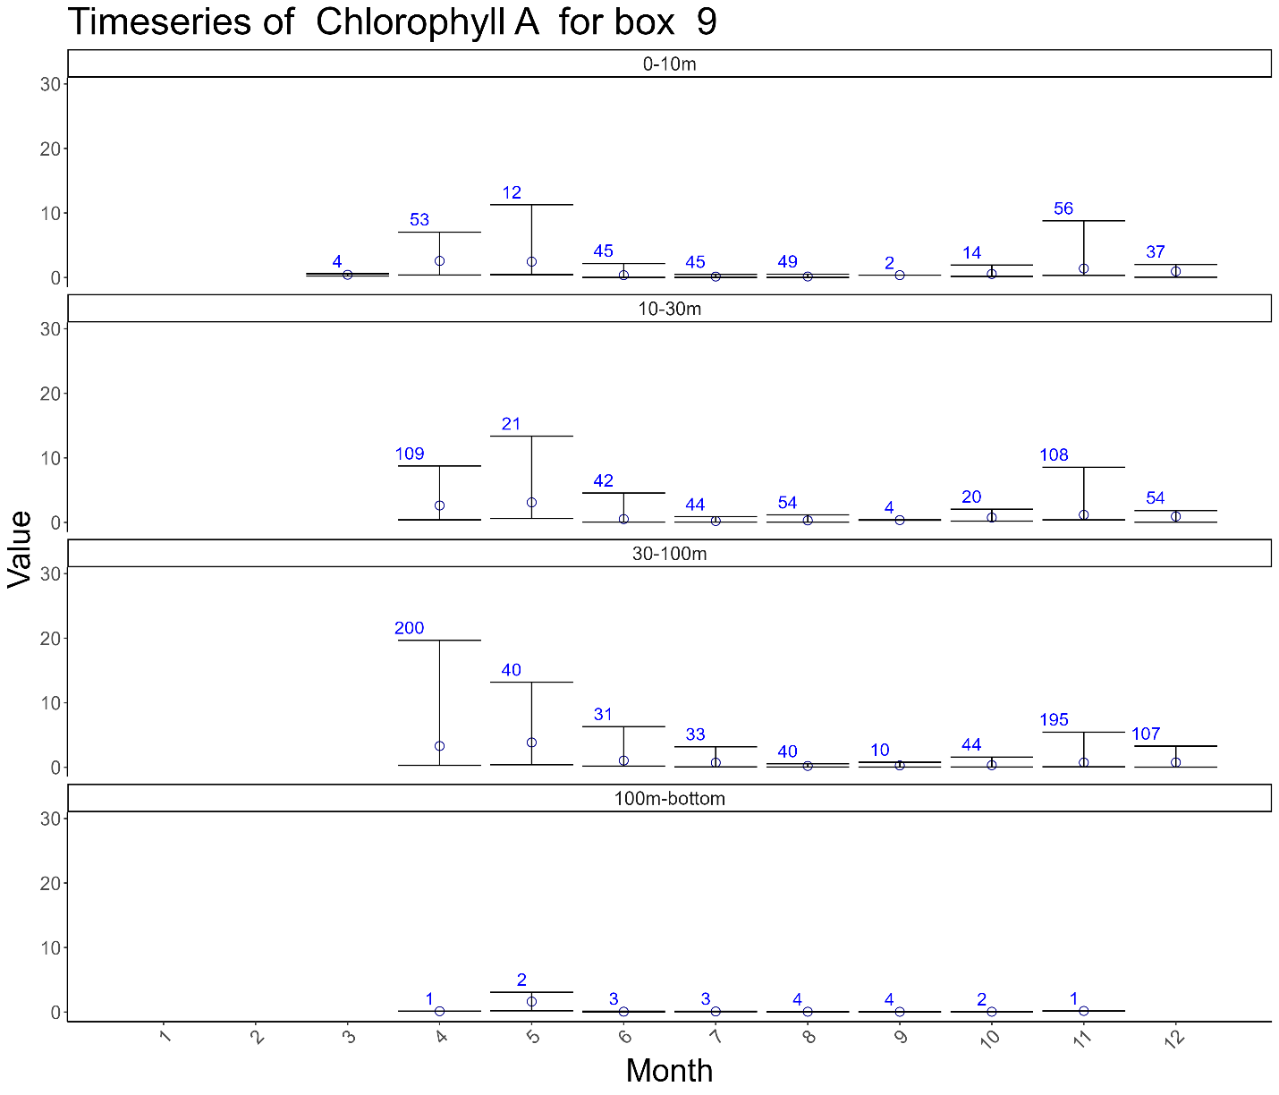

## Nitrate

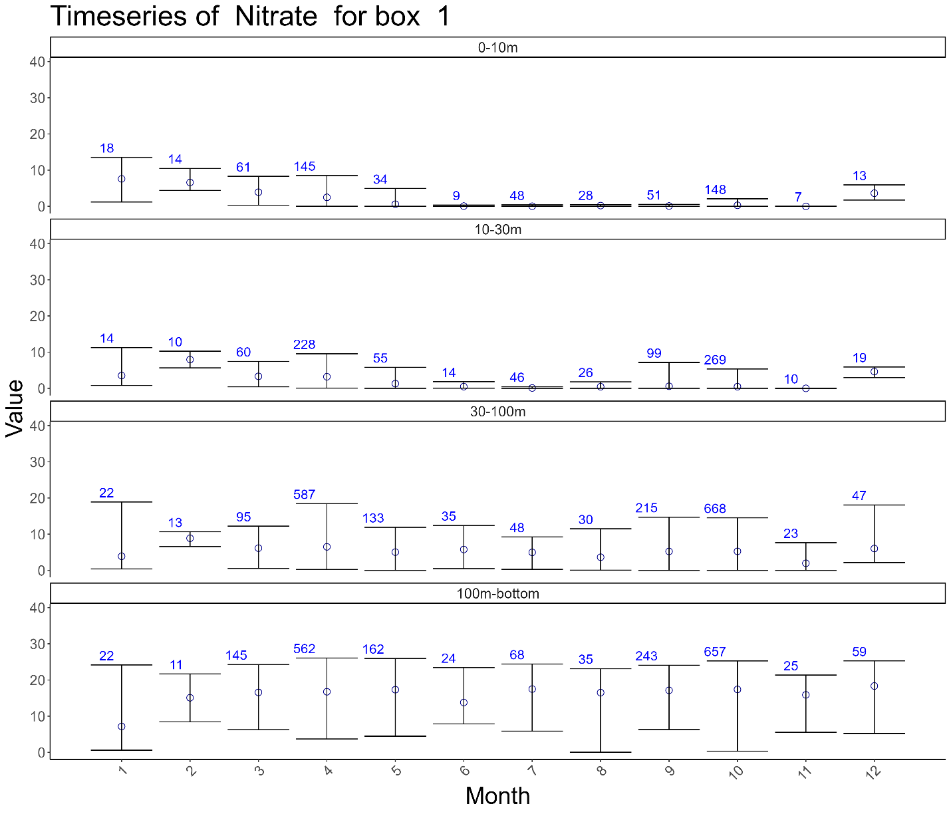

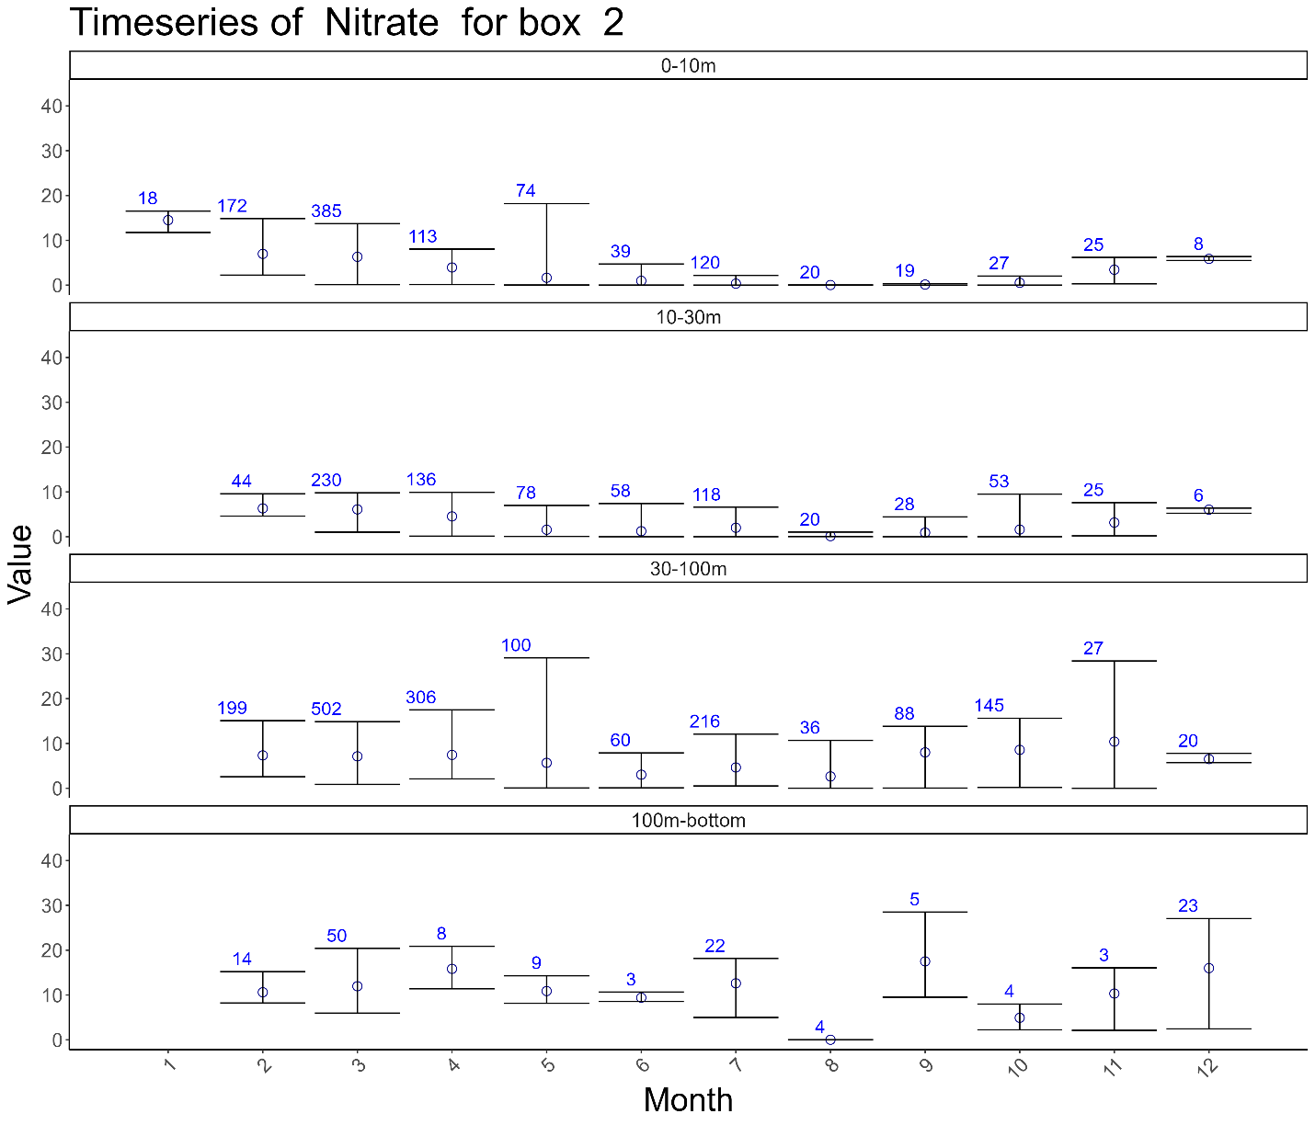

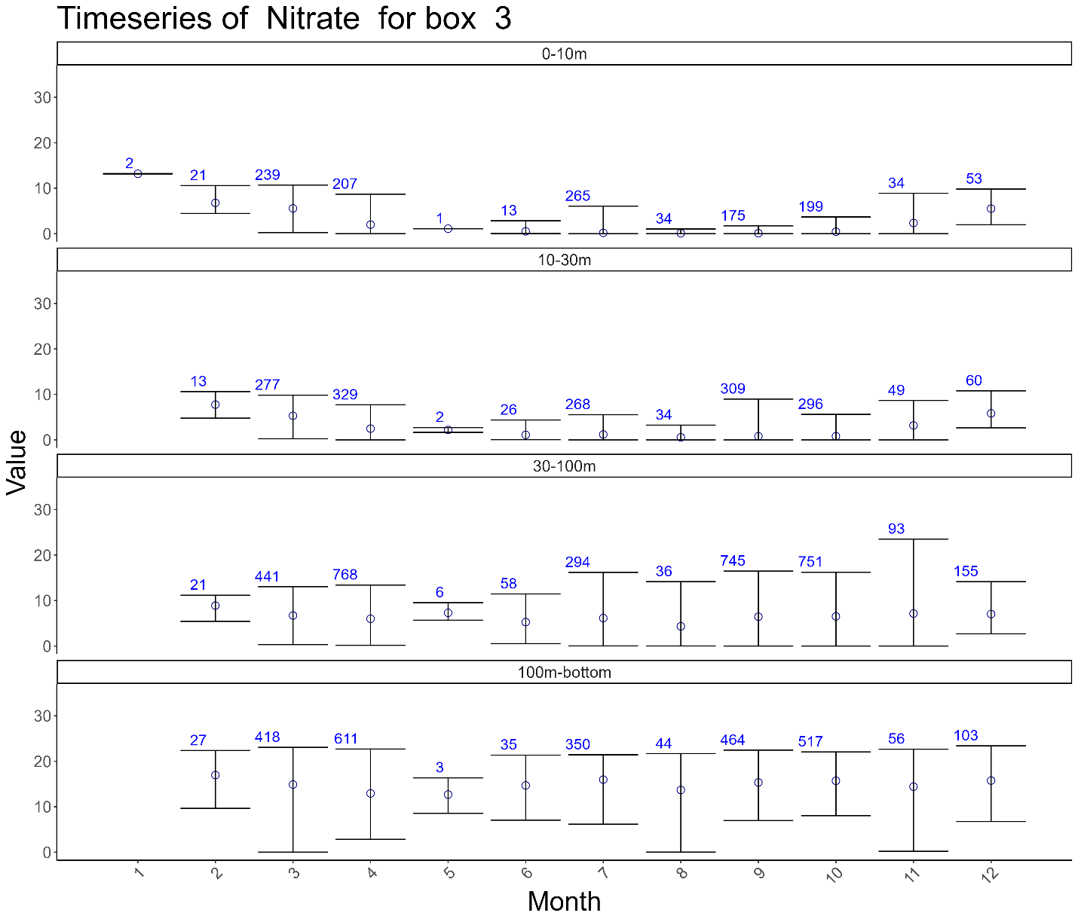

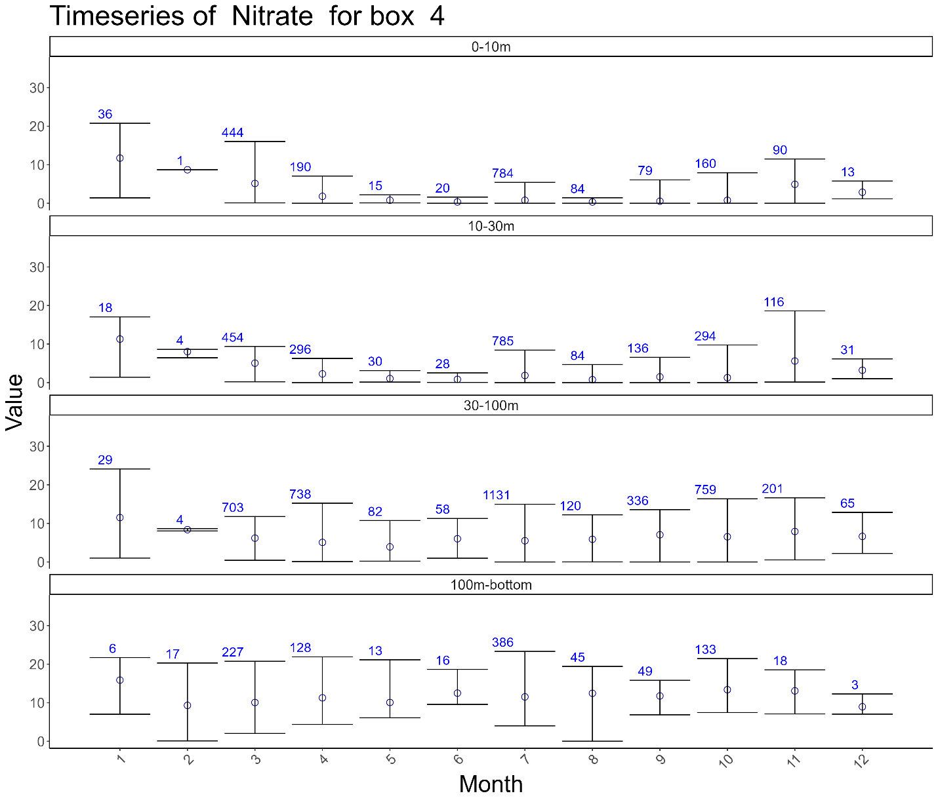

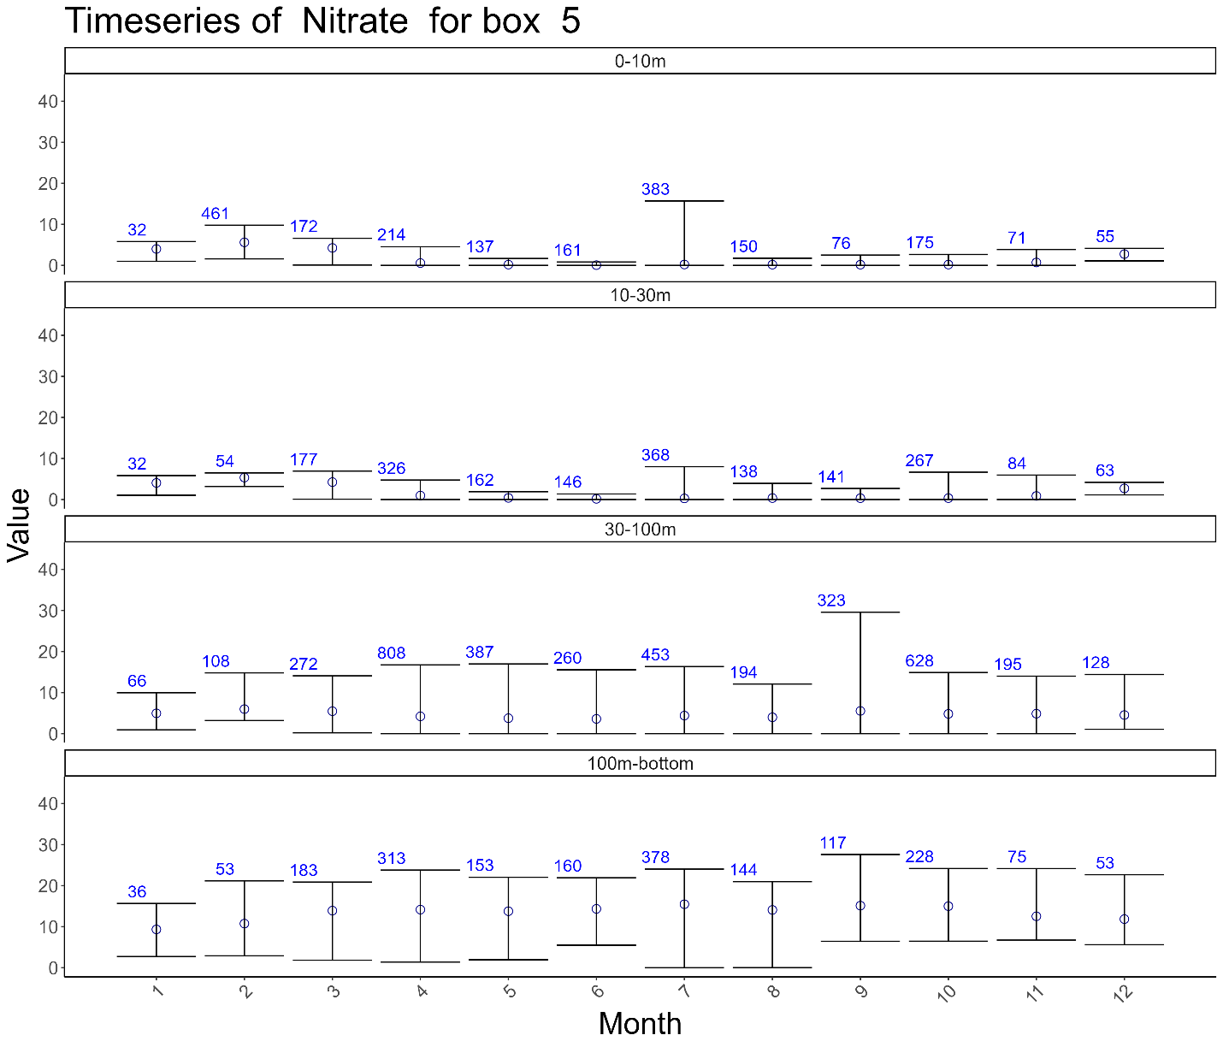

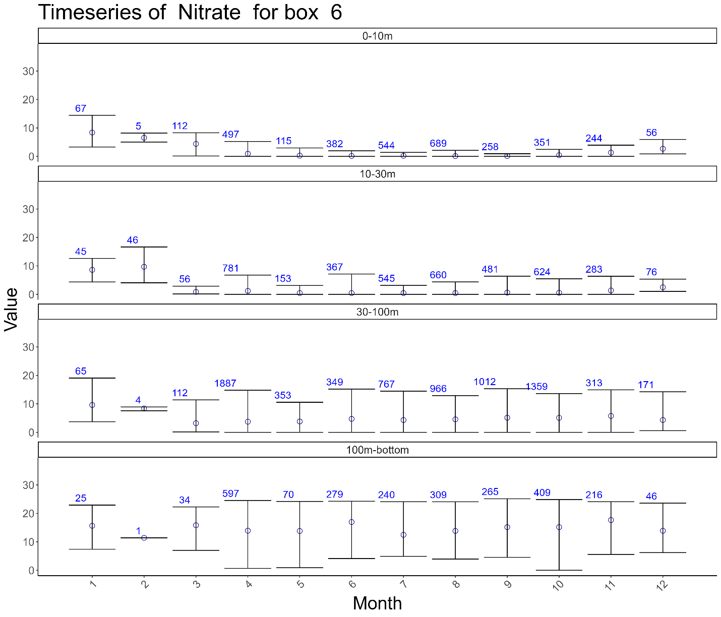

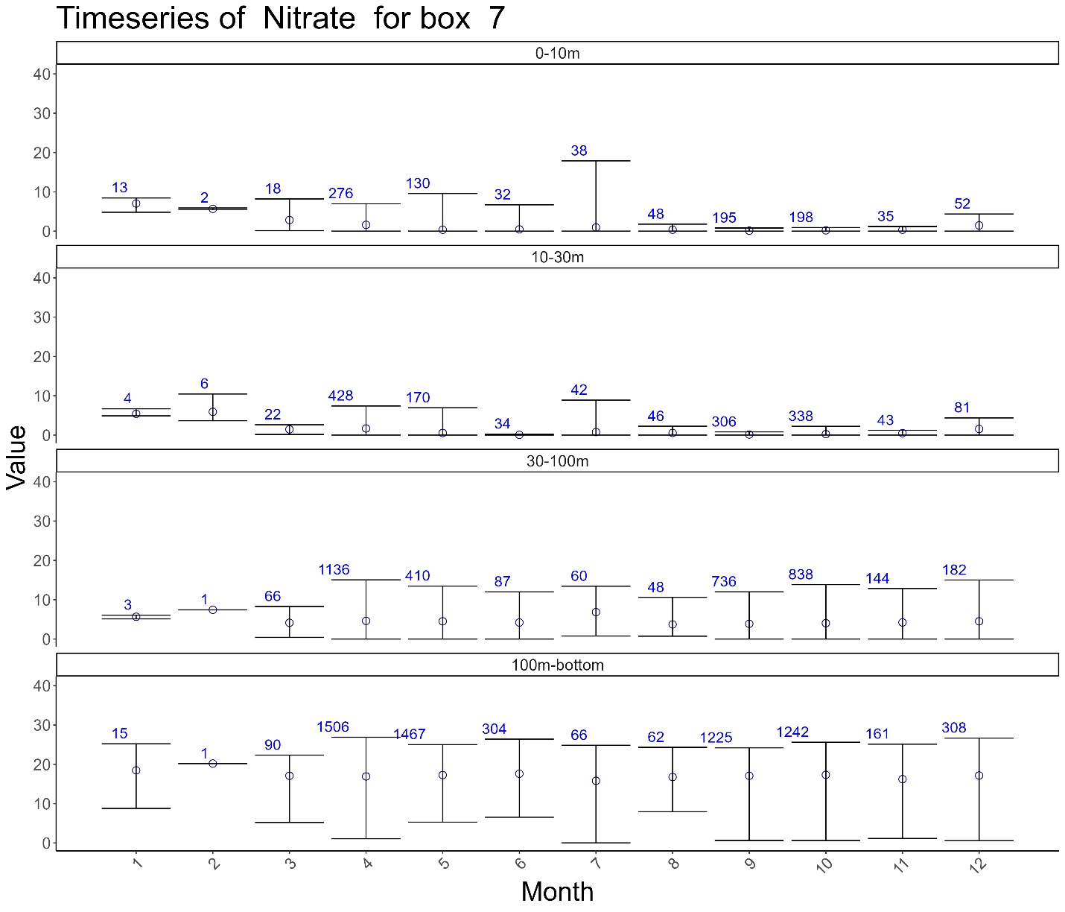

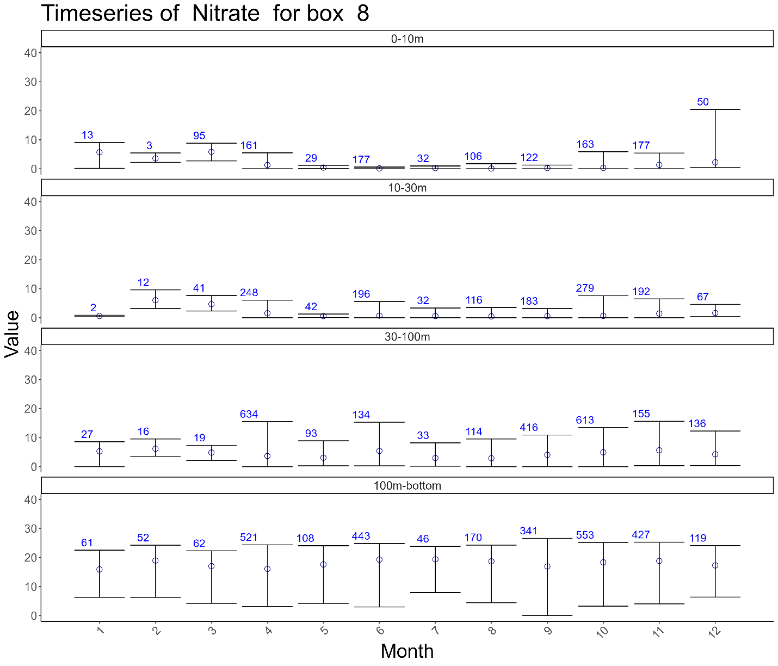

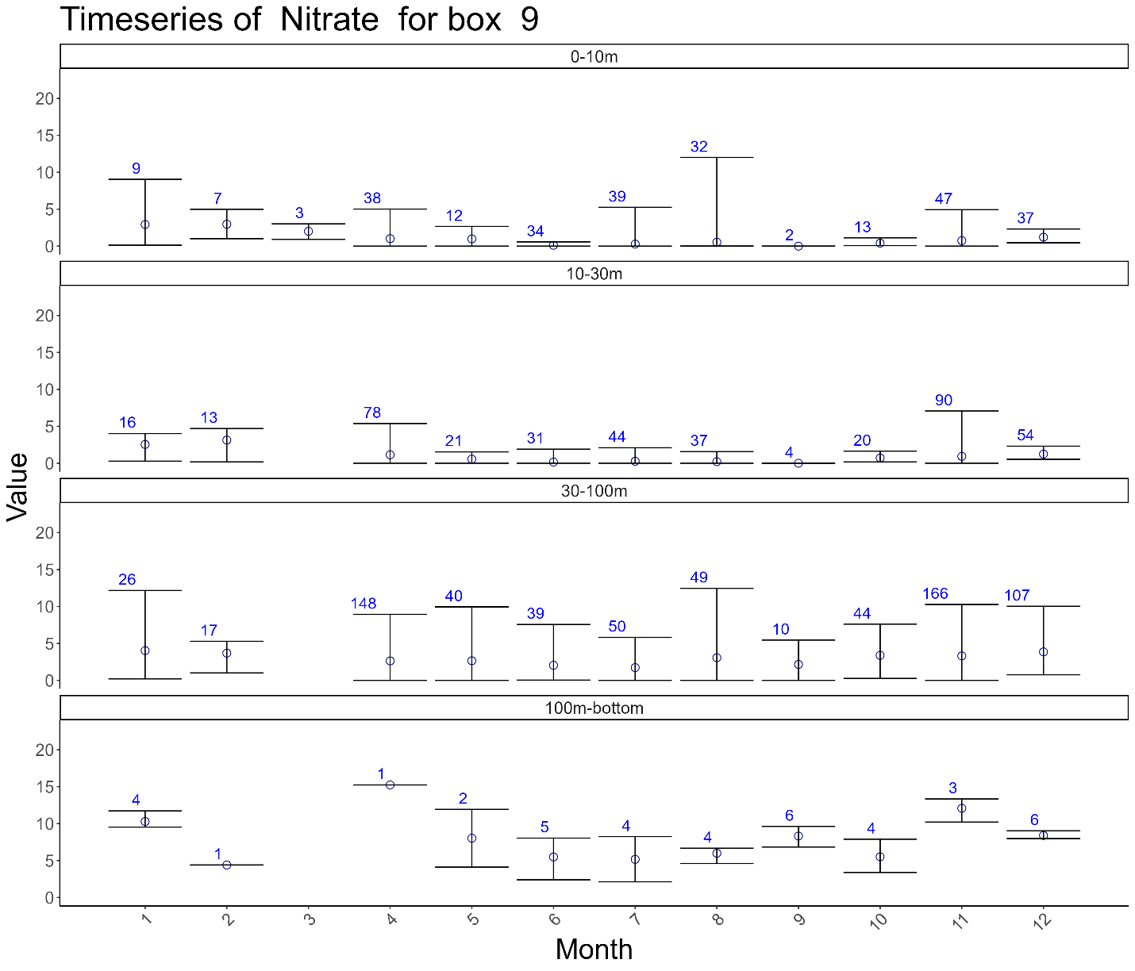

## Nitrite

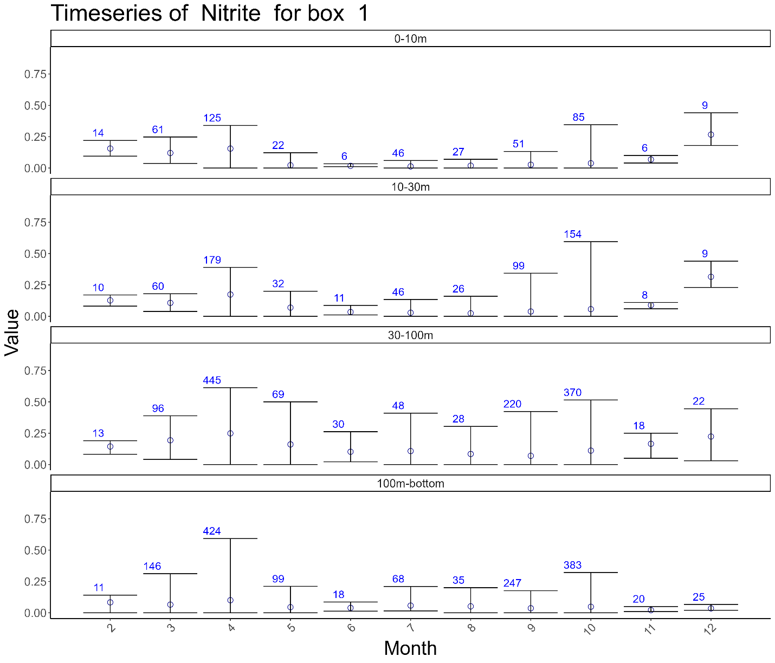

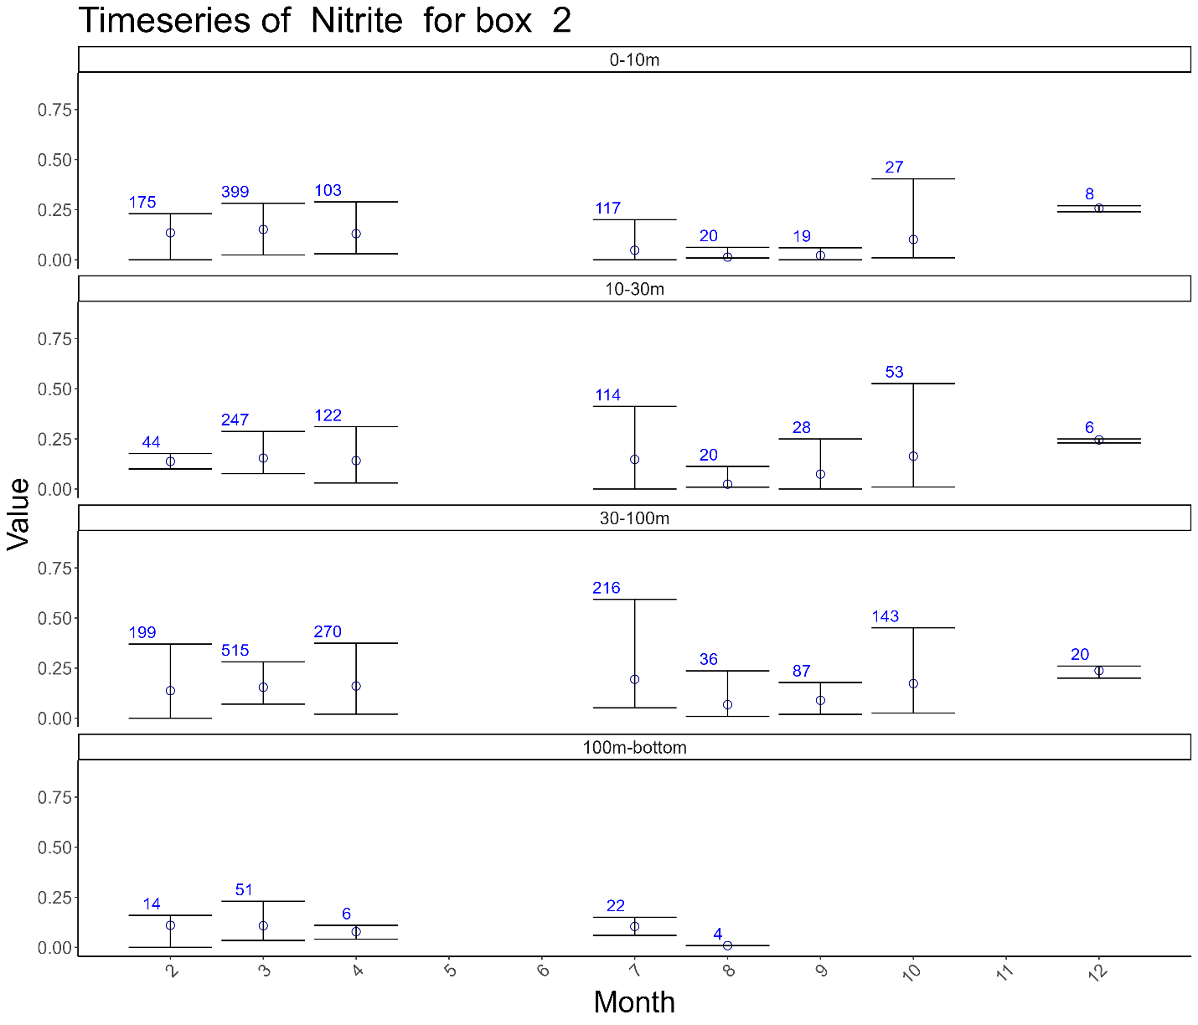

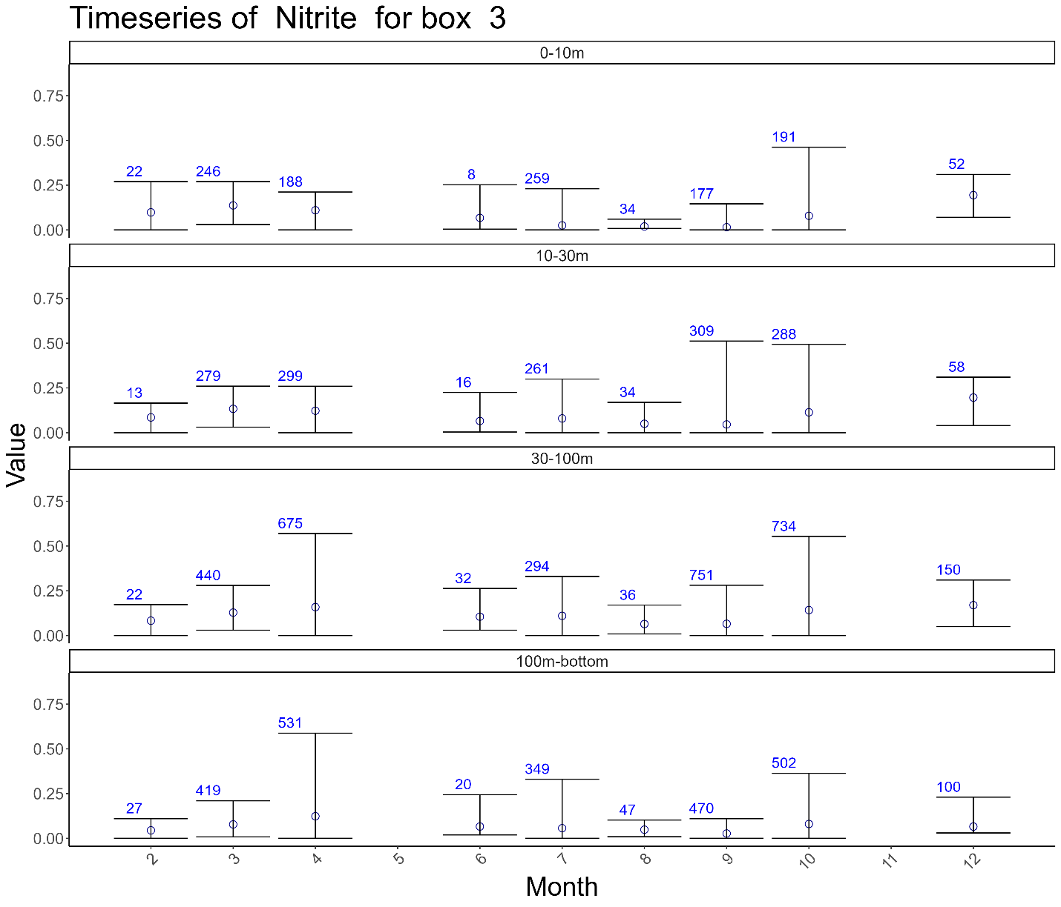

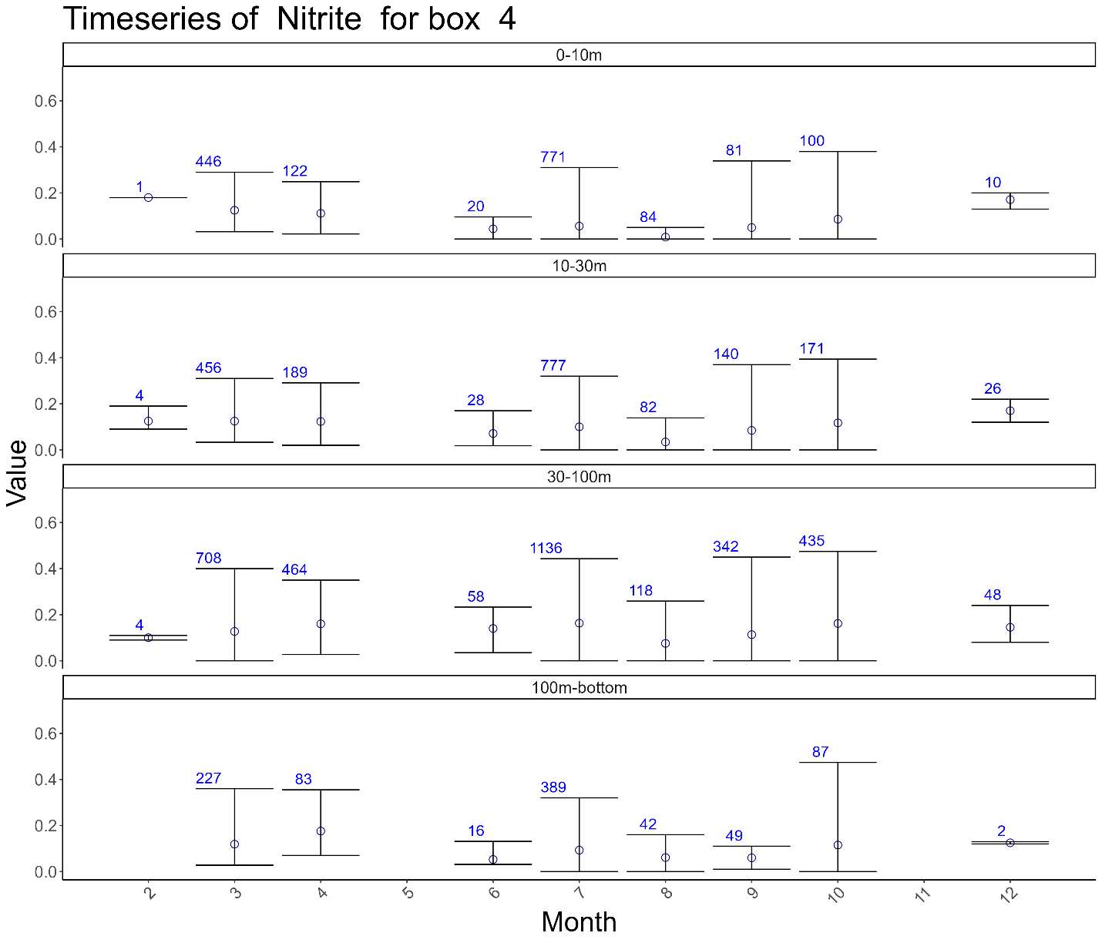

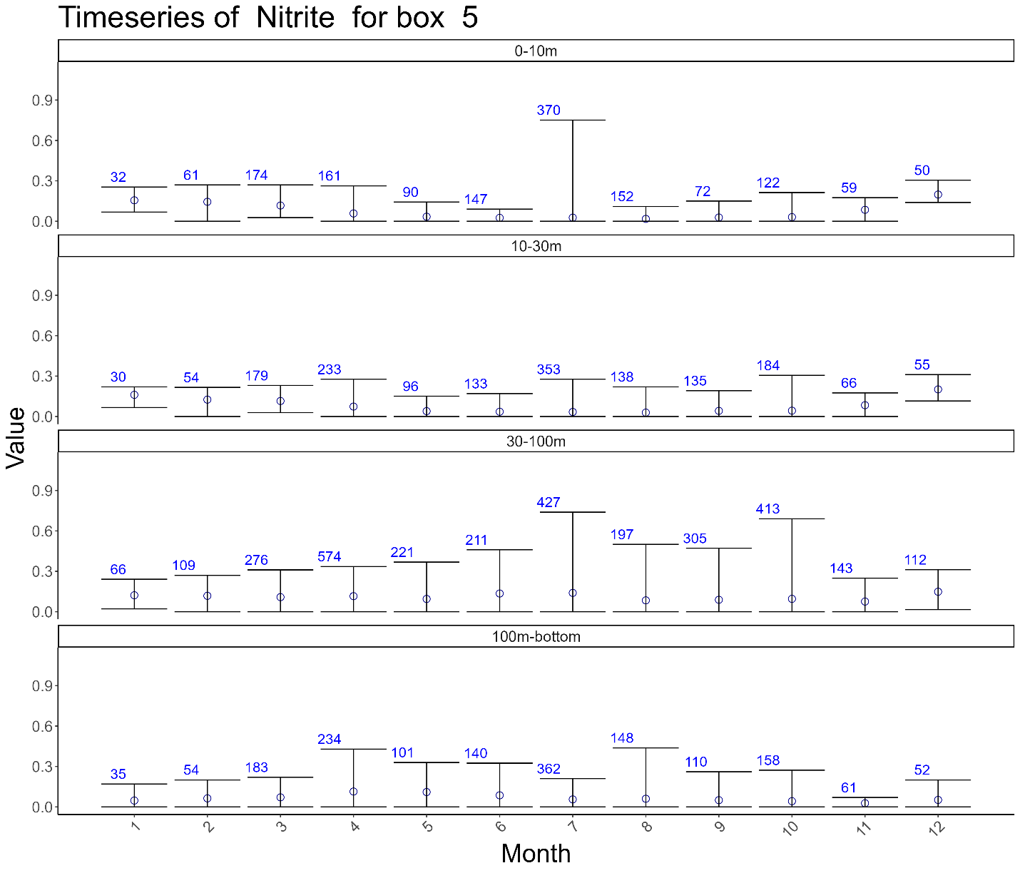

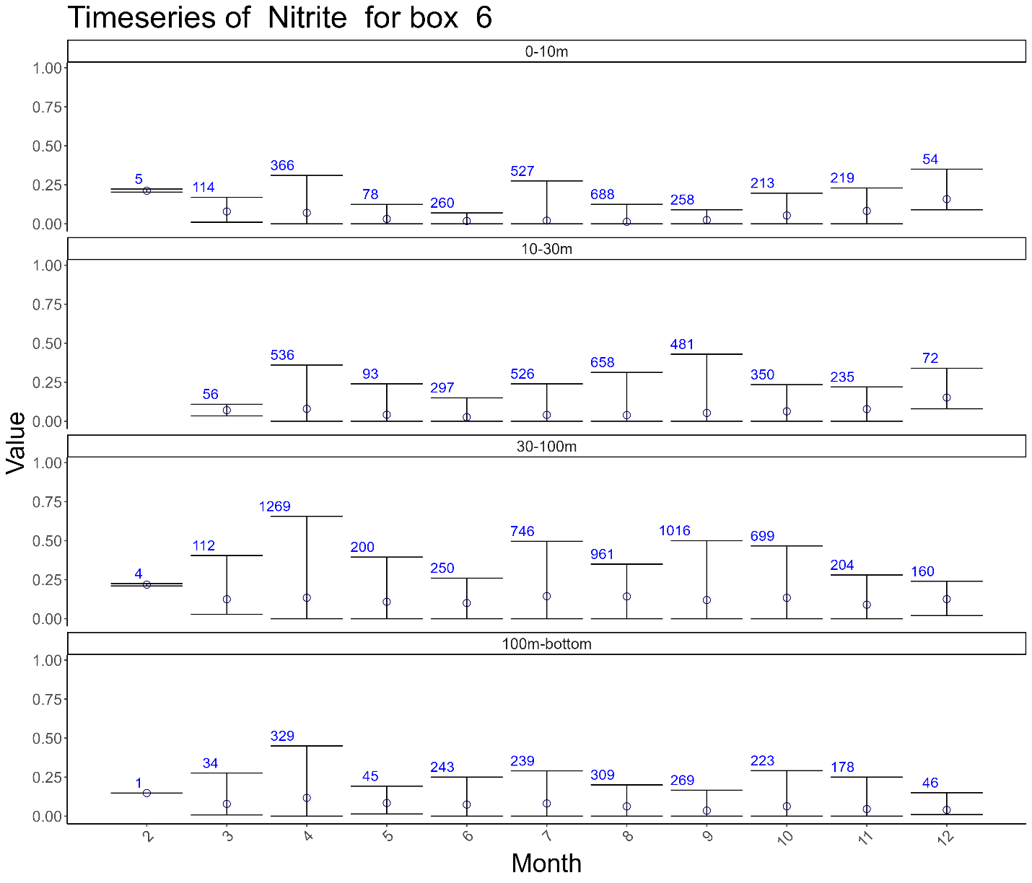

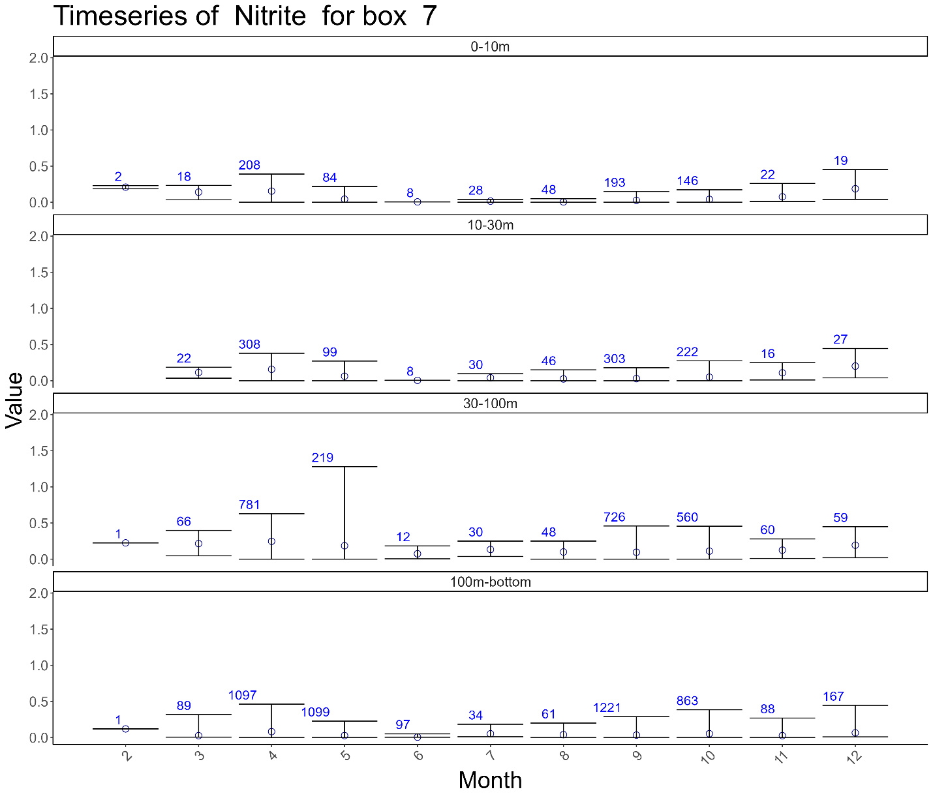

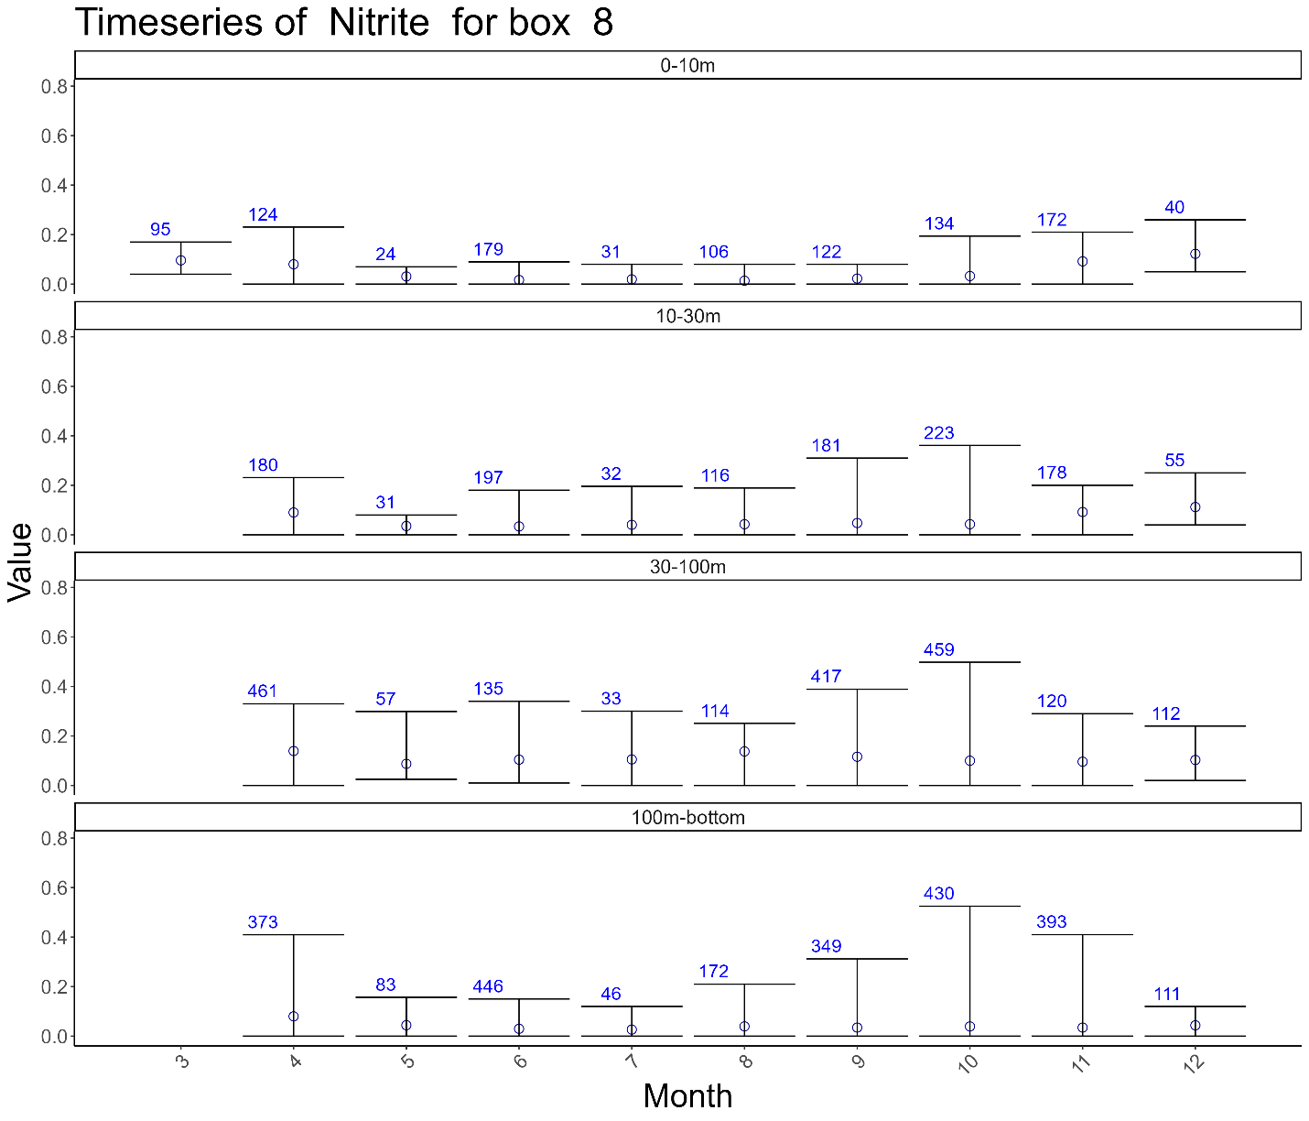

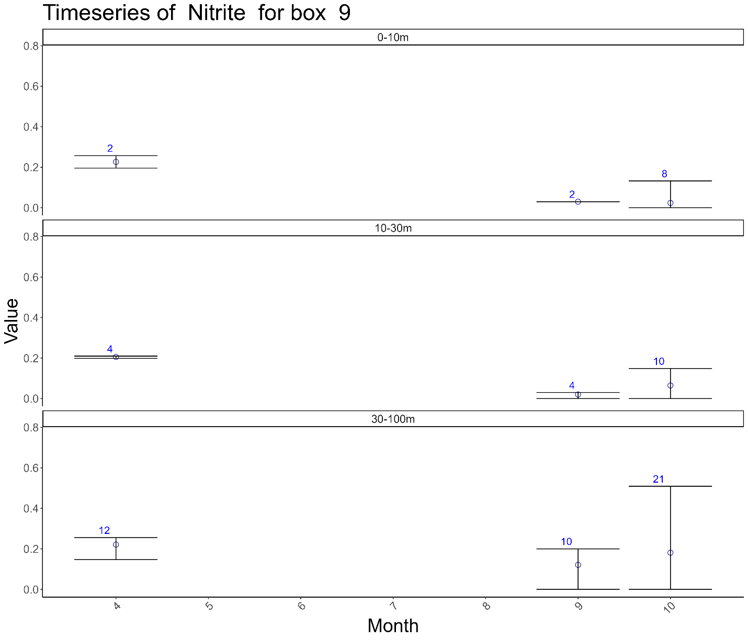

## Oxygen

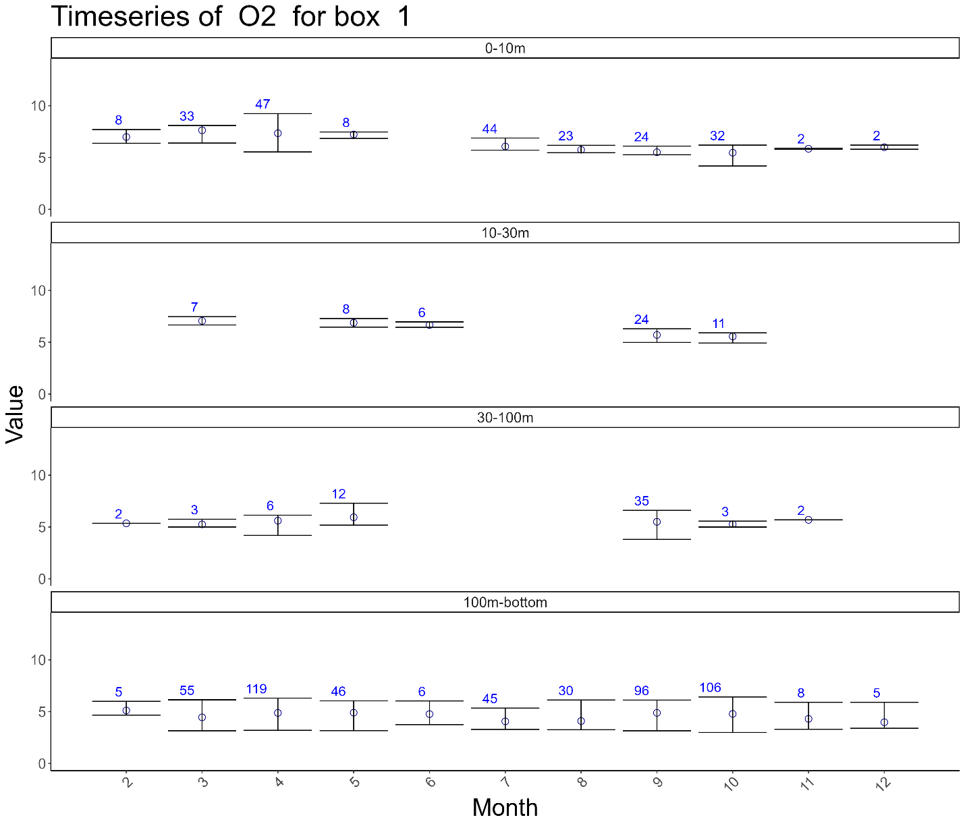

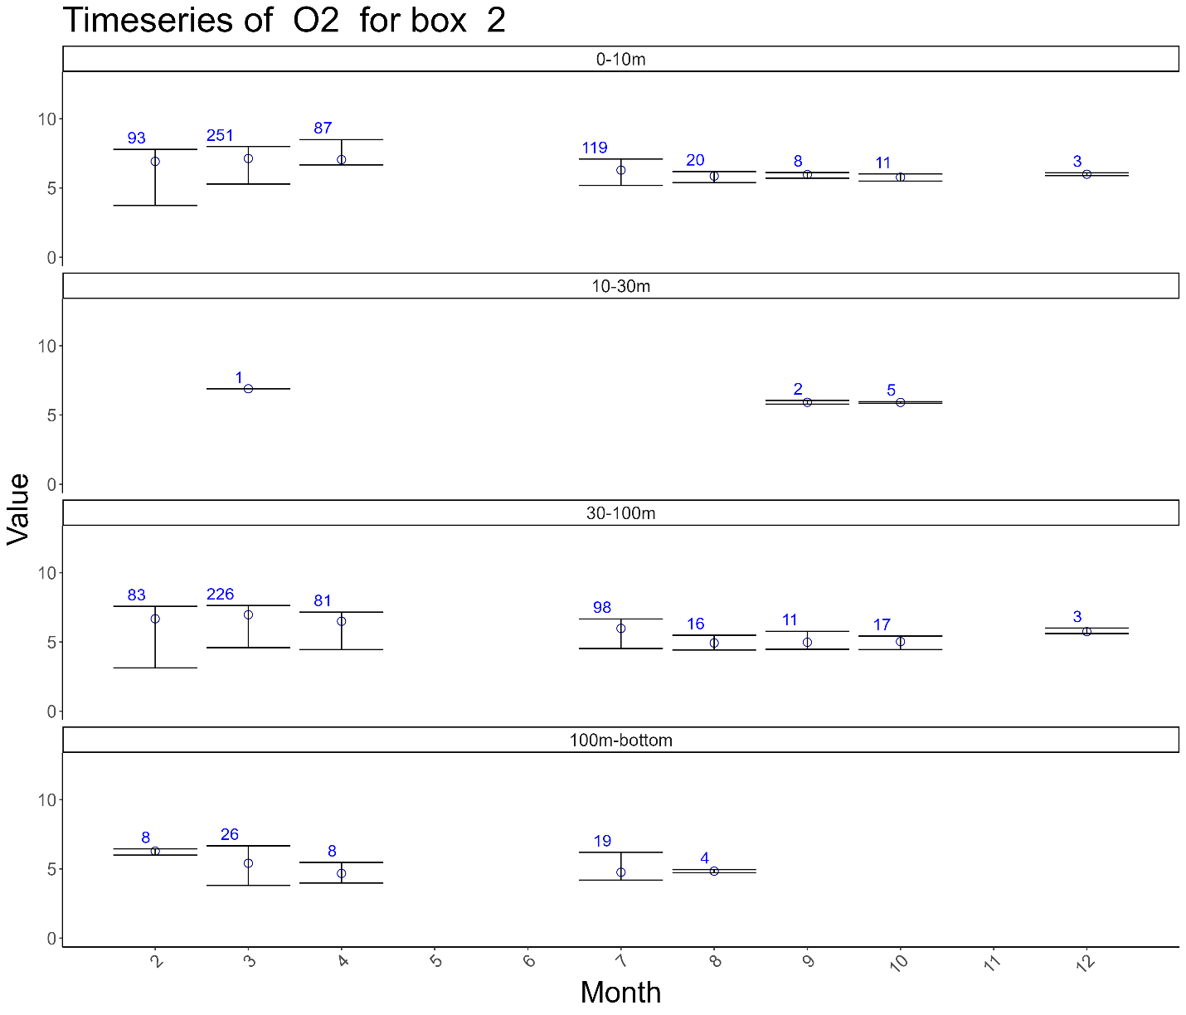

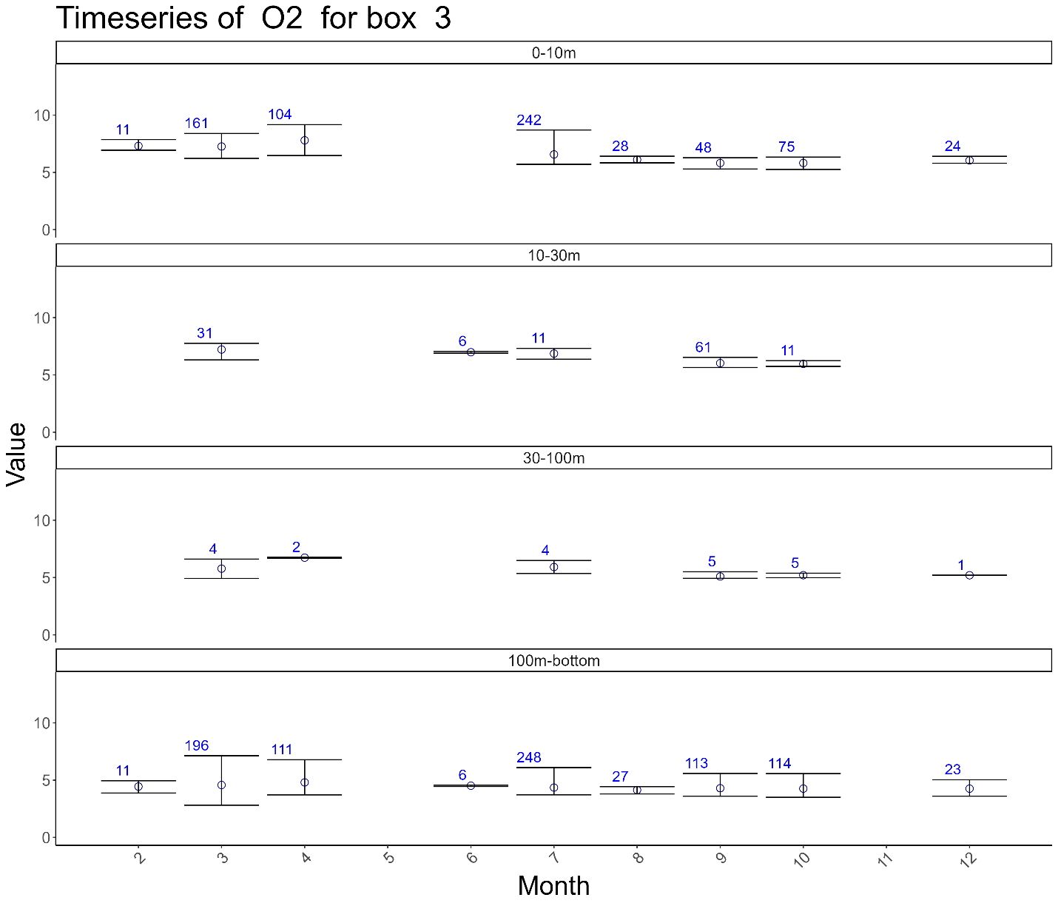

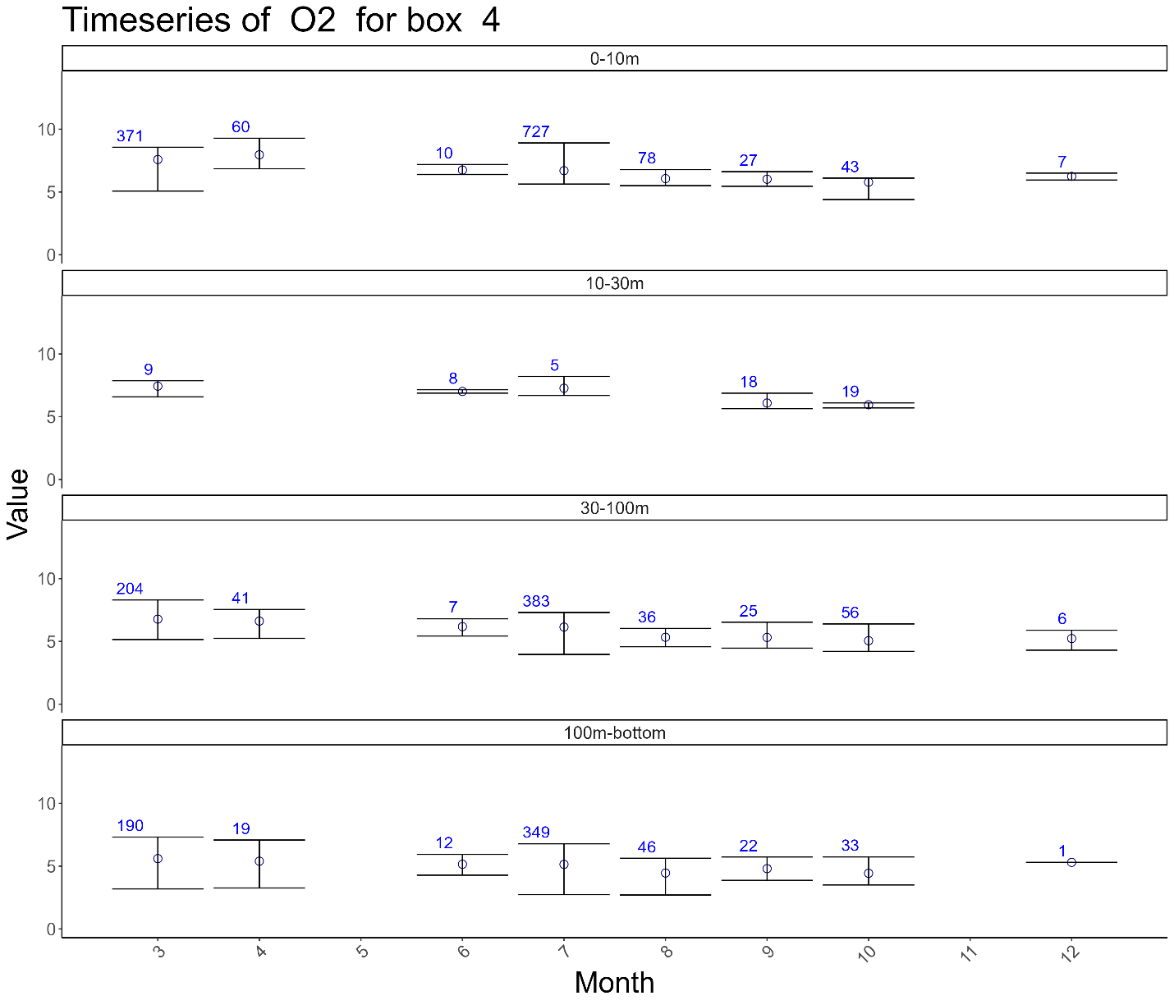

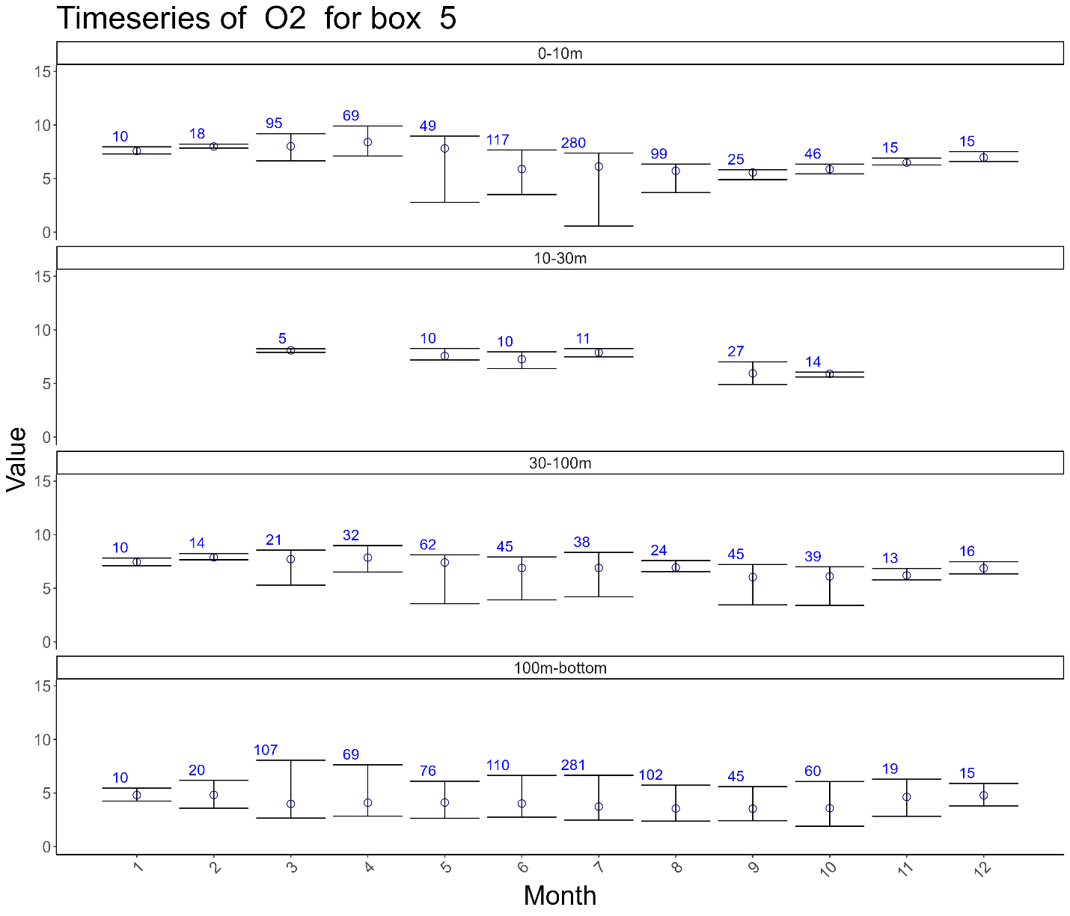

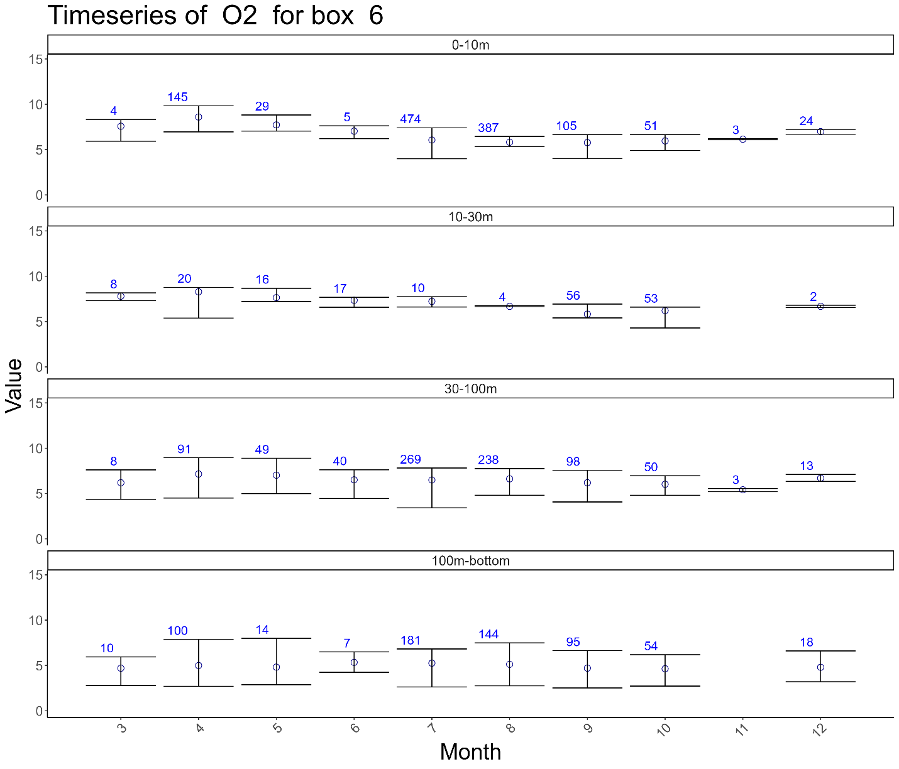

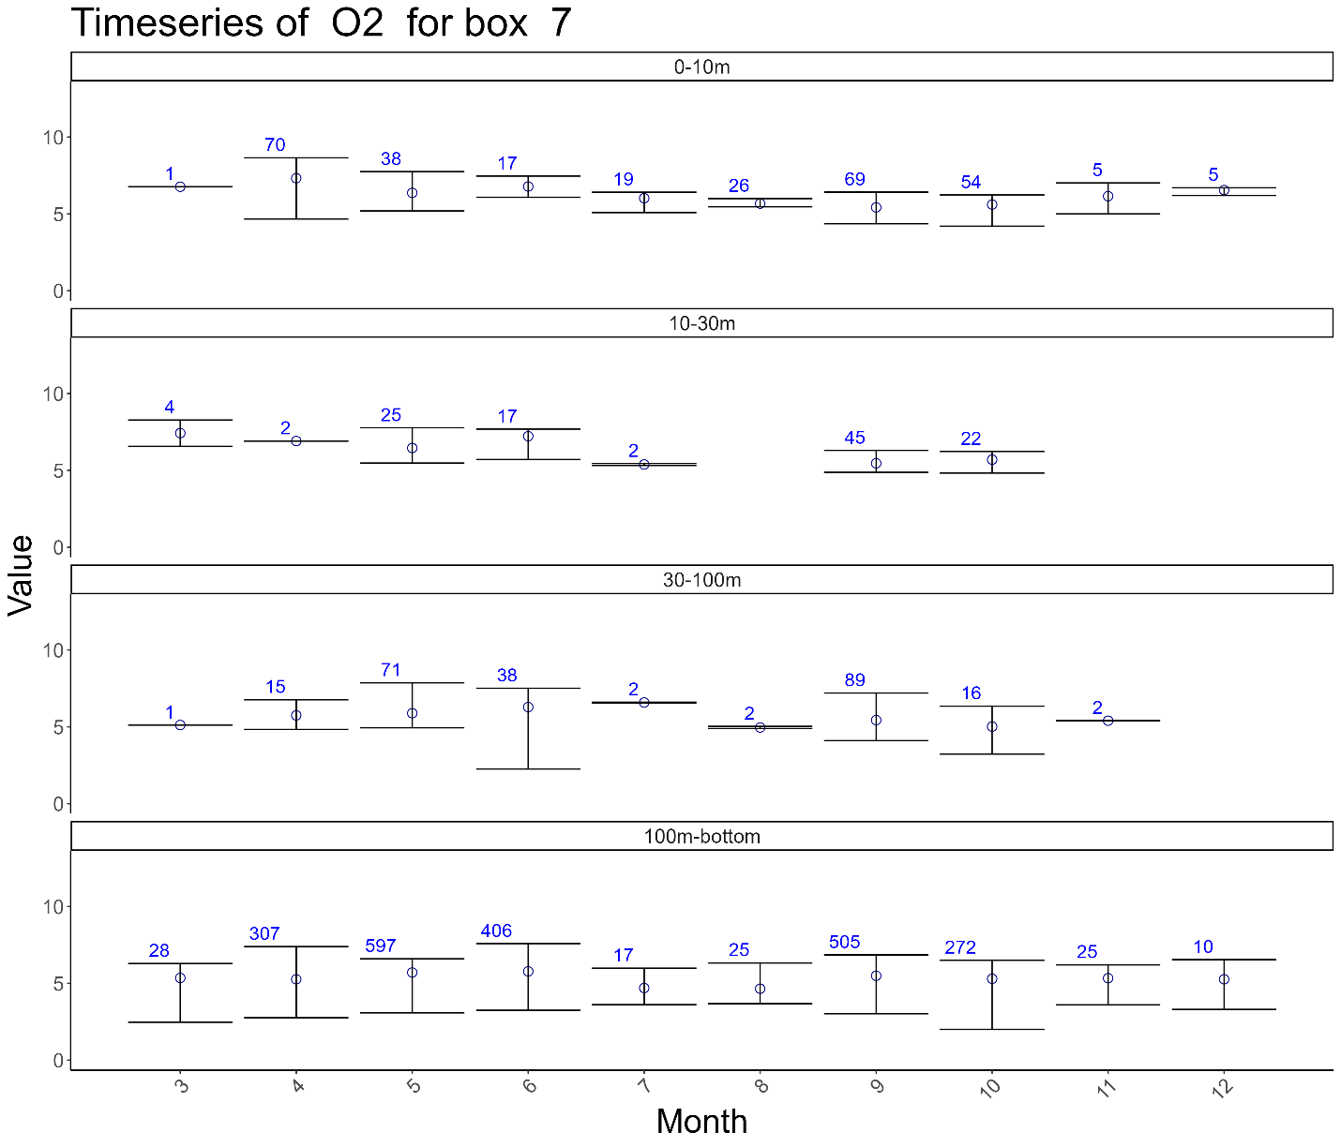

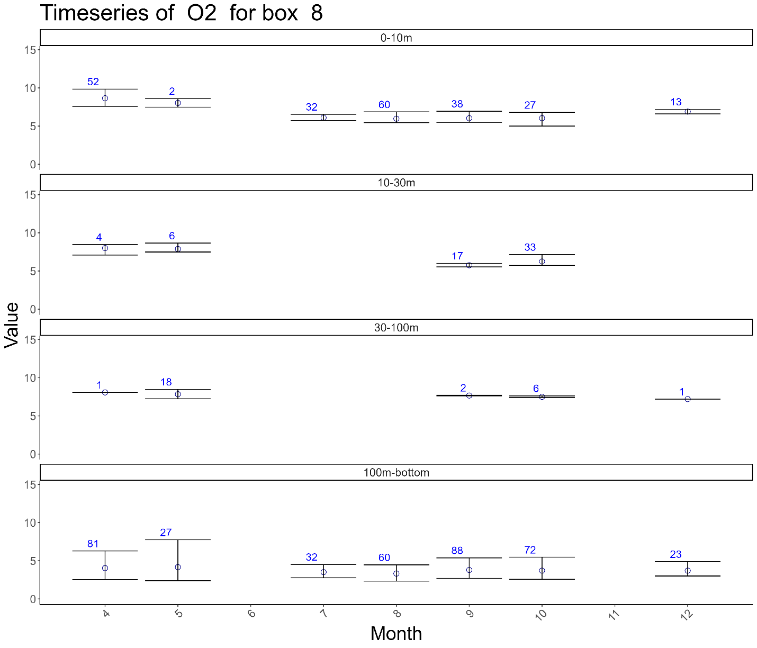

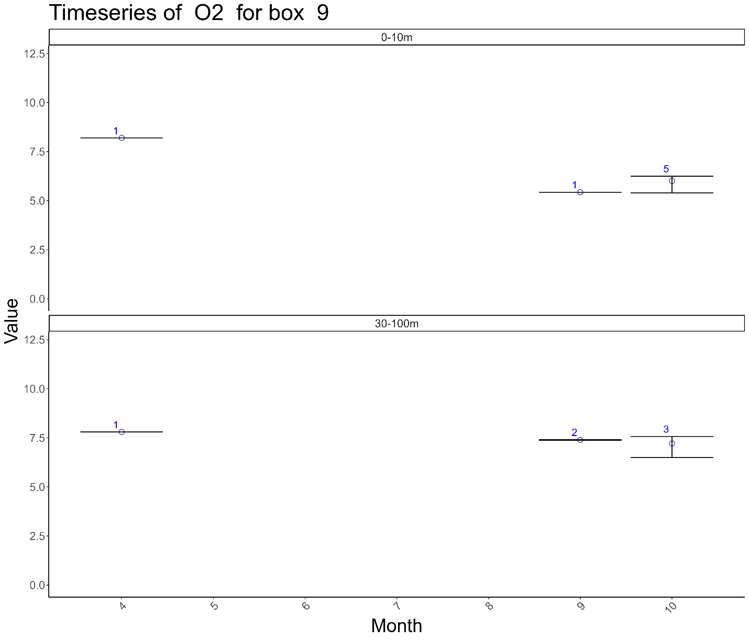

## Phaeophytin

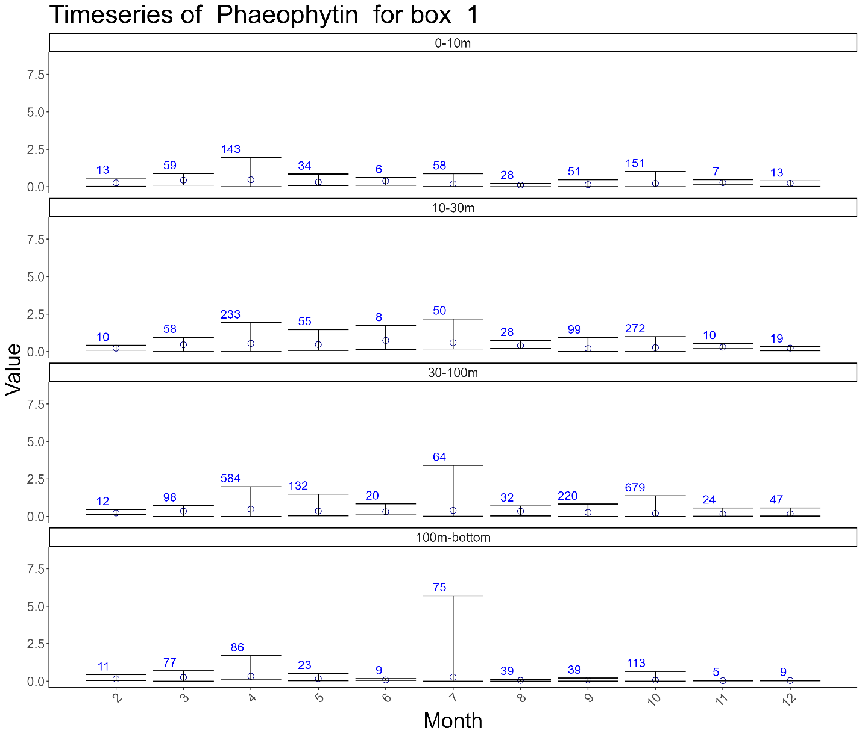

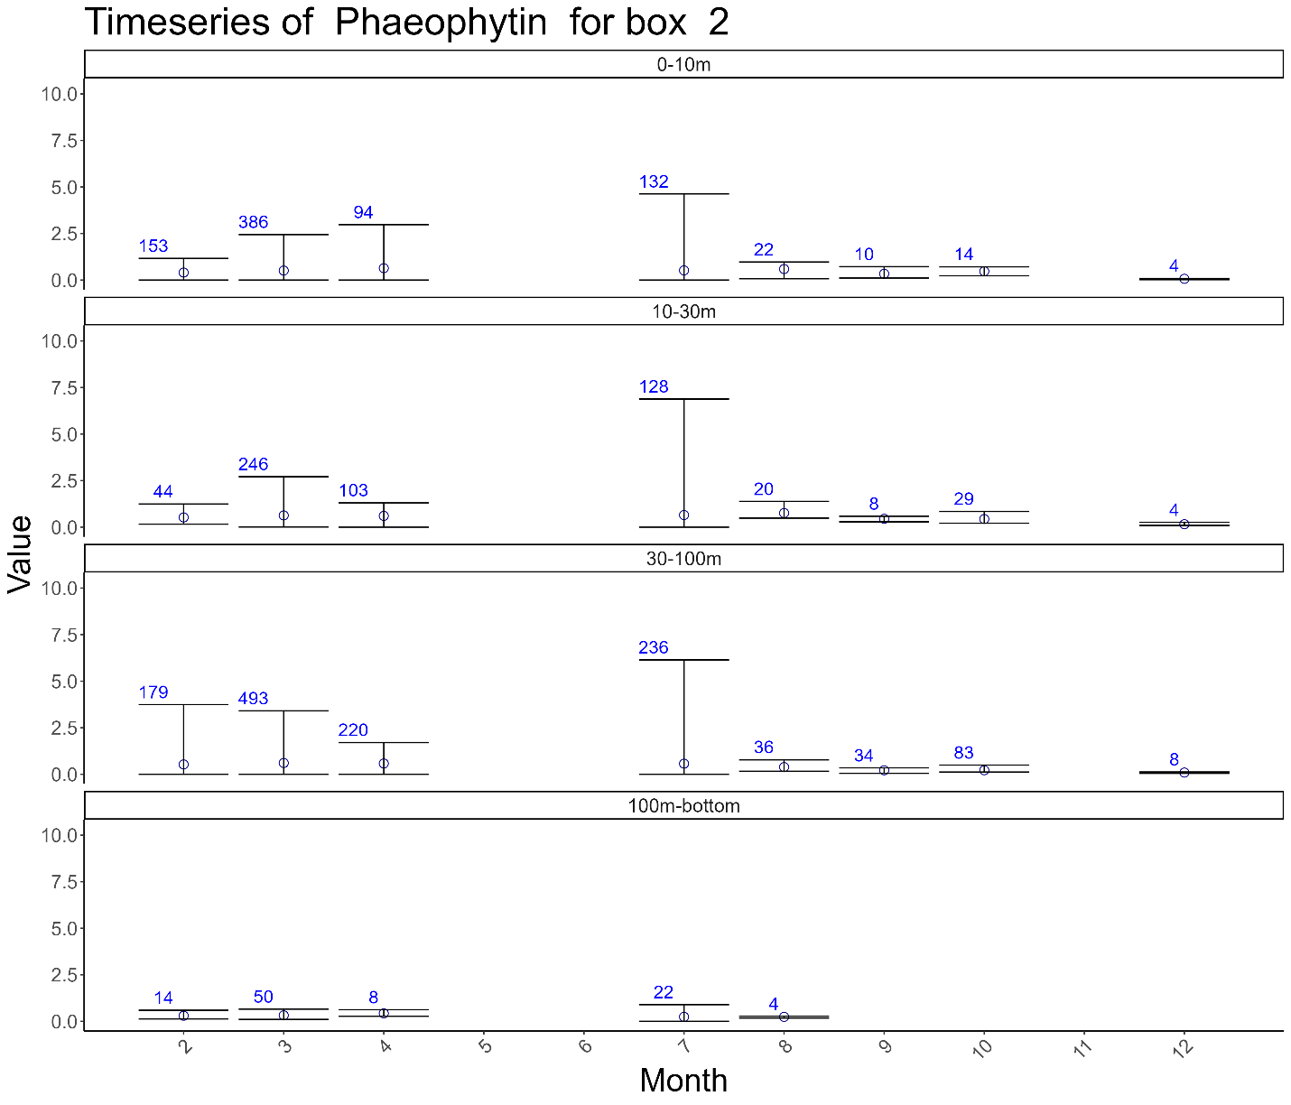

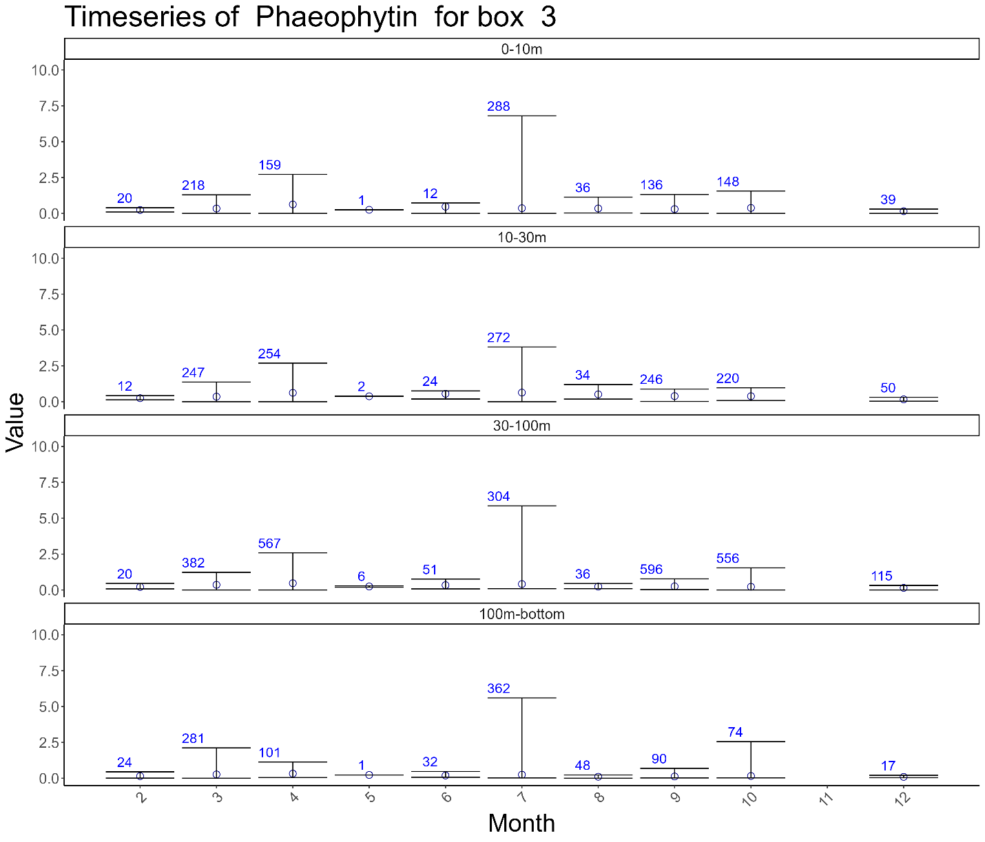

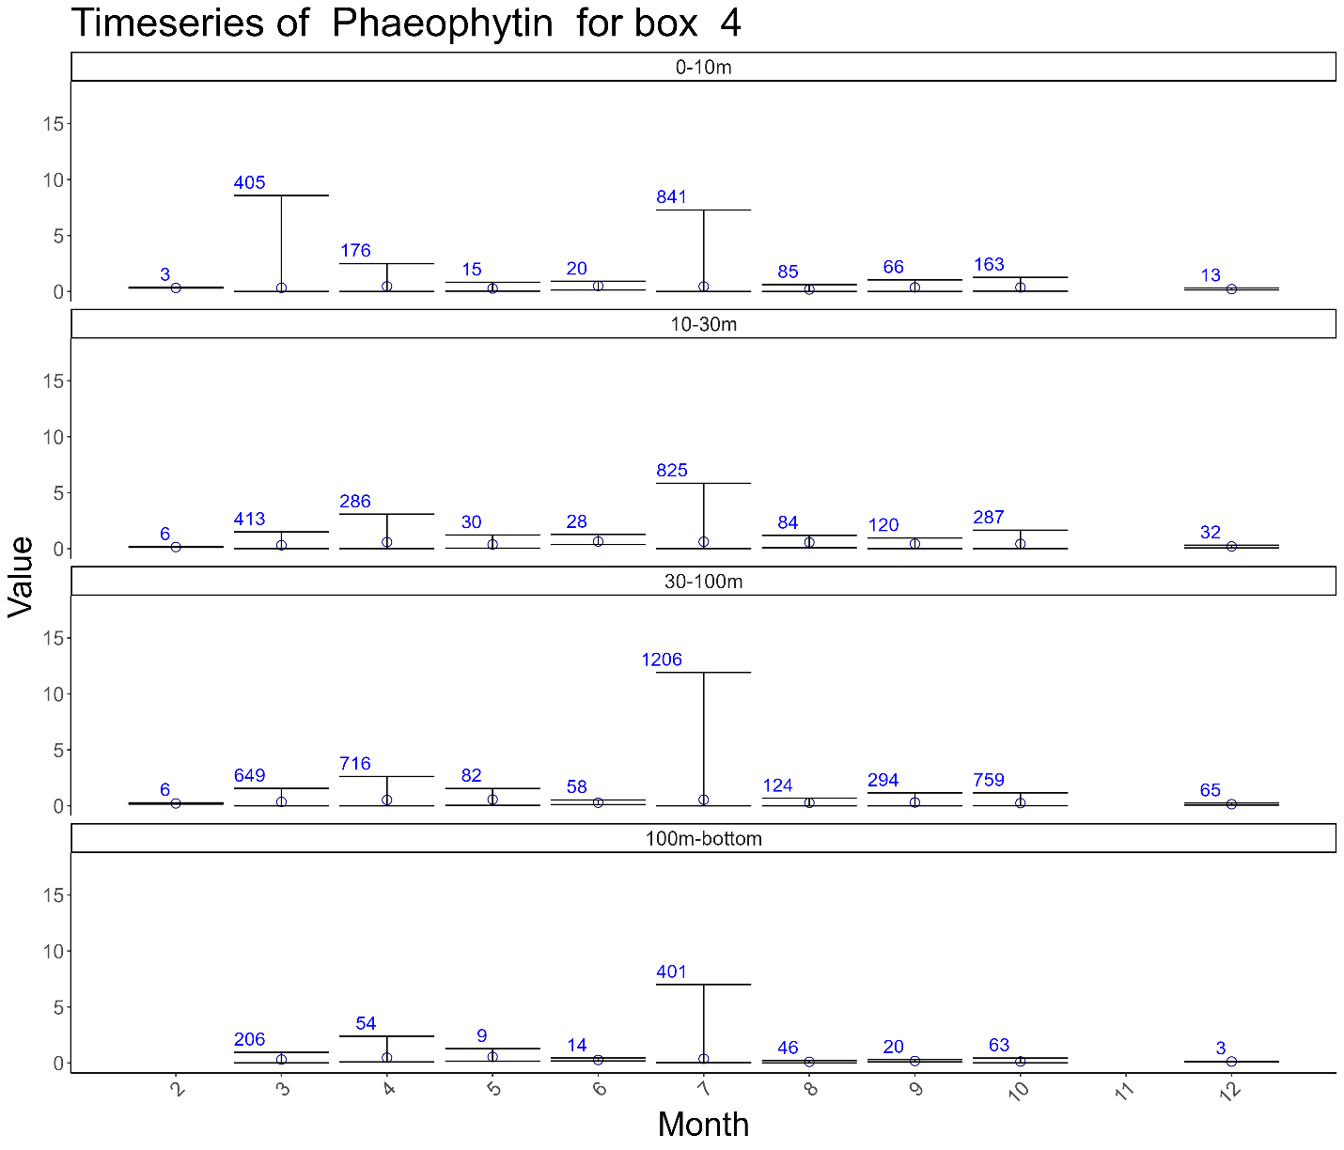

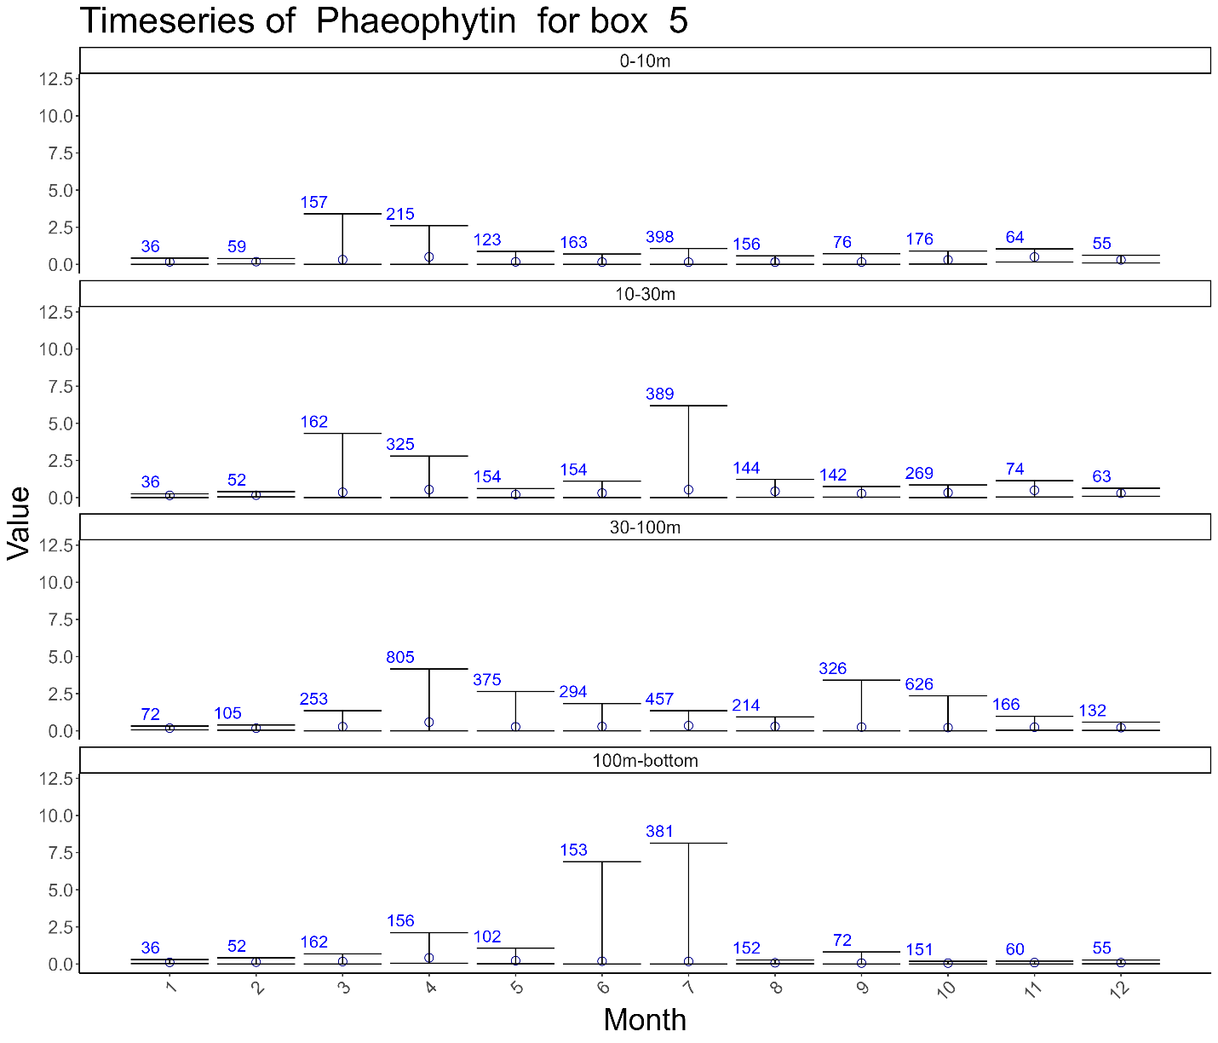

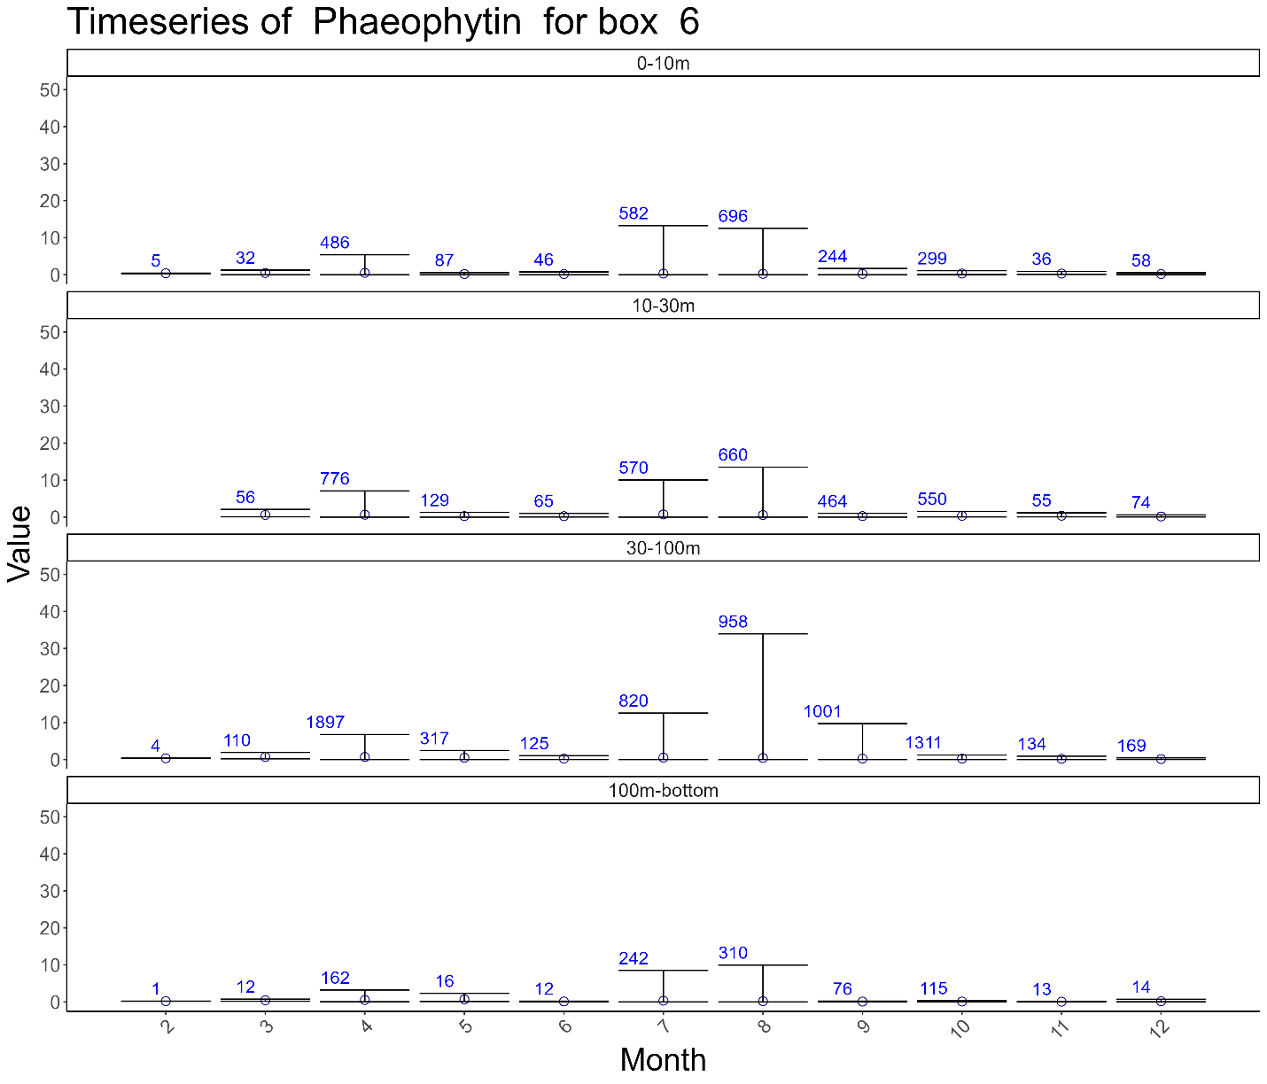

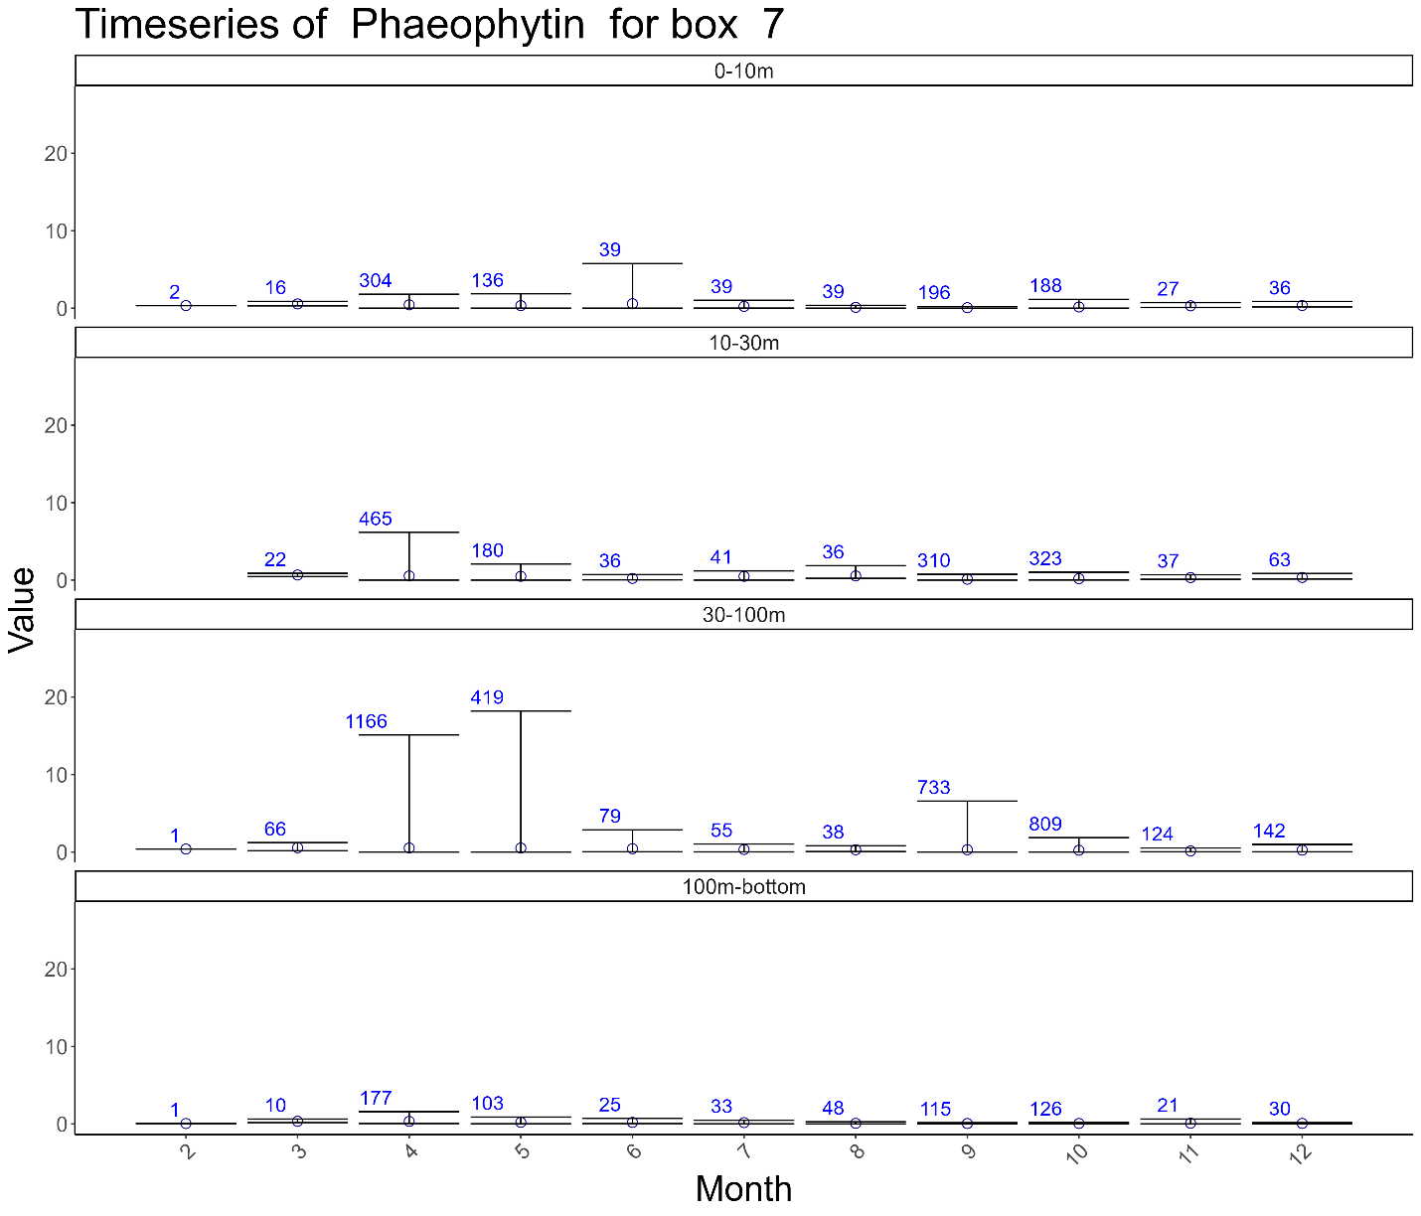

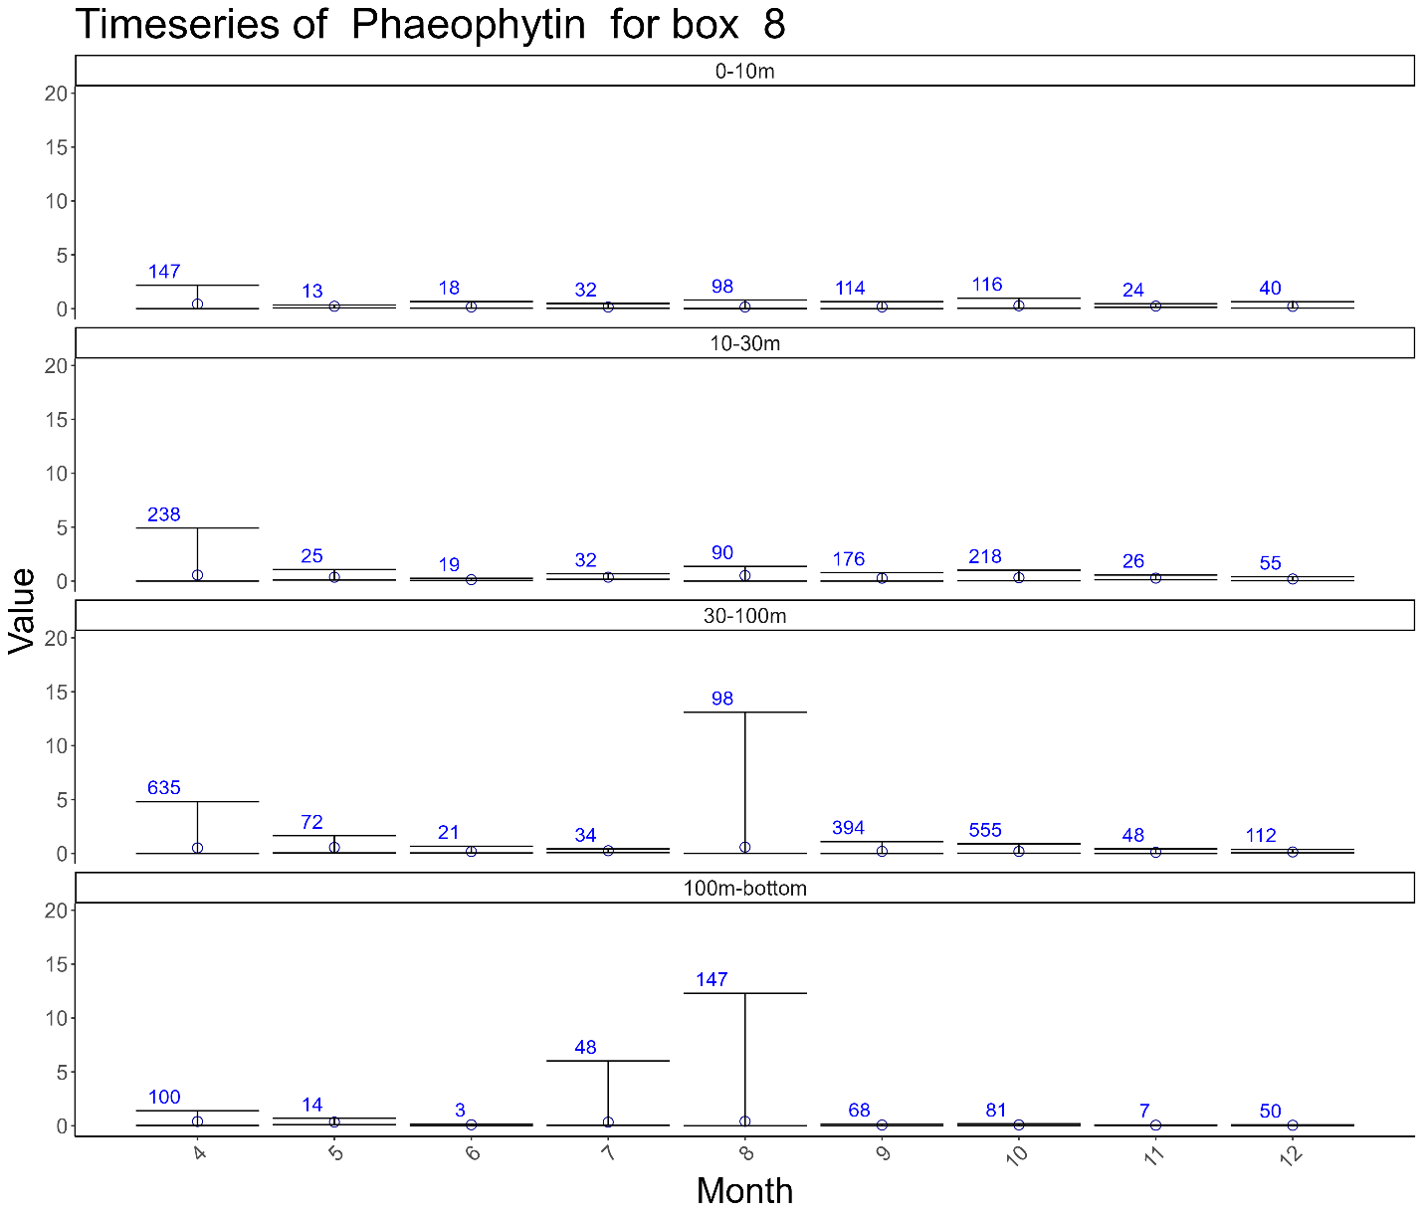

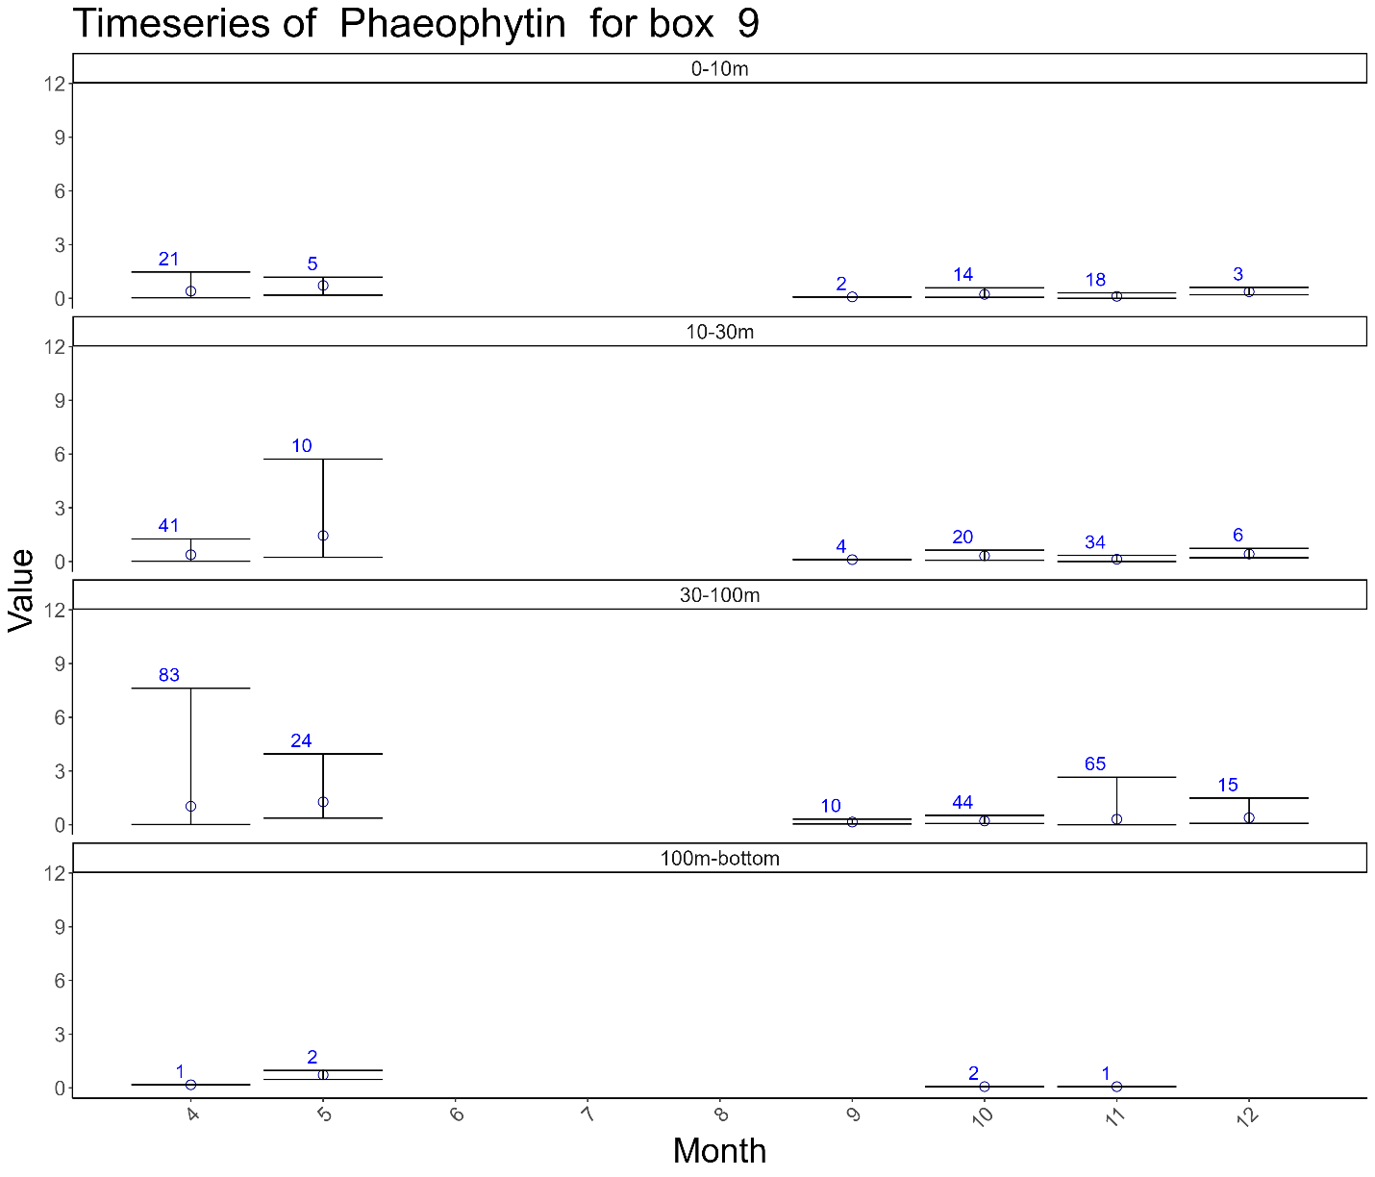

## Phosphate

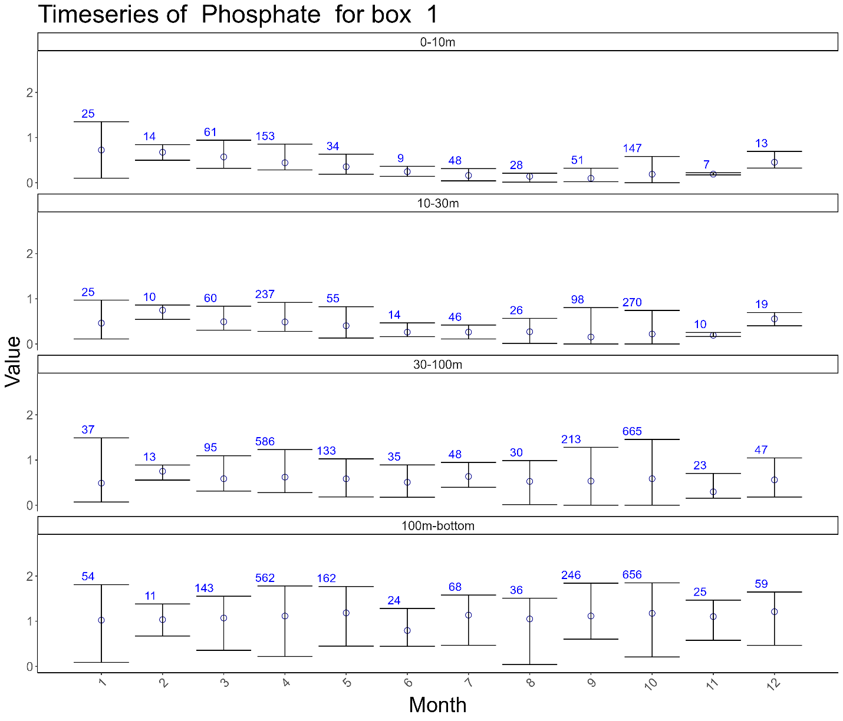

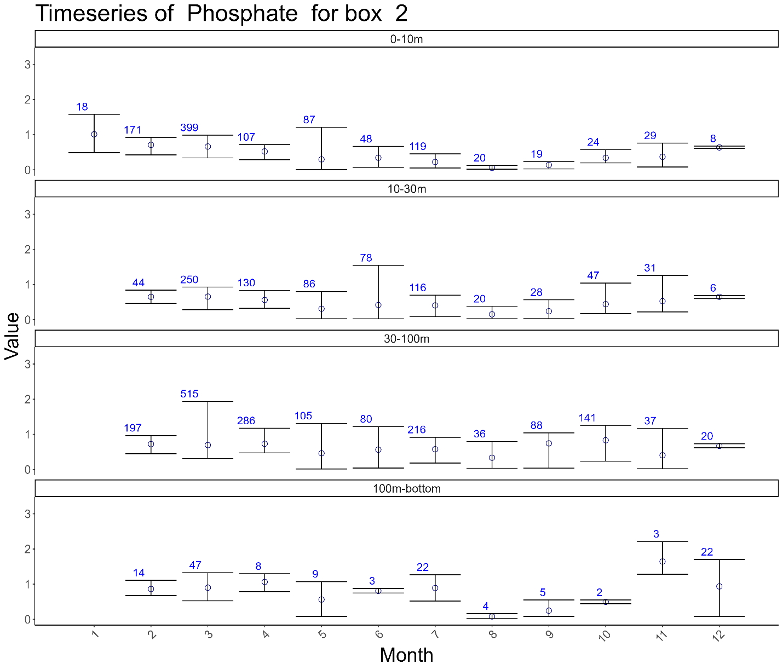

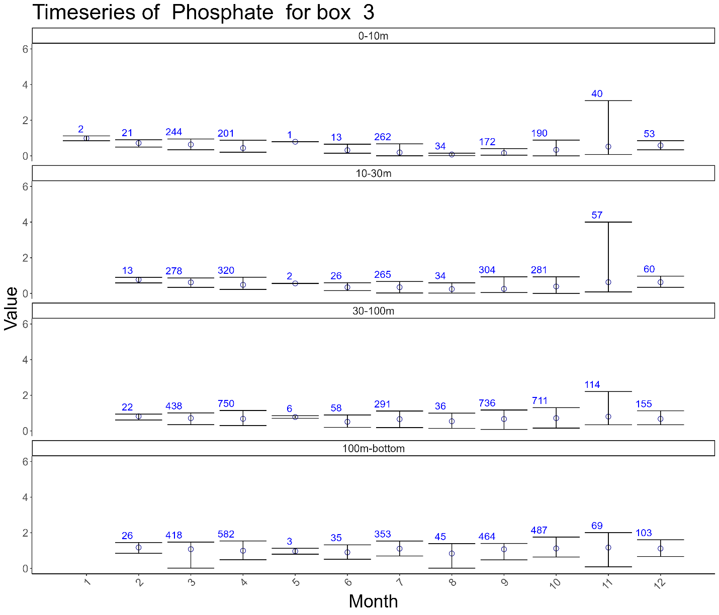

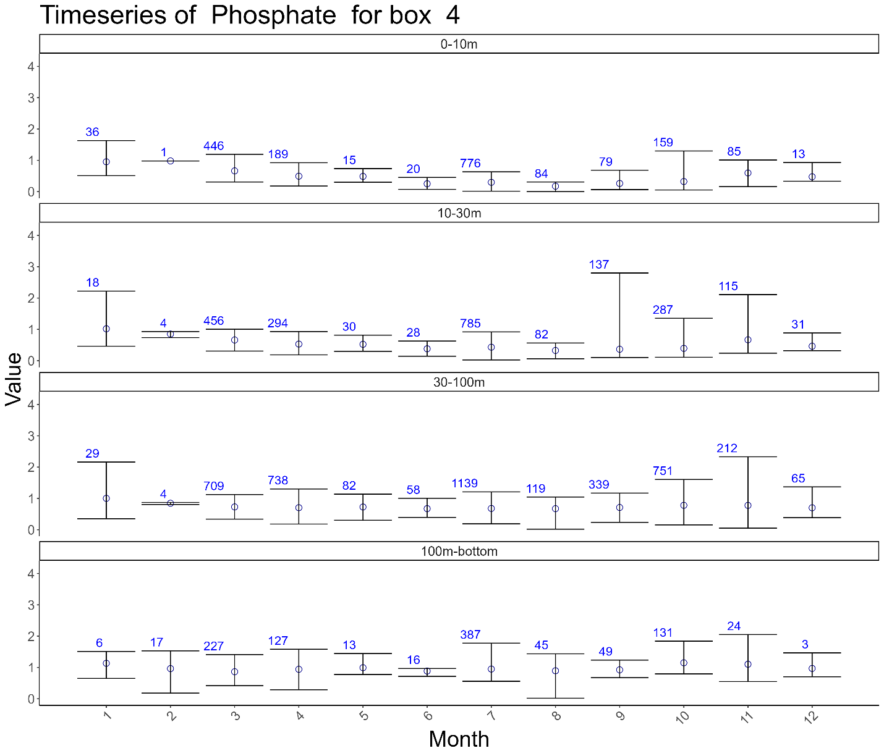

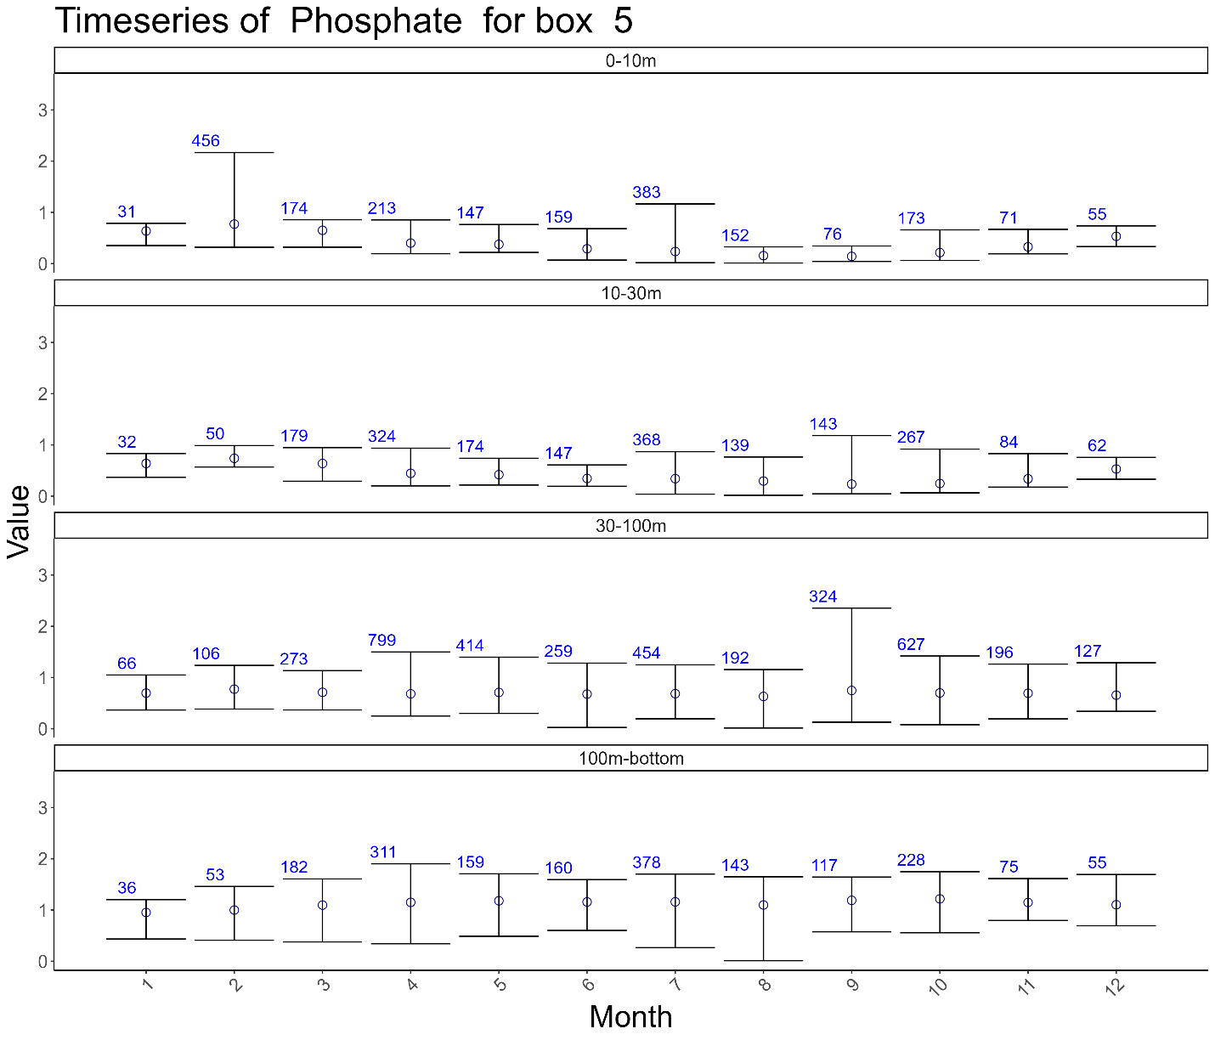

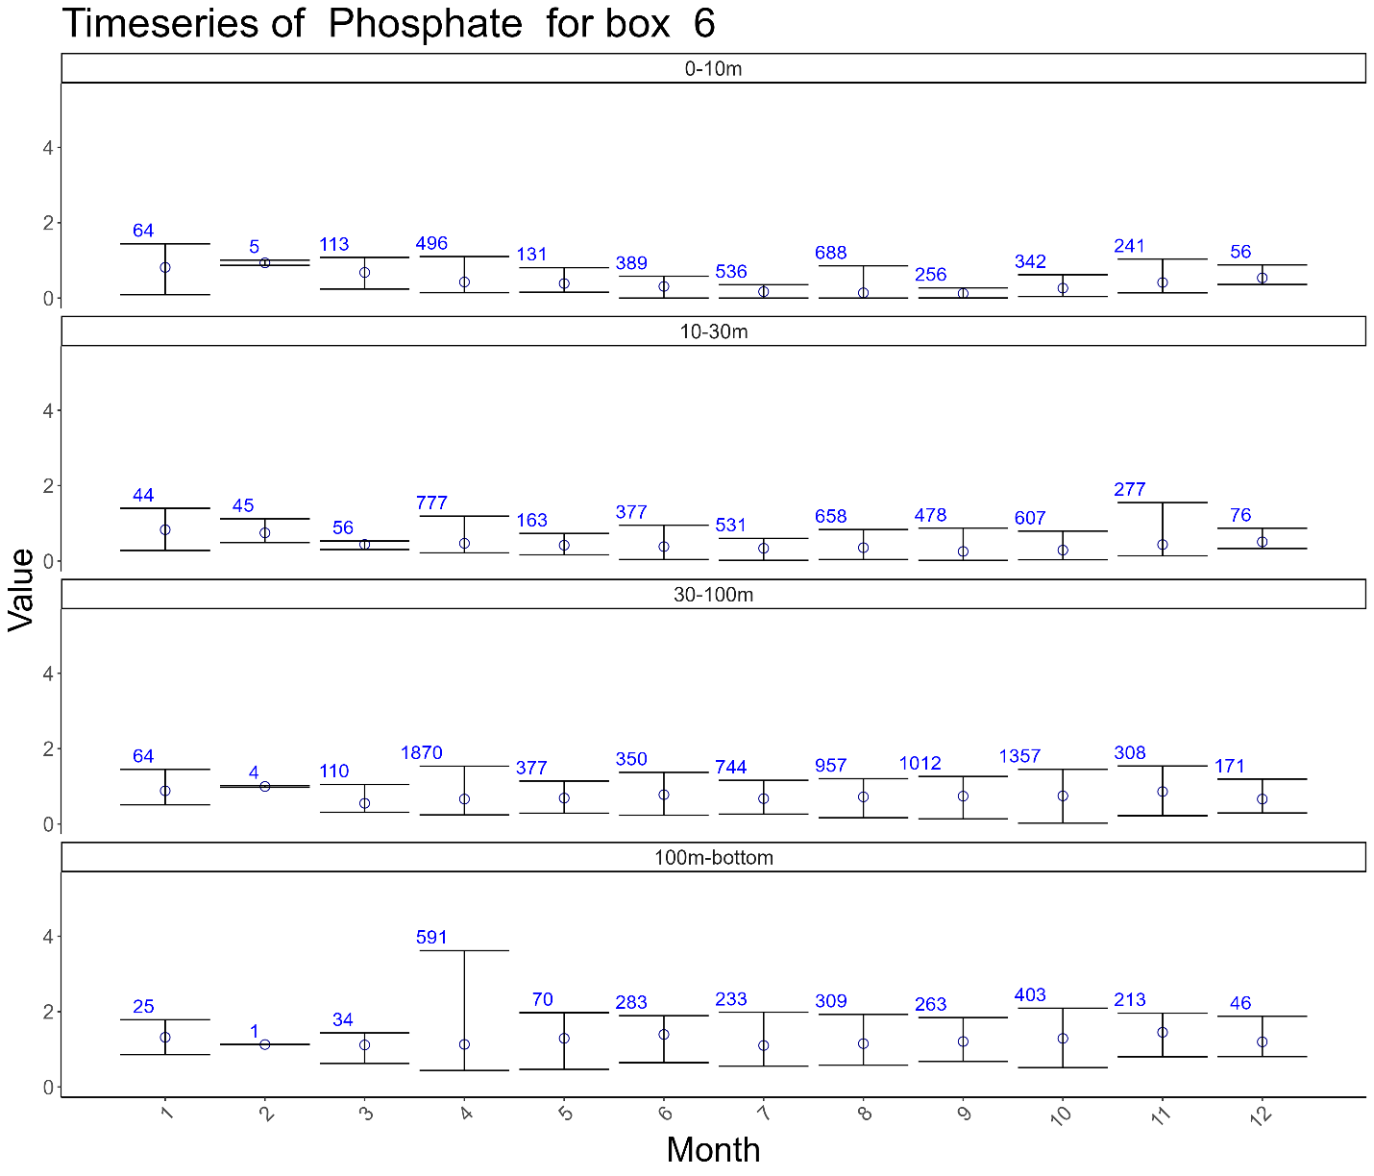

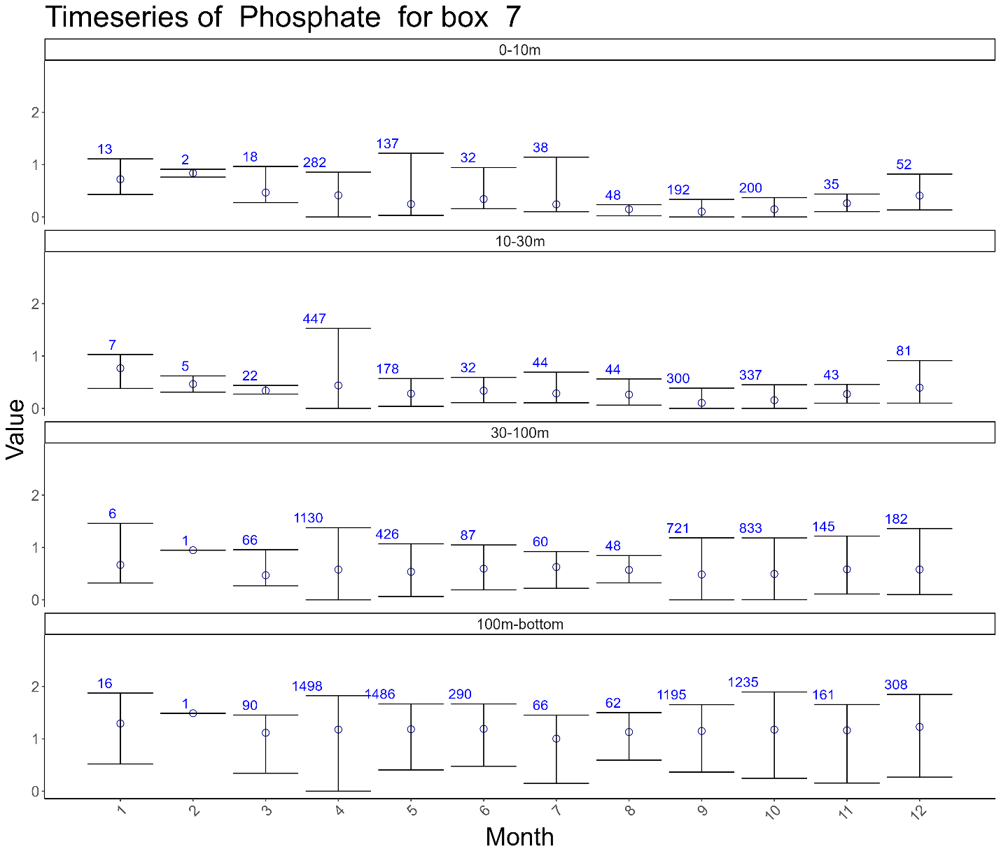

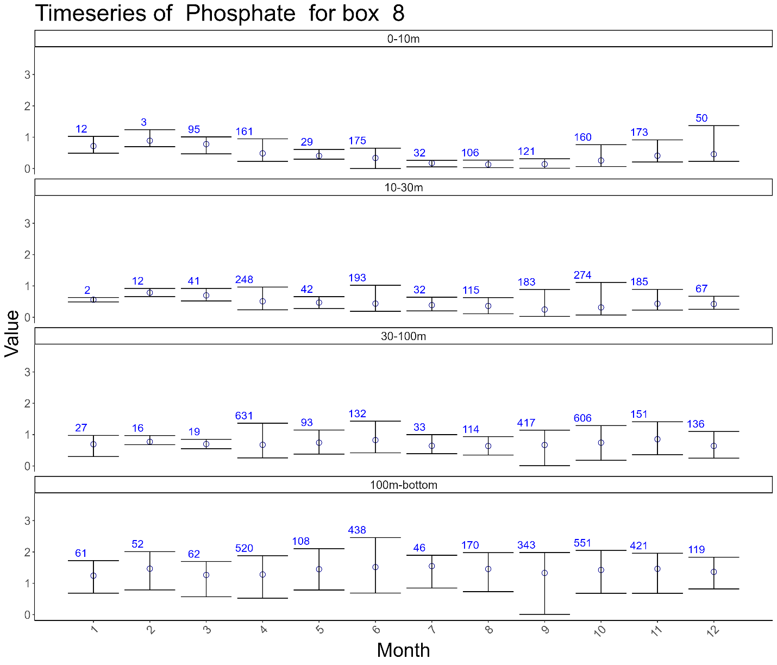

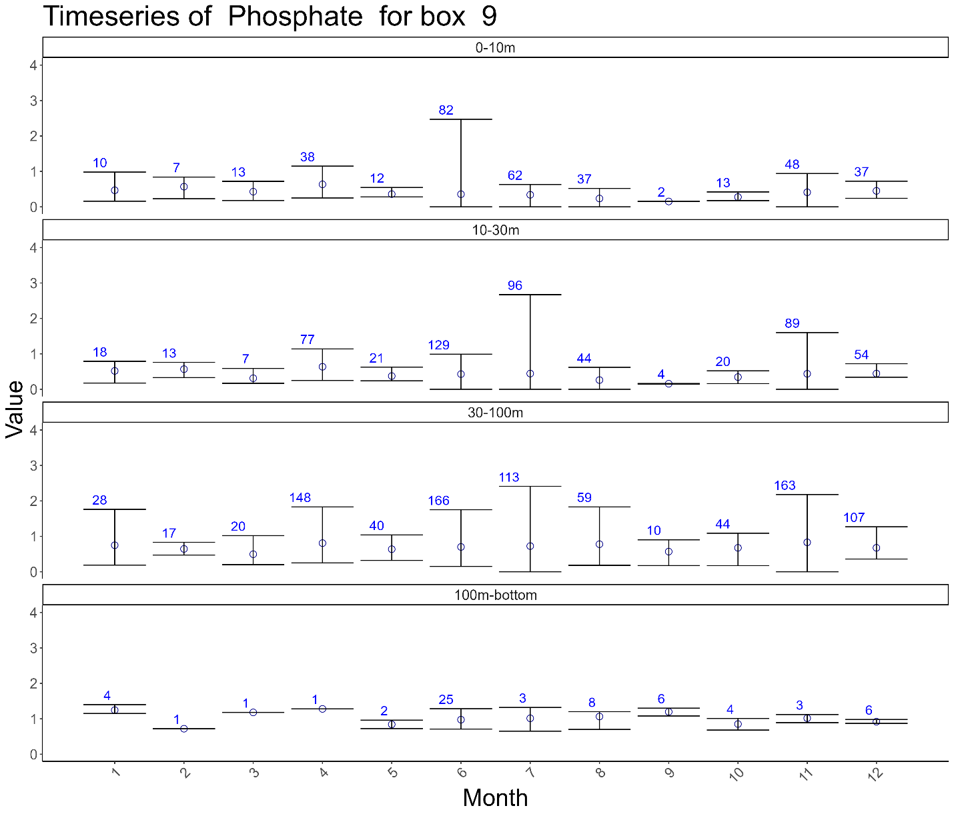

## Silicate

